ST. LUKE’S ANGLICAN CHURCH

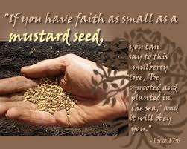

Sunday Communion Service

October 2, 2022, at 10:00 a.m.

The Rev. Robert Montgomery
Priest–in-Charge

rob.montgomery@anglican.nb.ca / (506) 608-1772

https://www.facebook.com/StLukesGP

Readings: Lamentations 3: 19 -26 Psalm 137 (BAS)

2 Timothy 1:1-14 Luke 17: 5-10

St. Luke’s News

INTERCESSIONS:
- Anglican Communion: Anglican Church of Canada, the Most Rev. Linda Nicholls, Primate. Council of the North, Bishop David Lehmann, Chair, and all the members of the Council. Ecclesiastical Province of Canada, Archbishop David, and the Provincial Council.
- Missions: The Rev. Canon Paul Jeffries, Bishop McAllister College, in Uganda, fellow missionaries, teachers, volunteers. The Diocese of Ho, Companion Diocese of the Diocese of Fredericton.
- Fredericton, Archbishop David, retired bishops Claude and William, and their families, the Lemmon family. Camp Medley and Camp Brookwood, Threshold Ministries, The Anglican Diocese of Yukon: our retired clergy, and our fellow Anglicans: Salisbury and Havelock, the Rev. Chris Hayes; Sussex, the Rev. Daniel McMullen; Gondola Point, the Rev. Rob Montgomery, and his family
- Gondola Point: Hymn Tortins Parish family: Malcolm and Audrey MacMillan and their family Parish Ministry: Parish Safe Church Officer and stewardship.
- Community Needs: those without work, food, or shelter, and those who serve and care for them. Pray also for those who are travelling.
- Shut-Ins, especially if due to COVID-1.9.
- Sick: Alice, Barb, Bev, Catharine, Diane, Flora, Janet, Katie, Laverne, Loie, Peter, Paul, Peggy, Shawn, Wanda., James F, Travis B., Jack D., Natalie D., James F., Isaac D. , John E., Lisa G., Diane M., Calvin M., Kathy M., Malcolm M., David S., Keaton S., Donna T., Wendy W., and any others we have been asked to include in our prays…
- Thanksgiving: Police, Firefighters, Teachers, Public Servants.

We would like to thank everyone who helped and supported St. Luke’s Annual Roast Beef Dinner on October 1/22.

St. Luke’s A.C.W meets every Monday at 10:00 am all are welcome.

The Rev. Montgomery’s Online Bible Study is on Tuesday’s at 3:30 p.m.

Rev. Rob Montgomery will resume our Midweek Contemplative Services in the church on Wednesdays, from 6:30-7PM.

Upcoming Activities and Events at St. Luke’s:

Oct. 15/22 Girls Day Out at St. Luke’s Parish Hall. 12 Quispamsis Road, 9:30 a.m. – 2:30 p.m. Contact Caroline Britten.

Oct. 25/22 St. Luke’s ACW ‘s Soup and Sandwich Takeout Lunch. Further details to come.

Nov. 5/22 St. Luke’s Christmas Bazaar at the Parish Hall. Further details to come.
November 5, 2022, 138th Session of the Diocesan Synod of Fredericton at Christ Church Cathedral, Fredericton
8:00am Registration Opens | 8:50am Synod Convenes | 4:00pm Adjournment
https://nb.anglican.ca/synod/sessions/pages/138th-session-2022

OTHERS:
October 1/22 Dear Layreaders (and Layreaders Emeriti), Archbishop David invites you to join him for a day together. Together Again - a gathering after unusual times
Saturday, October 1, 10:00 am - 3:30 pm
Christ Church Cathedral, Fredericton
Lunch will be provided.
Please register your intention to attend here | Website event page here

Oct 14 and 16/22 Yes... this is a promo for not one, but TWO ORGAN RECITALS... Fri. Oct. 14, 7pm and Sun. Oct. 16, 2pm at historic TRINITY Church, Saint John. The performances are on the same theme...Baroque organ music leading-up to the famous JOHANN SEBASTIAN BACH... but completely different (and famous) repertoire!
MICHAEL MOLLOY, who has his Masters in Performance of Sacred Organ Music, is our wonderful recitalist... and he loves to show-off the 280-voice digital pipe organ and fund-raise for the historic Church of the Loyalists!
At present we are rebuilding the exterior boundary walls, which date from the first Trinity Church, circa 1790. These have to be done by experienced, and expensive, stone masons. The two recitals will highlight Trinity organ’s German BAROQUE Specification. and feature sounds well-known and used by the immortal J.S. Bach and contemporaries.
Since it is a double feature, the concert-pair comes for a PACKAGE price. Each individual recital is $25. and purchased together are $45. TICKETS can be purchased through the Church office (693-8558) or at the door, 115 Charlotte St. Come and enjoy the huge organ filling the Church space up to the 65ft. ceiling, and let it raise YOUR SPIRITS!

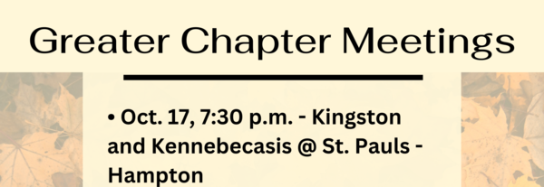

Quarters for A Kilometer: We will be collecting quarters ($0.25) for the distance of a kilometer for the Church Restoration Fund. There will be a container at the back table for the quarters.

Work on our Building Restoration Project is complete. St. Luke’s is in the process of raising funds for re- investments funds used for the Restoration repairs of St. Luke’s Anglican Church. White envelopes for this are on the entry table. If you have any questions, please speak with Rev. Rob Montgomery, Rosemarie Kingston, or Terry Sleep.

Safe Church Trainer and Renewals: Please note a new online safe church training platform has been developed to allow the Diocese to better track who has taken the training, as well as working to make the training more relevant, accessible, and simple to complete. The new training should take 30-45 minutes and the Diocese would appreciate all feedback that you can provide on the entire process to ensure this is the ideal system to roll out to the diocese. Please contact Donna Dobbin for your training, thank you.

Mission Visionary Group – Meet monthly for guidance and direction of out missionary outreach of the Parish. Further details please contact the Rev. Rob Montgomery.

We are collecting refundable items from the parish for the Restoration Fund for the Church. If you have any you would like picked up, you may call Terry and Susan Sleep at 847-7609, or Darryl.

On this website is also St. Luke's Blog, posting of our Orders of Service and Sermons for Sundays, as well as other resources for us from time to time. Feel free to explore and spread the news if you can.

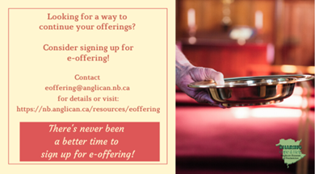
We must continue to meet our monthly expenses while we are unable to come to our church to meet at times for worship and fellowship. Since all worship services, meetings, and events at our church placed are on hold at times, and our bulletin has changed. As the situation changes, activities will begin to be re-scheduled. Please contact Terry Sleep at 847-7609. He is our Parish E-offering Representative or by mail to St. Luke’s Anglican Church, 12 Quispamsis Road, Quispamsis, New Brunswick, E2E 1M2 or e-transfer. Please contact Terry Sleep at 847-7609 for further information or instructions, thank you.

Many of you received the e-news from Gisele McKnight, Diocesan Communications Officer. It contains messages from the archbishop concerning the coronavirus and the resulting procedural changes and cancellations that have been put in place. Bishop David’s message contains links to his earlier messages on the coronavirus, as well as to prayers, on-line worship services and the Book of
Common Prayer. If you did not receive e-news, it may be found at https://nb.anglican.ca/newsletters/102/display A call to prayer has been issued and details may be found in e-news. As well, you can keep up with Diocesan events at https://nb.anglican.ca/

E - News wants subscriber
e-News is the best way to keep up to date on what is going on in the diocese
Click here to subscribe.

THE ANGLICAN JOURNAL AND THE NEW BRUNSWICK ANGLICAN: If you are not currently receiving the Anglican Journal and the New Brunswick Anglican and would like to, there are two ways to subscribe: 1. On-line at https://www.anglicanjournal.com/newsubscription/ checking off that you want the Diocesan paper called "Fredericton - New Brunswick Anglican" in the drop-down menu to accompany your subscription to the Anglican Journal, or 2. E-mail circulation@national.anglican.ca indicating that you would like to receive both the Anglican Journal and the New Brunswick Anglican. Include the name of your parish and the Diocese.

Donations for Ukraine relief
Donate via PWRDF
PWRDF is supporting Ukrainians forced to flee their homes due to the
Russian invasion. The initial grant of $20,000 issued to an ACT Alliance appeal has been increased to $50,000. The grants will fund the work of
Action by Churches Together (ACT) member Hungarian Interchurch Aid
(HIA).
On Feb. 27, HIA set up a 24-hour refugee support point on the Hungarian
side of the border at Beregsurány, where the line of refugees trying to cross into Hungary is kilometres long, says an ACT communiqué. HIA is providing hot tea, sandwiches, refreshments, blankets, and basic hygiene items for Ukrainians, including many elderly and children who are waiting long hours
to cross the border into Hungary.
How you can help. To make a donation to this response online, click here
You may also donate by phone at 416-822-9083 or leave a voicemail
toll-free at 1-866-308-7973 and PWRDF will return your call; or mail your cheque to PWRDF, 80 Hayden, 3rd floor, Toronto, Ontario, M4Y 3G2.
Please mark Ukraine in the memo field.
apply to be part of Say Yes! To Kids and be on their way to making their projects a reality.
The first step is to take a webinar, which are being held throughout March.

Visit Kings Landing
Sunday service @ 2 p.m.

Love Atlantic invites ‘radical generosity in Jesus’ name’
You would be forgiven if your parish is a bit rusty when it comes to missions. After all, two years of social distancing, closed churches, masking, and enforced isolation have discouraged and disheartened many a church.
“As Christians, we’re called to be a blessing to others,” said parish development officer Shawn Branch. “Coming out of the pandemic, many churches have gotten out of the habit.” So, if you are looking for a way to return to outreach, Love Atlantic is a good place to start.

Seniors' Retreat at Camp Medley
Sunday, October 2, 2022
Come, relax and enjoy camp life. Experience archery, canoeing,
specialty art projects, hiking, wellness stretching, work projects,
games and campfire (storytime) while living in a Christian community. Great food and lodging provided.
The retreat is geared to those 50 and older but all adults are welcome.
Cost: $150

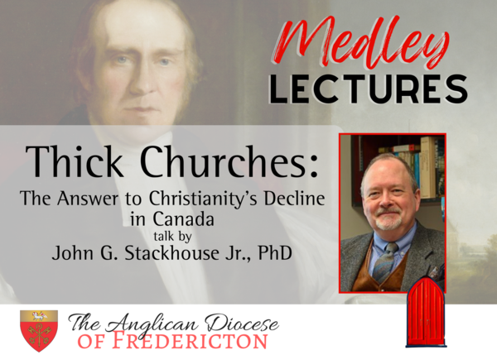

Thick Churches:
The Answer to Christianity's Decline in Canada - Wednesday, October 12, 2022
This presentation is open to all, regardless of denominational affiliation or faith connection, and will be available in person at Christ Church Cathedral, Fredericton or through webinar format.
For more information, contact Shawn C. Branch - 506-459-1801 ext. 1008.

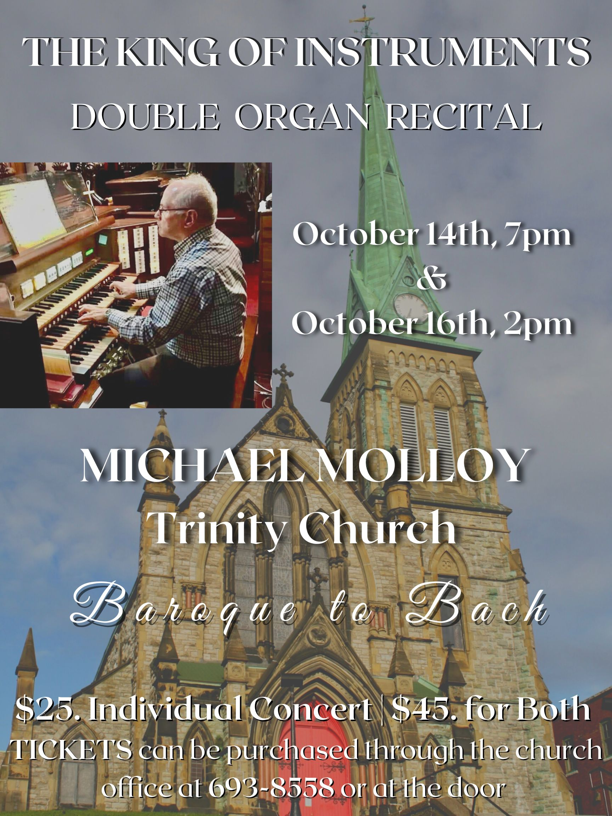

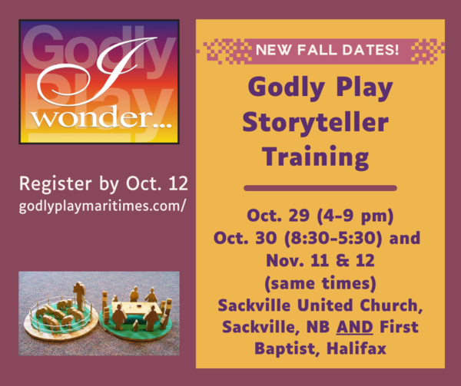

Godly Play t raining
Fall dates have changed
https://godlyplaymaritimes.com/

