ST. LUKE’S ANGLICAN CHURCH

Sunday Morning Communion

October 29, 2023, at 10:00 a.m.

The Rev. Rob Montgomery
Priest-In-Charge

rob.montgomery@anglican.nb.ca / 506-608-1772
https://www.facebook.com/StLukesGP

12, Quispamsis Road, Quispamsis, N.B. E2E 1M2

Readings: Deuteronomy 34: 1-12 Psalm 90: 1-6, 13-17

1 Thessalonians 2: 1-8 Matthew 22 : 34-46

St. Luke’s News
INTERCESSIONS:
- Anglican Communion: The Anglican Church of Melanesia, the Most Rev Leonard Dawea, Archbishop. Ecclesiastical Province of Rupert’s Land, Archbishop Gregory Kerr-Wilson, and the Provincial Council.
- Missions: The Rev. Canon Paul Jeffries, Bishop McAllister College, in Uganda, fellow missionaries, teachers, volunteers. The Diocese of Ho, Bishop Matthias Meduadues-Badohui, Ghana, West Africa the Companion Diocese of the Diocese of Fredericton
- Fredericton, Archbishop David, retired bishop William and his family, the Miller, and the Lemmon family. Camp Medley and Camp Brookwood, staff, and campers. Threshold Ministries, The Anglican Diocese of Yukon: our retired clergy, and our fellow Anglicans; Lancaster, the Rev. Keith Joyce; Sussex, the Rev. Tom Stradwick; Gondola Point, the Rev. Rob Montgomery, and his family and the Ven. Cathy Laskey's, honorary assistant and her family.
- Gondola Point: Parish Breakfasts Parish family: Richard and Pauline Sherwood and their family Parish Ministry: parish and cemetery treasurers and stewardship.
- Community Needs: those without work, food, or shelter, and those who serve and care for them. Pray also for those who are travelling.
- Shut-Ins.
- Sick: Barb, Bev, Catharine, Danielle, Diane, Donna, Katie, Laverne, Shawn, Wanda., Winnie C., James F, Travis B., Jack D., Natalie D., Isaac D. , John E., Lisa G., Diane M., Kathy M., Malcolm M., David S., Keaton S., Donna T., and any others we have been asked to include in our prays….
- Thanksgiving: Beauty and Wonder of Creation

From the Archbishop's desk
The Rev. Rob Montgomery has been appointed regional dean of the Deanery of Kingston-Kennebecasis, for a three-year period, to Oct. 31, 2026.
Congratulations from the Congregation of the Pariah of Gondola Point!

Today is Food Basket Sunday, the last Sunday of the month and we are thankful for the donations to the KV Food Basket.

Today is also Birthday Sunday:

Happy birthday to you.
To our Lord be true.
May God's love and blessings,
Rain down upon you.

Donnie Britten | Ken Mason
Charles Lee | Peggy Odell
And any others we may have missed.

Parish Mission Outreach: Parish Mission Outreach: For the next Sundays, we are collecting boxes of “Cheerios” Cereal for an Elementary School Breakfast Program. Non-name brands are acceptable if there are no nuts (peanuts, peanut oil) in the ingredients or facilities in which they are made. Again, we will collect them at the church and then deliver them to the school.

Nov. 4/23 Please save the date of Saturday, November 4, which is tentatively scheduled for a Layreader gathering / training day. The planned training will be on leading both BCP and BAS worship - looking at those liturgies in detail and finding how to find the daily and seasonal parts. Experienced layreaders are also encouraged to plan to attend to share your knowledge.
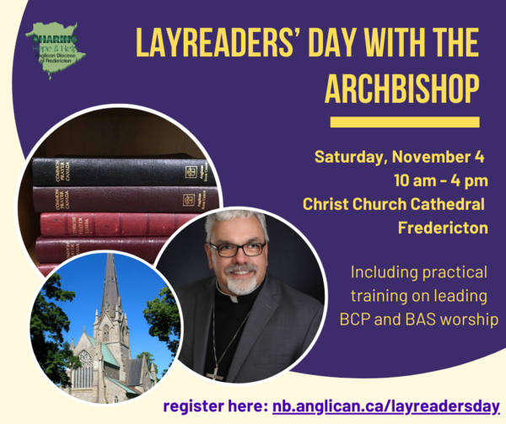

Layreaders' Day with the Archbishop Including practical training on leading BCP and BAS worship, Saturday, November 4, 2023

10:00 am - 4:00 pm Christ Church Cathedral, Fredericton

++++++++++++++++++++++++++++++++++++++++++++++
The Parish of Riverview Altar Guild is looking for children’s choir gowns and cruets, for purchase or donation. If you can help, contact the Rev. Julian Pillay > shepherdsheartsa@gmail.com
Clergy Conference

Saturday October 28th, 2023 from 2 pm - 4 pm
Holy Trinity Hammond River - DEATH & TAXES
Death and Taxes are part of life! What do you need to know? How do you plan for the future? Should you preplan funeral arrangements? Do you need a will? What are your options? Please join us for a special afternoon with guests David Nickerson from Brenan's Funeral Home & lawyer Kelli Lester.

Sunday October 29, 2:00 p.m. The Church of St. Simon and St. Jude's in Belleisle Creek (originally the Parish of Springfield, Kings County) is celebrating its 140th anniversary, with Archbishop Edwards presiding. The service will be a "Kirking of the Tartans" service, representing all the founding and significant families of this church and congregation over the years. Many families have moved away. The church is looking for the descendants of Northrups and Scovils, two families that no longer have representatives in the parish. All are welcome to this community and mission celebration. Refreshments (including Haggis) afterwards. Please pass this on to anyone with Belleisle Creek roots.

Saturday, Nov. 4, 11 a.m. Service of Remembrance and Thanksgiving, St. Paul’s in Hampton, for all whom we have laid to rest. One very special moment in the service will be the Rose Ceremony during which family members and friends can have the name(s) of their loved one(s) read aloud as a rose is offered in their memory.
If you have a loved one whose name you would like to have included in the rose ceremony, please contact the parish office by October 30th to let us know. Office Administrator: stpauls-hampton@outlook.com; Phone: (506) 832-3375 An offering will also be collected to support the ongoing preservation and maintenance of St. Paul’s cemetery.

Sunday, Nov. 26, 2:30 p.m. St. Paul’s Church in Rothesay will hold its 15th annual Sounds for Sigowet concert, followed by a silent auction and an elegant tea with treats. All proceeds will enable orphans to attend secondary school in Eldoret, Kenya. Tickets are $20 for adults, $10 for students and are available at the church office or by calling 506-847-1812 or 506-849-2414.
This year’s performers are Chris Buckley, viola; Ali Leonard, violin; Dani Sametz, violin and John Buckley, cello.

November 24/23 Holy Trinity, Hammond River - Christmas Community Lunch and Bake Sale on 11am to 1 pm.

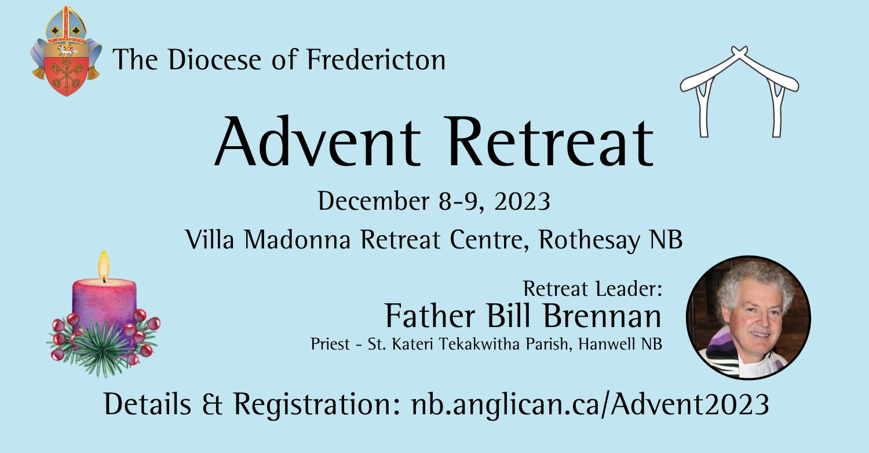

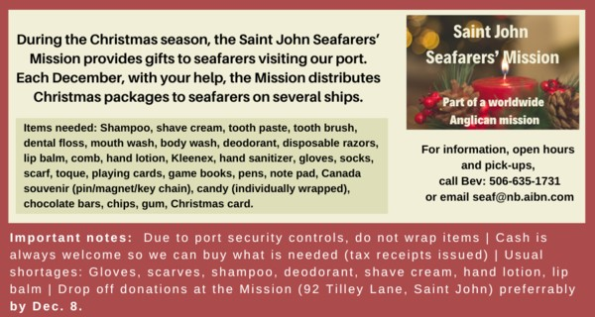

++++++++++++++++++++++++++++++++++++++++++++++++++++++

St. Luke’s A.C.W meet every Monday at 10:00 am all are welcome.

The Rev. Montgomery’s Online Bible Study on Tuesday at 3:00 p.m.

St. Luke’s Book Club the last Tuesday of the month at 10:00 a.m. at St. Luke’s Parish Hall. Please contact Heather Hynds for the list of books.

The Rev. Rob Montgomery’s Midweek Contemplative Services from 6:30PM - 7PM St. Luke’s Anglican Church.
Mission Visionary Group – Meet monthly for guidance and direction of out missionary outreach of the Parish. Further details please contact the Rev. Rob Montgomery.

Quarters for A Kilometer: We will be collecting quarters ($0.25) for the distance of a kilometer for the Church Restoration Fund. There will be a container on the back table for the quarters. Work on our Building Restoration Project is complete. St. Luke’s is in the process of raising funds for re- investments funds used for the Restoration repairs of St. Luke’s Anglican Church. White envelopes for this are on the entry table. If you have any questions, please speak with Rev. Rob Montgomery, Rosemarie Kingston, or Terry Sleep.

Safe Church Trainer and Renewals: Please note a new online safe church training platform has been developed to allow the Diocese to better track who has taken the training, as well as working to make the training more relevant, accessible, and simple to complete. The new training should take 30-45 minutes and the Diocese would appreciate all feedback that you can provide on the entire process to ensure this is the ideal system to roll out to the diocese. Please contact Donna Dobbin for your training, thank you.

We are collecting refundable items from the parish for the Restoration Fund for the Church. If you have any you would like picked up, you may call Terry and Susan Sleep on 847-7609, or Darryl.

On this website is also St. Luke's Blog, posting of our Orders of Service and Sermons for Sundays, as well as other resources for us from time to time. Feel free to explore and spread the news if you can.

We must continue to meet our monthly expenses while we are unable to come to our church to meet at times for worship and fellowship. Since all worship services, meetings, and events at our church are on hold at times, our bulletin has changed. As the situation changes, activities will begin to be re-scheduled. Please contact Terry Sleep at 847-7609. He is our Parish E-offering Representative or by mail to St. Luke’s Anglican Church, 12 Quispamsis Road, Quispamsis, New Brunswick, E2E 1M2 or e-transfer. Please contact Terry Sleep at 847-7609 for further information or instructions, thank you.

Many of you received the e-news from Gisele McKnight, Diocesan Communications Officer. It contains messages from the archbishop concerning the coronavirus and the resulting procedural changes and cancellations that have been put in place. Bishop David’s message contains links to his earlier messages on the coronavirus, as well as to prayers, on-line worship services and the Book of
Common Prayer. If you did not receive e-news, it may be found at https://nb.anglican.ca/newsletters/102/display A call to prayer has been issued and details may be found in e-news. As well, you can keep up with Diocesan events at https://nb.anglican.ca/
E - News wants subscriber
e-News is the best way to keep up to date on what is going on in the diocese.
Click here to subscribe.

THE ANGLICAN JOURNAL AND THE NEW BRUNSWICK ANGLICAN: If you are not currently receiving the Anglican Journal and the New Brunswick Anglican and would like to, there are two ways to subscribe: 1. On-line at https://www.anglicanjournal.com/newsubscription/ checking off that you want the Diocesan paper called "Fredericton - New Brunswick Anglican" in the drop-down menu to accompany your subscription to the Anglican Journal, or 2. E-mail circulation@national.anglican.ca indicating.
that you would like to receive both the Anglican Journal and the New Brunswick Anglican. Include the name of your parish and the Diocese.

Donations for Ukraine relief
Donate via PWRDF
PWRDF is supporting Ukrainians forced to flee their homes due to the
Russian invasion. The initial grant of $20,000 issued to an ACT Alliance appeal has been increased to $50,000. The grants will fund the work of
Action by Churches Together (ACT) member Hungarian Interchurch Aid
(HIA). On Feb. 27, HIA set up a 24-hour refugee support point on the Hungarian side of the border at Beregsurány, where the line of refugees trying to cross into Hungary is kilometres long, says an ACT communiqué. HIA is providing hot tea, sandwiches, refreshments, blankets, and basic hygiene items for Ukrainians, including many elderlies and children who are waiting long hours to cross the border into Hungary. How you can help. To donate to this response online, you may also donate by phone at 416-822-9083 or leave a voicemail, toll-free at 1-866-308-7973 and PWRDF will return your call; or mail your cheque to PWRDF, 80 Hayden, 3rd floor, Toronto, Ontario, M4Y 3G2. Please mark Ukraine in the memo field. Apply to be part of Say Yes! To Kids and be on their way to making their projects a reality. The first step is to take a webinar, which are being held throughout March

