Happy Thanksgiving

ST. LUKE’S ANGLICAN CHURCH

October 11, 2020
At 10:00 a.m.
The Rev. Rob Montgomery
Priest-In-Charge
Parish of Gondola Point in Quispamsis, N.B.
rob.montgomery@anglican.nb.ca / 506-608-1772
https://www.facebook.com/StLukesGP
Website - www.stlukesgp.ca
Parish Telephone: (506) 847-3670

Reading: Exodus 32:1-14 Psalm 106:1–6, 19–23 Philippians 4:1–9 Matthew 22:1–14

INTERCESSIONS:
- Anglican Communion: The Church of the Province of Uganda, the Most Rev. Stephen Samuel Kaziimba
- Missions: The Rev. Canon Paul Jeffries, Bishop McAllister College, in Uganda, fellow missionaries, teachers, volunteers. The Diocese of Ho, Companion Diocese of the Diocese of Fredericton
- Fredericton, Archbishop David Edwards, retired Bishops Claude, William and George, and their families. Camp Medley and Camp Brookwood, Threshold Ministries, The Anglican Diocese of Yukon: our retired clergy, and our fellow Anglicans: Christ Church Cathedral, the Very Rev. Geoffrey Hall; Hammond River, the Rev. Michael O’Hara; Gondola Point, the Rev. Rob Montgomery
- Gondola Point: Bible Studies Parish family: Craig and Shari Patstone Parish Ministry: Parish website designer and stewardship.
- Community Needs: those without work, food, or shelter, and those who serve and care for them. Pray also for those who are travelling.
- Shut Ins due to COVID-19
- Sick: Flora, Katie, Melissa, Shawn, Wanda., Travis B., Jack D., Doreen E., John E., Susan L., Karen M., Calvin M., Eleri P., Emilie P., David S., Keaton S., and any others we have been asked for prays…
- Thanksgiving: Our Church Family and Freedom to Worship.

We are collecting donations for the Saint John Community Christmas Exchange for the month of September and first part of October 2020. You will find small white envelopes marked Saint John Christmas Exchange on the back table. Thank you. The Saint John Community Christmas Exchange serves the areas of Browns Flat; Grand Bay - Westfield; Hampton; Quispamsis; Rothesay; St John County; Welsford; and Kingston Peninsula.

Oct 14/20 Wednesday is our next vestry meeting at the hall at 7:00 p.m. If you are not able to attend please send regrets to Rev. Rob Montgomery, the Wardens, or our vestry clerk.

Oct. 24/20 HOMEMADE BAKED BEANS, BROWN BREAD & APPLE CRISP TAKEOUT! Saturday October 24th, 2020. Cost $8.00 per take out. Call Mark & Kathy to Pre-Order at 832-3759. Pick up between 11 am and 1 pm at Holy Trinity Anglican Church 2 Hammond River Rd., Quispamsis (Next to the Hammond River Bridge). Treat yourself to a lovely fall meal & help support Holy Trinity's Mission Projects!

Trinity Church Columbarium The Trinity Columbarium is located inside the Germaine Street entrance at Trinity Anglican Church in Saint John, NB. This beautiful, historical church provides a place of remembrance for families wanting that connection with the church. There are various niche sizes (individual, couples, and family) available for purchase. Inquiries can be directed to the Trinity Parish office at (506) 693-8558 or email: trinsj@nb.aibn.com

The Rev. Montgomery has put our Parish Bible Study on Tuesday, on hold for the summer.
On this website is also St. Luke's Blog, posting of our Orders of Service and Sermons for Sundays, as well as other resources for us from time to time. Feel free to explore and spread the news if you can.

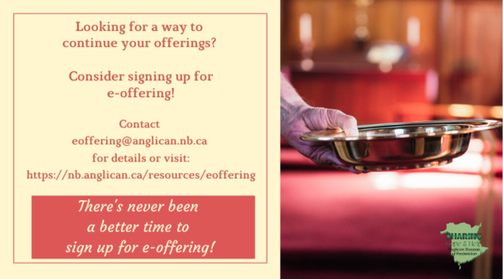
We must continue to meet our monthly expenses too while we are unable to come to our church to meet for worship and fellowship. Since all worship services, meetings and events at our church has been put on hold for the time being, our bulletin has changed. As the situation changes, activities will begin to be re-schedule. Please contact Terry Sleep at 847-7609. He is our Parish E-offering Representative or by mail to St. Luke’s Anglican Church, 12 Quispamsis Road, Quispamsis, New Brunswick, E2E 1M2 or e-transfer. Please contact Terry Sleep at 847-7609 for further information or instructions, thank you.

St. Luke’s is in the process of raising Funds for Restoration repairs of St. Luke’s Anglican Church with the matching of fund coming from a grant we have applied for from the Federal Government. White envelopes for this may be found on the entry table. If you have any questions, please speak with Rev. Rob Montgomery, Rosemarie Kingston, or Terry Sleep. We how you can help.

Share your favourite Christmas recipe for publication!
Send to the editor for publication in the New Brunswick Anglican: gmcknight@diofton.ca

Many of you received the e-news from Gisele McKnight, Diocesan Communications Officer. It contains messages from the Bishop concerning the coronavirus and the resulting procedural changes and cancellations that have been put in place. Bishop David’s message contains links to his earlier messages on the coronavirus, as well as to prayers, on-line worship services and the Book of
Common Prayer. If you did not receive e-news, it may be found at https://nb.anglican.ca/newsletters/102/display A call to prayer has been issued and details may be found in e-news. As well, you can keep up with Diocesan events at https://nb.anglican.ca/
E - News wants subscriber
e-News is the best way to keep up to date on what is going
on in the diocese Click here to subscribe.

Thank You Letters to the Frontline Workers:
During these unparalleled, and honestly scary times, most of us have a social responsibility to help stop the spread of COVID-19 by staying home and staying safe; but not everyone. Doctors, nurses, and other medical staff, as well as police, firefighters, grocery store employees, postal/delivery workers, gas station attendants, public transportation workers, mental health and social services workers, farmers, and countless other “essential workers” are putting themselves in harm’s way daily so the rest of us can stay safe. We want to thank you for all the hard work you are doing to keep our community safe during this time. Thank you for being so dedicated, courageous, and selfless as we continue to work together to overcome this challenge we are currently facing. We are all trying to do our part by staying at home. You are inspiring us to take care of our community, and in the future, we will continue to take care of it. Your efforts, sacrifices, commitment, and leadership during these uncertain times is greatly appreciated! We are all in this together. Thank you again!

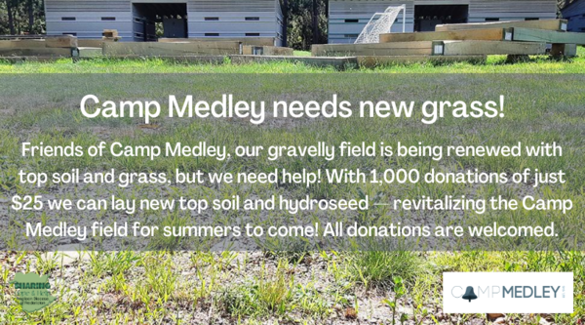

Calling all friends of Camp Medley
Want to help? Click here to donate! Under the “fund” drop-down menu, choose Camp Medley.
Check out the Camp Medley video on this topic here.

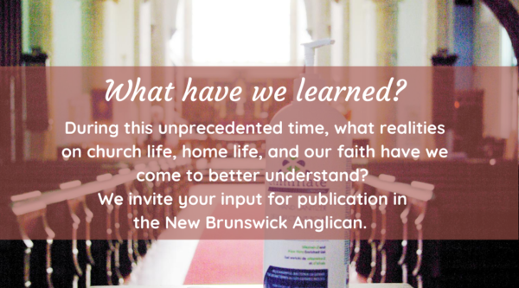

"What have we learned?"
NB Anglican editor Gisele McKnight would like to launch a series called "What Have We Learned" regarding the past six months living under pandemic conditions.
The aim is for answers to encompass mostly church life and how that has affected you, but could also include personal epiphanies, mental health issues and the like. As long as they are relevant to your life as a Christian, we’re interested in hearing from you.
Please write economically and try to limit your answer to 300 words.
This series, assuming there is enough feedback, will be ongoing throughout the fall. The next deadline is Sept. 25.
Send to gmcknight@diofton.ca . Thank you!

Diocese of Ho mobile medical clinic
Please give if you can to this worthy cause. COVID-19 has devastated the Volta region where Ho is located. There is no healthcare in the area and no testing kits, and we are hearing authorities are completely overwhelmed and people are fearful.
Donate here.

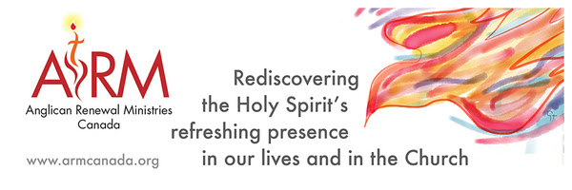
Anglican Renewal Ministries
Anglican Renewal Ministries is dedicated to bringing the life and power of the Holy Spirit to all Christians. ARM has been serving the Anglican Church of Canada for over 30 years. In addition to workshops, we offer a quarterly magazine with articles to uplift and encourage people in their walk with Christ. We hope it will be a source of encouragement to all in these difficult times. Sample articles and a free copy of the magazine are available on our website.

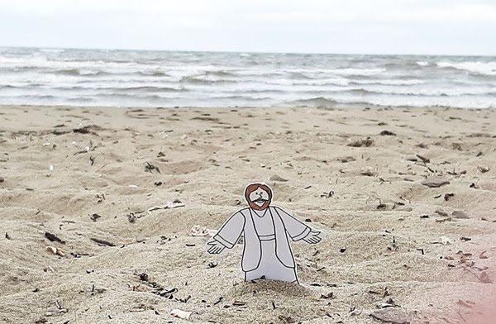

News from YIG
Did you take part in the Take-Out Church Fruit of the Spirit program this summer? Did you download the document? YIG would like your feedback via a survey to help plan future events and programs. Five minutes is all you need. Even if you didn’t use it in full, your feedback is important. Click the link to participate.
Did you take Flat Jesus with you in your travels this summer? Share your photos of Flat Jesus with us! Send them to yigfton@gmail.com to be included in an upcoming NB Anglican story.
YIG stands for Youth & Intergenerational Ministry.

The Parish Development Officer and Council Spiritual Development Team, on behalf of Bishop David, are coordinating some diocesan-wide initiatives to recognize this time. We ask you to share these with your parishioners.

We certainly also encourage you in any parish or church events you are planning - and would be happy to publicize these on our diocesan event page.

Links to join and for resources are being added here: https://nb.anglican.ca/events/thy-kingdom-come

Shawn offers a video summary of all of this at: https://youtu.be/qCTgUSaIS-0

1. Video Testimonies
Jesus talking with the disciples asked, “Who do you say that I am?” (Matthew 16) That’s a great and important question! Who do you say Jesus is? We’re inviting you to share your response to this question. Record a 2-minute video and post it to your social media, tagging it with #ThyKingdomCome #NBAnglicans .

2. 24-7 Prayer Vigil
Everyone is invited to sign up for one or more 1-hour time slots and pray in their own space for God's Kingdom to come, for their church, and for family, friends and neighbours. Prayer guidelines will be available.
Daily Morning and Evening Prayer Offices using the Thy Kingdom Come prayer booklet (text will be provided) at 8:00 am and 6:00 pm (temporarily replacing the Litany@

Keep in touch with your favourite summer camps using the links below.
St. Michael’s Youth Conference
https://smyc.ca/
https://www.facebook.com/SMYCAtlantic/
Diocesan Choir School
http://www.anglicanchoirschool.com/
https://www.facebook.com/groups/121354914558579/
Camp Brookwood
http://www.campbrookwood.ca/
camp.brookwood@outlook.com
http://campmedley.ca/
https://www.facebook.com/camp.medley/

