ST. LUKE’S ANGLICAN Church

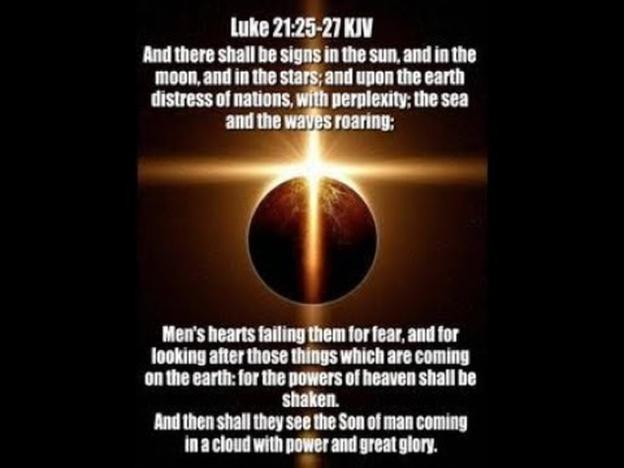

1st Sunday in Advent

Sunday Service

November 28, 2021, at 10:00 a.m.
The Rev. Robert Montgomery
Priest–in-Charge
rob.montgomery@anglican.nb.ca / (506) 608-1772

Facebook: https://www.facebook.com/StLukesGP
Website: http://www.stlukesgp.ca

Readings: Jeremiah 33: 14-16 Psalm 25: 1-10

1 Thessalonians 3: 9-13 Luke 21: 25-36
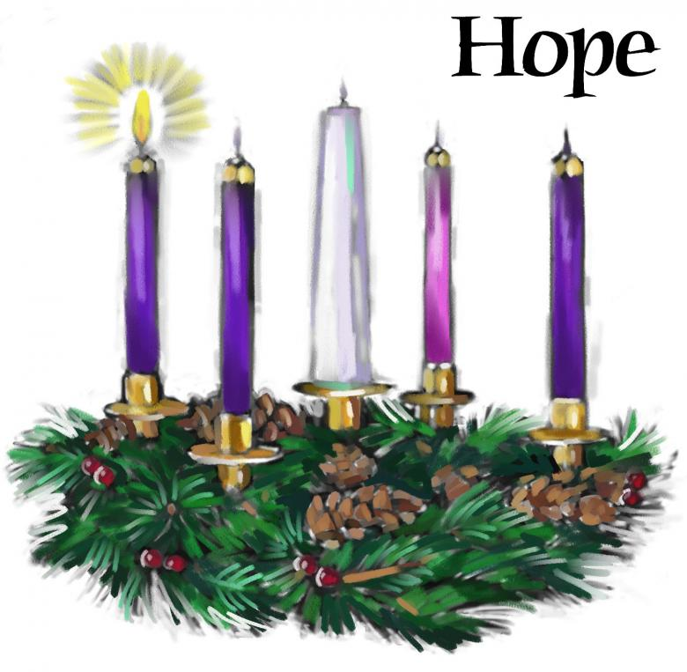

St. Luke’s News

INTERCESSIONS:
- Anglican Communion: Igreja Episcopal Anglicana do Brasil. Archbishop Linda Nicholls, Anglican Church of Canada. Ecclesiastical Province of British Columbia and Yukon, Archbishop Lynne McNaughton and the Provincial Council.
- Bishop McAllister College, in Uganda, fellow missionaries, teachers, volunteers. The Diocese of Ho, Companion Diocese of the Diocese of Fredericton
- Fredericton, Archbishop David Edwards, retired Bishops Claude, William and George, and their families. Camp Medley and Camp Brookwood, Threshold Ministries, The Anglican Diocese of Yukon: our retired clergy, and our fellow Anglicans: Bathurst, the Rev. Christopher Tapera; Central Kings, the Ven. Robert Marsh; Gondola Point, the Rev. Rob Montgomery, and his family
- Gondola Point: Romero House Parish family: David and Carolyn MacLeod Parish Ministry: Vestry and stewardship.
- Community Needs: those without work, food, or shelter, and those who serve and care for them. Pray also for those who are travelling.
- Shut-Ins, especially if due to COVID-19.
- Sick: Flora, Katie, Lori, Shawn, Wanda., James F, Travis B., Jack D., James F., Isaac D. Doreen E., John E., Lisa G., Laverne L., Diane M., Calvin M., Malcolm M., David S., Keaton S., John W., Wendy W., and any others we have been asked to include in our prays…
- Thanksgiving: Police, Firefighters, Teachers, Public Servants
Advent Readings

First Candle - The Candle of Hope

Leader: Today is the First Sunday of Advent, in which we recall the hope we have in Christ.

God told Abraham that through him all the nations of the world would be blessed, because he trusted and put his hope in God:

“I will make you into a great nation,” God told Abraham. “I will bless you and you will be a blessing to others … All the families on earth will be blessed through you.”

The Old Testament spoke of the coming of Christ, of how a Saviour would be born, a king in the line of King David. He would rule the world wisely and bless all the nations.

We too believe in God's promise to bless all people through Jesus. And we believe Jesus will come again to this world to bring light into the darkness and to establish his kingdom upon the earth.

(A person lights the First Candle here)
Hope is like a light shining in a dark place. As we look at the light of this candle, we celebrate the hope we have in Jesus Christ.

Leader: Let us pray:

All: All-mighty, all-loving God, y our love is revealed to us in Jesus Christ, Son of God, and Son of David. Help us in preparing to celebrate his birth, to make our hearts ready and to place our hope in you. Help us today and every day to worship you, to hear your word, and to do your will by sharing your hope with others. We ask it in the name of the one who was born in Bethlehem. Amen
Dec. 5/21 St. Luke’s Blue Christmas Service at 7:00 p.m.

CHRISTMAS FAMILIES: St. Luke’s Christmas Families project will be collecting cash donations again this year to be used to purchase gift cards for needy families. If you would like to help, please place cash or a cheque in an envelope marked “Christmas Families” in the collection plate and be sure to note your offering envelope number. All money donations must be in by Sun Dec 5th

Quarters for A Kilometer: We will be collecting quarters ($0.25) for the distance of a kilometer for the Church Restoration Fund. There will be a container at the back table for the quarters.

Work continues on our Building Restoration Project and will continue throughout this Fall. Stay tuned for more updates on our Building Restoration Project progress and funds raised towards it so far.

Restoration of St. Luke’s Anglican Church: As of October 31/21

Funds needed: $ 62,500.00. Funds on hand: $ 24,061.94

Safe Church Trainer and Renewals: Please note a new online safe church training platform has been developed to allow the Diocese to better track who has taken the training, as well as working to make the training more relevant, accessible, and simple to complete. The new training should take roughly 30-45 minutes and the Diocese would appreciate all feedback that you can provide on the entire process to ensure this is the ideal system to roll out to the diocese. Please contact Donna Dobbin for your training, thank you.

Upcoming Events:

Nov. 28/21, Sunday, 2 p.m. Trinity Church, 115 Charlotte St., Saint John, will host an early Advent organ program by Michael Molloy, well-known local organist, entitled From Darkness into Light on Trinity’s ‘king of instruments.” Tickets are $20. TICKETS are available from TRINITY CHURCH,115 Charlotte Street, N.B. E2L 2J2 (693-8558) Payment to the Anglican Parish of Saint John.
Reserve by calling 506-693-8558 or emailing trinsj@nb.aibn.com, or get them at the door. The program begins with Advent and transitions into the arrival of the Light. Featuring classical organ music from Germany and France, based on familiar Christmas Carols.
Tickets also available at the door, at the event.
NOTE: Due to current regulations proof of double vaccination and masks will be required.

Saint John Seafarers’ Mission – Christmas 2021
During the Christmas season, the Saint John Seafarers’ Mission provides gifts — necessities and a little extra — to seafarers far from home visiting our port.
In 2020, with help from many groups and individuals, the Mission distributed 146 Christmas packages to 7 ships.
Ideas for giving:
Toiletries: shampoo, shave cream, tooth paste, tooth brush, dental floss, mouth wash, body wash, deodorant, disposable razors, lip balm, comb, hand lotion, Kleenex
Warm Items: gloves, socks, scarf, toque
Something Extra: playing cards, game book, pen, Canada souvenir (pin/magnet/key chain), candy (individually wrapped), chocolate bars, chips, gum, Christmas card
Note: We generally have a shortage of gloves, scarves, shampoo, deodorant, shave cream, hand lotion, lip balm.
Note: Please do not wrap anything due to port security controls.
Ways to give: You can fill a gift bag (10 1/2” (h), 8 3/4” (w) and 4 1/2” (d)); give some items listed above; or make a donation (tax receipts issued).
Drop off at the Mission (92 Tilley Lane, Saint John) by Dec. 3, but
late donations are gratefully accepted. To ensure the Mission is open or if you need someone to pick up your items, please contact Bev at 506-635-1731 or email seaf@nb.aibn.com .

PWRDF's 2021 World of Gifts
The 2021 World of Gifts is officially here. This year's guide will bring new opportunities and hope for communities across the world as our PWRDF partners strive to build a truly just, healthy and peaceful world.
Click here to start shopping our secure, online guide today!
There are lots of ways to order! Copies of the World of Gifts Guide are included in issues of the Anglican Journal. You can also download the PDF version by clicking here.
Prefer to speak with us? Give us a call toll-free at 1-877- 936-9199, between 9 a.m. and 5 p.m. EST and make your order over the phone

Mission Visionary Group - Further details to follow by speaking to the Rev. Rob Montgomery.
St. Luke’s A.C.W. will be on holding their meeting on Monday in the hall starting at 10:00 a.m.,

The Rev. Montgomery leads St. Luke’s Parish Bible Study online on Tuesdays at 3:00 pm. Please contact Rev. Rob for further instructions.

We are collecting refundable items from the parish for the Restoration Fund for the Church. If you have any you would like picked up, you may call Terry and Susan Sleep at 847-7609, or Darryl.

On this website is also St. Luke's Blog, posting of our Orders of Service and Sermons for Sundays, as well as other resources for us from time to time. Feel free to explore and spread the news if you can.

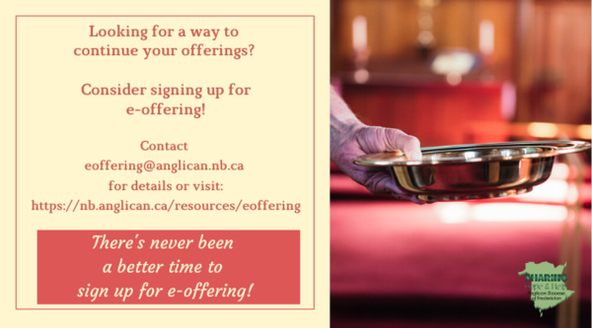
We must continue to meet our monthly expenses too while we are unable to come to our church to meet at times for worship and fellowship. Since all worship services, meetings, and events at our church has been put on hold at times, for the time being, our bulletin has changed. As the situation changes, activities will begin to be re-schedule. Please contact Terry Sleep at 847-7609. He is our Parish E-offering Representative or by mail to St. Luke’s Anglican Church, 12 Quispamsis Road, Quispamsis, New Brunswick, E2E 1M2 or e-transfer. Please contact Terry Sleep at 847-7609 for further information or instructions, thank you.

St. Luke’s is in the process of raising Funds for Restoration repairs of St. Luke’s Anglican Church with the matching of fund coming from a grant we have applied for from the Federal Government. White envelopes for this may be found on the entry table. If you have any questions, please speak with Rev. Rob Montgomery, Rosemarie Kingston, or Terry Sleep. They can help you.

Many of you received the e-news from Gisele McKnight, Diocesan Communications Officer. It contains messages from the Bishop concerning the coronavirus and the resulting procedural changes and cancellations that have been put in place. Bishop David’s message contains links to his earlier messages on the coronavirus, as well as to prayers, on-line worship services and the Book of
Common Prayer. If you did not receive e-news, it may be found at https://nb.anglican.ca/newsletters/102/display A call to prayer has been issued and details may be found in e-news. As well, you can keep up with Diocesan events at https://nb.anglican.ca/

WOODWORKING GROUP: The woodworking group at St. Augustine’s is on-going most days of the week. They welcome new ideas for seasonal craft projects. Please contact Kevin Tupper for more information or if you are interested in joining.

Trinity Church Columbarium the Trinity Columbarium is located inside the Germaine Street entrance at Trinity Anglican Church in Saint John, NB. This beautiful, historical church provides a place of remembrance for families wanting that connection with the church. There are various niche sizes (individual, couples, and family) available for purchase. Inquiries can be directed to the Trinity Parish office at (506) 693-8558 or email: trinsj@nb.aibn.com

E - News wants subscriber
e-News is the best way to keep up to date on what is going
on in the diocese Click here to subscribe.

THE ANGLICAN JOURNAL AND THE NEW BRUNSWICK ANGLICAN: If you are not currently receiving the Anglican Journal and the New Brunswick Anglican and would like to, there are two ways to subscribe: 1. On-line at https://www.anglicanjournal.com/newsubscription/ checking off that you want the Diocesan paper called "Fredericton - New Brunswick Anglican" in the drop-down menu to accompany your subscription to the Anglican Journal, or 2. E-mail circulation@national.anglican.ca indicating that you would like to receive both the Anglican Journal and the New Brunswick Anglican. Include the name of your parish and the Diocese.

