ST. LUKE’S ANGLICAN CHURCH
6th Sunday in Easter
Sunday Morning Communion Service
May 5, 2024, at 10:00 a.m.
The Rev. Rob Montgomery- Regional Dean of the Deanery of Kingston-Kennebecasis
Priest-In-Charge
The Rev. Canon Cathy Laskey's, honorary assistant
rob.montgomery@anglican.nb.ca / 506-608-1772
https://www.facebook.com/StLukesGP
12, Quispamsis Road, Quispamsis, N.B. E2E 1M2

Readings: Acts 10: 44-48 Psalm 98

1 John 5:1-6 John 15: 9-17

St. Luke’s News

INTERCESSIONS:
- Anglican Communion: Igreja Episcopal Anglicana do Brasil, the Most Rev. Marinez Rosa Dos Santos Bassotto, Primate. Council of the North, Diocese of the Arctic, Bishop David Parsons, Suffragan Bishops Annie Ittoshat, Lucy Netser and Joseph Royal, clergy and people, the Arthur Turner Training School in Pangnirtung. Anglican Church of Canada, Archbishop Linda Nicholls. Ecclesiastical Province of Rupert’s Land, Archbishop Gregory Kerr-Wilson, and the Provincial Council.
- Missions: The Rev. Canon Paul Jeffries, Bishop McAllister College, in Uganda, fellow missionaries, teachers, volunteers. The Diocese of Ho, Bishop Matthias Meduadues-Badohui, Ghana, West Africa the Companion Diocese of the Diocese of Fredericton
- Fredericton, Archbishop David, retired bishop William and his family, the Miller family, and the Lemmon family. Camp Medley and Camp Brookwood, staff, and campers. Threshold Ministries, The Anglican Diocese of Yukon: our retired clergy, and our fellow Anglicans; Riverview, the Rev Julian Pillay; Quispamsis, the Rev. Michael O’Hara; Gondola Point, the Rev. Rob Montgomery, and his family and the Rev. Canon Cathy Laskey and her family. – honorary assistant and Hospital Chaplain
- Gondola Point: Food Bank Parish family: Bob and Jill Lloyd and their family Parish Ministry: synod delegates and stewardship.
- Community Needs: those without work, food, or shelter, and those who serve and care for them. Pray also for those who are travelling.
- Shut-Ins.
- Sick: Barb, Catharine, Danielle, Diane, Donna, Katie, Kyle, Laverne, Shawn, Winnie C., James F, Travis B., Jack D., Natalie D., Isaac D., John E., Lisa G., Diane M., Kathy M., Malcolm M., David S., Keaton S., and any others we have been asked to include in our prays….
- Thanksgiving: Health and our Health Care System

The Parish would like to thank everyone who assisted with the Cemetery Cleanup yesterday.

May 26/24 All Ages Pentecost Party /BBQ Shared Meal from 4-6 pm at St. Luke’s, Gondola Point Parish, Quispamsis. We would like to invite the local Anglican Parishes Hammond River, Quispamsis, Rothesay, and Renforth. We hope you can come and bring the family.

St. Luke’s has expanded Hymn Tortins Coffee Time to include Tuesday mornings at 10:00 a.m. in the hall. Come for coffee and time to chat with friends. We hope to see you there.

Parish Mission Outreach: Parish Mission Outreach: For the next Sundays, we are collecting boxes of Cereal for an Elementary School Breakfast Program. Non-name brands are acceptable of any kind this time. Again, we will collect them at the church and then deliver them to the school.

As the temperature changes, the need for warm dry socks has come up. The need for the socks has started the collection of new warm socks of all sizes to be collected at the church and distributed to the many centers that need them.
++++++++++++++++++++++++++++++++++++++++++++++

Holy Trinity: SENIORS DROP- IN at Holy Trinity (Trinity Corner Café) - 1st and 3rd Thursday of the month from 1 pm to 3 pm. Coffee & Chats. A great opportunity to meet over coffee and snacks for card games, puzzles, explore the library or just sit and chat!

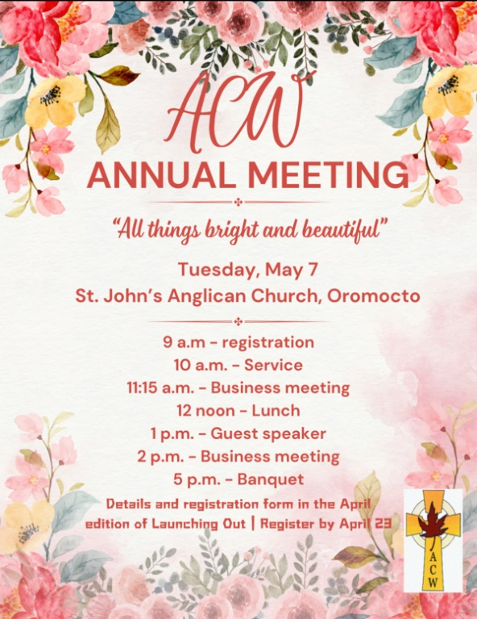

May 9, 2024 Thursday, The 2024 Vital Church Maritimes Conference is set for May 9 to May 11, in Truro, NS.
This event is hosted and sponsored by our friends in the Diocese of Nova Scotia and Prince Edward Island. More details and registration can be found here.
May 11, 11:30-1:30 Mother’s Day Luncheon at St. Paul’s Anglican Church, 4 Church Ave., Rothesay. Sandwiches, tea, coffee and sweets will be served. There will also be a jewellery table, book stall, jams and preserves. Tickets are $12 in advance and $15 at the door. To buy tickets, contact the parish office at 506-847-1812 or 506-849-2414. Proceeds go to support the outreach and charitable work of St. Paul’s.
Saturday, May 25, 11 a.m.-1 p.m. Spring tea and quilt show at St. Mary & St. Bartholomew’s Church, 646 Westmorland Rd., Saint John. Enjoy crafts, gifts, books, silent auction, bake sale. Sandwiches and cakes served. Tickets are $10, or $5 for children, available at the church office or at the door.

Young Adult Pilgrimage Friday, May 17, 2024
Attention Young Adults, aged 19-30...
Join us on a spiritual expedition to Grand Manan Island, New Brunswick! Connect with the Divine through the island's breathtaking landscapes & hospitable residents. Strengthen your bonds with fellow pilgrims through shared experiences, reflective conversations, and opportunities for prayer & worship together.
Led by Kurt Schmidt, the Rev. David Smith, and companion reflector Alan Hall. Ferry travel days are slated for Friday and Monday, main pilgrimage (hiking) day on Saturday, and worship on Sunday. Preparation period and weekly Sunday-evening Zoom prep sessions to begin on 7 April (the first Sunday after Easter). Online registration fee of $20, with the registration deadline to be 31 March (Easter Sunday).
For more information, contact Kurt Schmidt.

June 6, 2024 Clergy Day Thursday, June 6, 2024
Clergy Day with Dr Alan Roxburgh. Part of the day will include discussion on where we are as a diocese, post-pandemic and Alan will provide some perspective on what he has learned from journeying with others across the globe and what insights we can gain.
All active and licensed leaders (clergy, evangelists and students) are invited to attend.
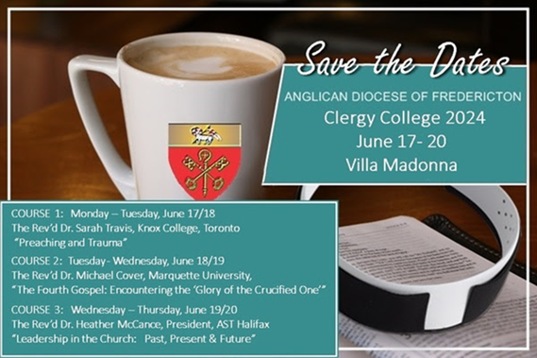

Choir School July 11-14, 2024
Choristers aged 16 and above are invited to attend this three-day choral weekend filled with singing, learning, friendship and fun, culminating, as usual, with a glorious and beautiful Choral Evensong.
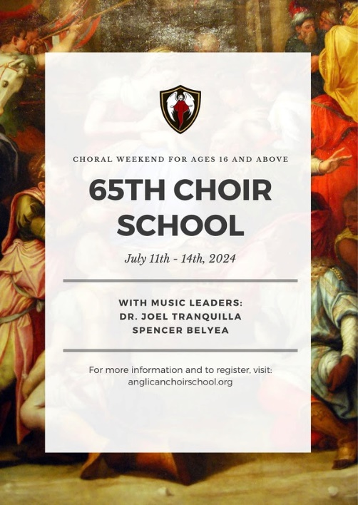
Founded in 1957, the Diocese of Fredericton Choir School has brought generations of Christians together through the beautiful spirit of music.
For more information or to register (by May 15), see the choir school website.

St. Luke’s Book Club the last Tuesday of the month at 11:00 a.m. at St. Luke’s Parish Hall. Please contact Heather Hynds for the list of books.

The Rev. Rob Montgomery’s Midweek Contemplative Services from 6:30PM - 7PM St. Luke’s Anglican Church.

Mission Visionary Group – Meet monthly for guidance and direction of out missionary outreach of the Parish. Further details please contact the Rev. Rob Montgomery.

Quarters for A Kilometer: We will be collecting quarters ($0.25) for the distance of a kilometer for the Church Restoration Fund. There will be a container on the back table for the quarters.

Work on our Building Restoration Project is complete. St. Luke’s is in the process of raising funds for re- investments funds used for the Restoration repairs of St. Luke’s Anglican Church. White envelopes for this are on the entry table. If you have any questions, please speak with Rev. Rob Montgomery, Don Smith, Bob Perry, or Terry Sleep.

Safe Church Trainer and Renewals Please contact Donna Dobbin for your training, thank you.: Please note a new online safe church training platform has been developed to allow the Diocese to better track who has taken the training, as well as working to make the training more relevant, accessible, and simple to complete. It may be found on https://nb.anglican.ca/safe-church/pages/group-training page. The new training should take 55 minutes and the Diocese would appreciate all feedback that you can provide on the entire process to ensure this is the ideal system to roll out to the diocese. Please contact Donna Dobbin for your training, thank you.

Police VP Checks and Criminal Record Checks are a requirement in the Diocese of Fredericton for clergy and lay volunteers. They are required to be renewed every 3 years.
a) The prevention of misconduct towards anyone, including children, youth, and vulnerable adults, by applying effective processes to ensure the church is a safe place for all people including Clergy, lay-leaders, Diocesan and parish staff, and other volunteers
b) The protection of all members of the church community from misconduct, particularly children, youth, and vulnerable adults; and
c) The legal protection of the Diocese, each Diocesan or Parish Corporation and their leadership.
Please contact Donna Dobbin for the volunteer form you require, thank you.

We are collecting refundable items from the parish for the Restoration Fund for the Church. If you have any you would like picked up, you may call Terry and Susan Sleep on 847-7609, or Darryl.

On this website is also St. Luke's Blog, posting of our Orders of Service and Sermons for Sundays, as well as other resources for us from time to time. Feel free to explore and spread the news if you can.
We must continue to meet our monthly expenses while we are unable to come to our church to meet at times for worship and fellowship. Since all worship services, meetings, and events at our church are on hold at times, our bulletin has changed. As the situation changes, activities will begin to be re-scheduled. Please contact Terry Sleep at 847-7609. He is our Parish E-offering Representative or by mail to St. Luke’s Anglican Church, 12 Quispamsis Road, Quispamsis, New Brunswick, E2E 1M2 or

e-transfer. Please contact Terry Sleep at 847-7609 for further information or instructions, thank you.

Many of you received the e-news from Gisele McKnight, Diocesan Communications Officer. It contains messages from the archbishop concerning the coronavirus and the resulting procedural changes and cancellations that have been put in place. Bishop David’s message contains links to his earlier messages on the coronavirus, as well as to prayers, on-line worship services and the Book of
Common Prayer. If you did not receive e-news, it may be found at https://nb.anglican.ca/newsletters/102/display A call to prayer has been issued and details may be found in e-news. As well, you can keep up with Diocesan events at https://nb.anglican.ca/

E - News wants subscriber
e-News is the best way to keep up to date on what is going on in the diocese. Click here to subscribe.

THE ANGLICAN JOURNAL AND THE NEW BRUNSWICK ANGLICAN: If you are not currently receiving the Anglican Journal and the New Brunswick Anglican and would like to, there are two ways to subscribe: 1. On-line at https://www.anglicanjournal.com/newsubscription/ checking off that you want the Diocesan paper called "Fredericton - New Brunswick Anglican" in the drop-down menu to accompany your subscription to the Anglican Journal, or 2. E-mail circulation@national.anglican.ca indicating.
that you would like to receive both the Anglican Journal and the New Brunswick Anglican. Include the name of your parish and the Diocese.

Donations for Ukraine relief
Donate via PWRDF
PWRDF is supporting Ukrainians forced to flee their homes due to the
Russian invasion. The initial grant of $20,000 issued to an ACT Alliance appeal has been increased to $50,000. The grants will fund the work of
Action by Churches Together (ACT) member Hungarian Interchurch Aid
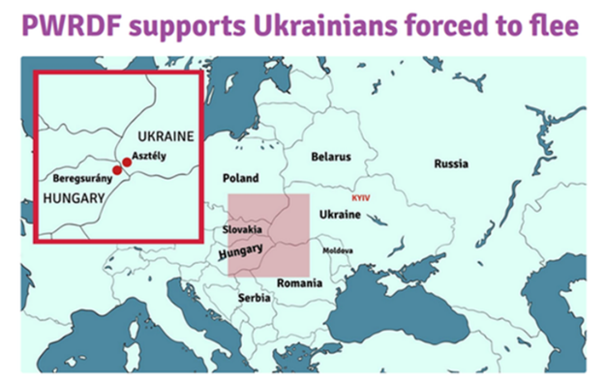
(HIA). On Feb. 27, HIA set up a 24-hour refugee support point on the Hungarian side of the border at Beregsurány, where the line of refugees trying to cross into Hungary is kilometres long, says an ACT communiqué. HIA is providing hot tea, sandwiches, refreshments, blankets, and basic hygiene items for Ukrainians, including many elderlies and children who are waiting long hours to cross the border into Hungary. How you can help. To donate to this response online, you may also donate by phone at 416-822-9083 or leave a voicemail, toll-free at 1-866-308-7973 and PWRDF will return your call; or mail your cheque to PWRDF, 80 Hayden, 3rd floor, Toronto, Ontario, M4Y 3G2. Please mark Ukraine in the memo field. Apply to be part of Say Yes! To Kids and be on their way to making their projects a reality. The first step is to take a webinar, which are being held throughout March.

