ST. LUKE’S ANGLICAN CHURCH

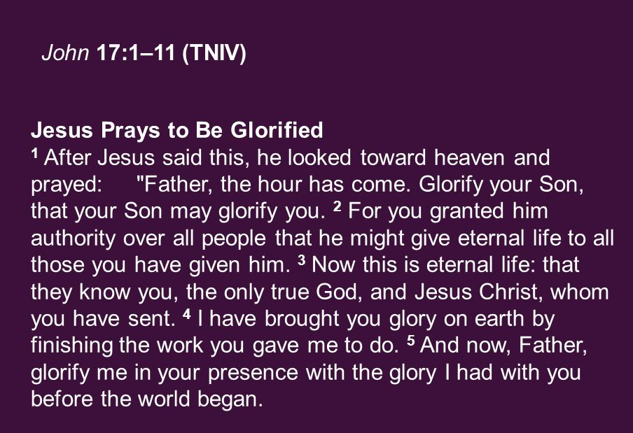

Sunday Morning Communion Service

May 21, 2023, at 10:00 a.m.
The Rev. Rob Montgomery
Priest-In-Charge

rob.montgomery@anglican.nb.ca / 506-608-1772
https://www.facebook.com/StLukesGP

12, Quispamsis Road, Quispamsis, N.B. E2E 1M2

Readings: Acts 1:6 -14 Psalm 68: 1-10, 32-35

1 Peter 4: 12-14; 5: 6-11 John 17: 1 – 11

Sunday After Ascension Of
Our Lord on May 18, 2023

St. Luke’s News
INTERCESSIONS:
- Anglican Communion: The Church in the Province of the West Indies, the Most Rev Howard Gregory, Primate. Thy Kingdom Come global prayer initiative. Archbishop Linda Nicholls, Anglican Church of Canada. Diocese of Montréal, Bishop Mary Irwin-Gibson.
- Missions: The Rev. Canon Paul Jeffries, Bishop McAllister College, in Uganda, fellow missionaries, teachers, volunteers. The Diocese of Ho, Bishop Matthias Meduadues-Badohui, Ghana, West Africa the Companion Diocese of the Diocese of Fredericton
- Fredericton, Archbishop David, retired bishops Claude and William, and their families, the Lemmon family. Camp Medley and Camp Brookwood, Threshold Ministries, The Anglican Diocese of Yukon: our retired clergy, and our fellow Anglicans; New Bandon, the Rev. Paul Gwese; Sussex, the Rev. Tom Stradwick; Gondola Point, the Rev. Rob Montgomery, and his family
- Gondola Point: Hymn Tortins Parish family: Don Heron and his family Parish Ministry: cemetery committee and stewardship.
- Community Needs: those without work, food, or shelter, and those who serve and care for them. Pray also for those who are travelling.
- Shut-Ins, especially if due to COVID-1.9.
- Sick: Alice, Barb, Bev, Catharine, Danielle, Diane, Flora, Janet, Katie, Laverne, Peggy, Shawn, Wanda., James F, Travis B., Jack D., Natalie D., Isaac D. , John E., Lisa G., Diane M., Calvin M., Kathy M., Malcolm M., Donna P., David S., Keaton S., Donna T., Wendy W., and any others we have been asked to include in our prays….
- Thanksgiving: Our Church Family and Freedom to Worship.

Parish Mission Outreach: For the next Sundays, we are collecting boxes of “Cheerios” Cereal for an Elementary School Breakfast Program. Non-name brands are acceptable if there are no nuts (peanuts, peanut oil) in the ingredients or facilities in which they are made. Again, we will collect them at the church and then deliver them to the school.

May 28/23 Will be our next All Ages Event on Pentecost Sunday in Hall 3-6pm. Games of all types and a BBQ 3pm-6pm. We hope you can come and bring a friend,

Monday, May 29th
Time: 10 am
Place: Church Hall building basement - Connie Dykeman Memorial Room

As announced last Sunday - we will be holding a meeting on Monday morning, May 29th to discuss maintenance of our two main parish buildings.

We will be welcoming all members of the congregation who may wish to find out more about how our committee works and the things that we get involved with, such as the following agenda items:

- Repairs to the Narthex window - to be investigated.
- Repair to plaster on the balcony - Church interior
- Eavestrough system for the Church Hall roof - modification proposal
- Paint condition of the Church building - water table board and basement entrance
- Walkdown of grounds and both buildings - weather permitting
- Design a preventive maintenance Checklist.

Hope to see you there!

... on Behalf of the Care and Preservation Committee ...
Don Smith
tel. 506 849-7515

June10/23 Cemetery Cleanup- Day Saturday starting at 9:00 am to 1:00 pm Lunch will be served in the hall. If you can help, we hope to see you.

June 7/23 Mission and Visioning Group at the Church at 7 p.m. Everyone is welcome. Please speak with Rev. Montgomery if interested.

July 9/23 2nd Annual Churchyard Morning Prayer Service Sunday on July 9/23 at 10 am at St. Luke’s Anglican Church, 12 Quispamsis Road.

July 13/23 St. Luke’s Annual Strawberry Festival, St. Luke's Parish Hall, 12 Quispamsis Road, Quispamsis, Thursday, July 13, 2022
Pickup from: 4:30 pm - 6:00 pm Tickets: $18:00 For Tickets: Call Susan at 847-7609 “Drive Through” Take-Out Only. Call Early. Tickets Must Be Picked Up & Paid for Before Dinner.

+++++++++++++++++++++++++++++++++++++++++++++++++++++

Camp Medley workdays
Camp Medley will hold two camp workdays: Saturday, June 3. day run 9 a.m.-4 p.m. There are lots of cleaning and projects requiring different skill levels. All welcomed and needed. Please let camp director John Galbraith know if you are thinking of coming as it will help him prepare. Lunch will be provided.
director@campmedley.ca

May 26/23 COMMUNITY LUNCH FRIDAY, FROM 11AM TO 1PM : Holy Trinity Community Lunches are back! It has been a long 3 years since our last community lunch, but we are looking forward to seeing everyone again. Friday May 26th 11 am to 1 pm at Holy Trinity Church 2 Hammond River Rd Quispamsis. Free will offering for mission projects. Everyone is welcome!

Saturday, May 27, 8 - 11 a.m. Monthly breakfast at St. Luke's Hall, corner of Metcalf and Lansdowne, Saint John. Sausages, eggs, toast, pancakes, home fries and beverage. $10 per person. A joint presentation of the Saint John Y Service Club and St. Luke's, with proceeds to St. Luke's parish ministries.
Saturday, May 27, 8:30 a.m.-12:30 p.m. Mothers’ Union will hold a yard sale at St. Paul’s Church Hall, Hampton to raise funds for a student in school in Uganda and to help kids in New Brunswick enjoy a week of summer camp at Camp Medley. We are happy to receive donations of books, toys, treasures, and plants, but please, NO clothing, baby furniture, or food. Items for the sale can be left in the parish hall, May 22 – May 25, 9 a.m. -12 p.m., and Fri. May 26 from 6-8 p.m.

May 28/23 Trinity Church, Saint John. We’re hosting an Organ Concert on Sunday, at 2 pm. César Auguste FRANCK 1822-2022 Belated Bicentennial Birthday Bash A FRANCK ORGAN FEST, Trinity Church, Saint John Admission $25 available at the door or tel. 506 693 8558Includes a Birthday Party Reception!
Recitalist Michael Molloy will play music of famous composer César Franck, featuring the 70 stops of the French division of our huge Digital-Pipe Organ. Proceeds will go toward Church renovations.
Tickets, available through the office (693-8558 or trinsj@nb.aibn.com) include a Bicentennial Birthday reception for the Composer!

June 5/23 Do not miss the area’s own award-winning choir...the SAINT JOHN CHORALE with Director SPENCER BELYEA, on Monday June 5th, 7:30 pm at St. Marks Church, West Saint John. The concert features favourite and famous FOLKSONGS from the British Isles, North America and Canada’s Maritimes. Our featured guest will be violinist DANI SAMETZ, interim Concertmaster of SNB. The evening will end with a TEA and homemade DESSERTS by the Choir.
TICKETS from members and at the door are $25. Adult and $10. Youth.

JULY 8/23, Please save the date for a one-day Choir School Workshop and Evensong. Clinicians and music are being finalized.
Trinity Church is the locale. There will be an optional rehearsal on Friday July 7 and music selections will be available before the event.

++++++++++++++++++++++++++++++++++++++++++++++++++++++

St. Luke’s A.C.W meet every Monday at 10:00 am all are welcome.

The Rev. Montgomery’s Online Bible Study continues Tuesday at 3:30 p.m.

St. Luke’s Book Club the last Tuesday of the month at 2:00 p.m. at St. Luke’s Parish Hall. Please contact Heather Hynds for the list of books.

The Rev. Rob Montgomery’s Midweek Contemplative Services on hold until after Easter at St. Luke’s Anglican Church
Mission Visionary Group – Meet monthly for guidance and direction of out missionary outreach of the Parish. Further details please contact the Rev. Rob Montgomery.

Quarters for A Kilometer: We will be collecting quarters ($0.25) for the distance of a kilometer for the Church Restoration Fund. There will be a container on the back table for the quarters.

Work on our Building Restoration Project is complete. St. Luke’s is in the process of raising funds for re- investments funds used for the Restoration repairs of St. Luke’s Anglican Church. White envelopes for this are on the entry table. If you have any questions, please speak with Rev. Rob Montgomery, Rosemarie Kingston, or Terry Sleep.

Safe Church Trainer and Renewals: Please note a new online safe church training platform has been developed to allow the Diocese to better track who has taken the training, as well as working to make the training more relevant, accessible, and simple to complete. The new training should take 30-45 minutes and the Diocese would appreciate all feedback that you can provide on the entire process to ensure this is the ideal system to roll out to the diocese. Please contact Donna Dobbin for your training, thank you.

We are collecting refundable items from the parish for the Restoration Fund for the Church. If you have any you would like picked up, you may call Terry and Susan Sleep on 847-7609, or Darryl.

On this website is also St. Luke's Blog, posting of our Orders of Service and Sermons for Sundays, as well as other resources for us from time to time. Feel free to explore and spread the news if you can.

We must continue to meet our monthly expenses while we are unable to come to our church to meet at times for worship and fellowship. Since all worship services, meetings, and events at our church are on hold at times, our bulletin has changed. As the situation changes, activities will begin to be re-scheduled. Please contact Terry Sleep at 847-7609. He is our Parish E-offering Representative or by mail to St. Luke’s Anglican Church, 12 Quispamsis Road, Quispamsis, New Brunswick, E2E 1M2 or e-transfer. Please contact Terry Sleep at 847-7609 for further information or instructions, thank you.

Many of you received the e-news from Gisele McKnight, Diocesan Communications Officer. It contains messages from the archbishop concerning the coronavirus and the resulting procedural changes and cancellations that have been put in place. Bishop David’s message contains links to his earlier messages on the coronavirus, as well as to prayers, on-line worship services and the Book of
Common Prayer. If you did not receive e-news, it may be found at https://nb.anglican.ca/newsletters/102/display A call to prayer has been issued and details may be found in e-news. As well, you can keep up with Diocesan events at https://nb.anglican.ca/
E - News wants subscriber
e-News is the best way to keep up to date on what is going on in the diocese.
Click here to subscribe.

THE ANGLICAN JOURNAL AND THE NEW BRUNSWICK ANGLICAN: If you are not currently receiving the Anglican Journal and the New Brunswick Anglican and would like to, there are two ways to subscribe: 1. On-line at https://www.anglicanjournal.com/newsubscription/ checking off that you want the Diocesan paper called "Fredericton - New Brunswick Anglican" in the drop-down menu to accompany your subscription to the Anglican Journal, or 2. E-mail circulation@national.anglican.ca indicating
that you would like to receive both the Anglican Journal and the New Brunswick Anglican. Include the name of your parish and the Diocese.

Annual Clergy Spouses Retreat Registration: ceroutledge@yahoo.ca

Camp Brookwood is waiting for you!
Reserve your spot at Camp Brookwood this summer!
http://campbrookwood.ca

Donations for Ukraine relief
Donate via PWRDF
PWRDF is supporting Ukrainians forced to flee their homes due to the
Russian invasion. The initial grant of $20,000 issued to an ACT Alliance appeal has been increased to $50,000. The grants will fund the work of
Action by Churches Together (ACT) member Hungarian Interchurch Aid
(HIA). On Feb. 27, HIA set up a 24-hour refugee support point on the Hungarian side of the border at Beregsurány, where the line of refugees trying to cross into Hungary is kilometres long, says an ACT communiqué. HIA is providing hot tea, sandwiches, refreshments, blankets, and basic hygiene items for Ukrainians, including many elderlies and children who are waiting long hours to cross the border into Hungary. How you can help. To donate to this response online, you may also donate by phone at 416-822-9083 or leave a voicemail, toll-free at 1-866-308-7973 and PWRDF will return your call; or mail your cheque to PWRDF, 80 Hayden, 3rd floor, Toronto, Ontario, M4Y 3G2. Please mark Ukraine in the memo field. Apply to be part of Say Yes! To Kids and be on their way to making their projects a reality. The first step is to take a webinar, which are being held throughout March

Thy Kingdom Come
Starts this Thursday, Ascension Day!

Praying and Living the Kingdom
Empowered by the Holy Spirit
Thy Kingdom Come is a global prayer movement which the Archbishop of Canterbury invited people around the world to join. The wave of prayer runs for 11 days between the Christian festivals of Ascension and Pentecost. During this time, people are asked to pray in whatever way they want and with whoever they want for others to come to know Jesus Christ.

Activities in the Diocese of Fredericton
Please let us know what your parish is doing.

Resources
- Thy Kingdom Come prayer booklet (or use this reformatted version)
- Thy Kingdom Come 2023 prayer journal and novena, by the Archbishop of Canterbury
  - the Bishop's Office has ordered some hard copies in bulk
- 23 Ideas of 2023
- Bright prayer ideas for your church (2022)
- Commissioning prayers
- We Seek Your Kingdom lyrics

ReFrame Missional Cohort, Round II
Applications are now open for the second round of our diocesan ReFrame Missional Cohort. The purpose of the cohort is to wrestle with the changing realities of leadership in the Church during our time and as well consider implementing some outreach and missional initiatives within their parish/community.
Interested individuals need to apply, as spaces are limited and only one participant per parish in each cohort.
More information is available here.

