ST. LUKE’S ANGLICAN CHURCH

3rd Sunday In Lent

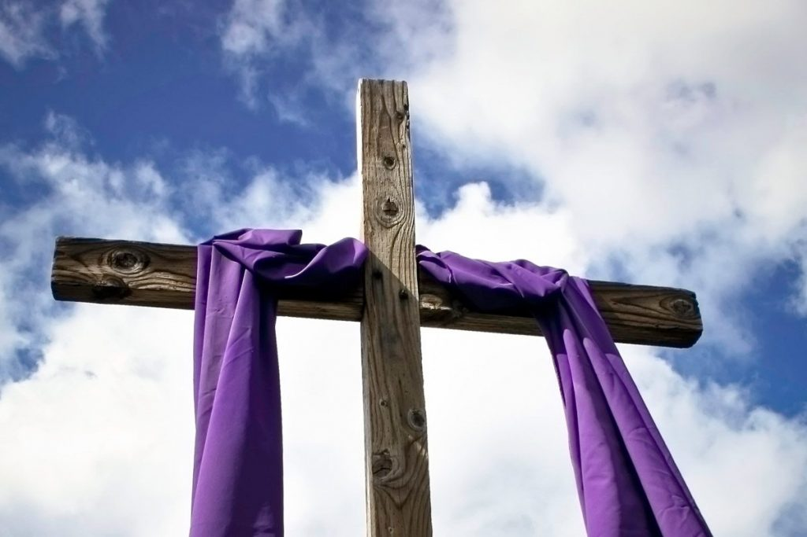

Sunday Morning Service

March 7, 2021 at 10:00 a.m.

The Rev. Robert Montgomery
Priest–in-Charge
rob.montgomery@anglican.nb.ca / (506) 608-1772
https://www.facebook.com/StLukesGP

Readings: Exodus 20:1-17 Psalm 19

1 Corinthians 1:18-25 John 2:13-22

St. Luke’s News

INTERCESSIONS:
- Anglican Communion: Province de L’Eglise Anglicane Du Congo. Council of the North, Territory of the People (Central Interior, BC), Bishop Lincoln McKeon
- Bishop McAllister College, in Uganda, fellow missionaries, teachers, volunteers. The Diocese of Ho, Companion Diocese of the Diocese of Fredericton
- Fredericton, Archbishop David Edwards, retired Bishops Claude, William and George, and their families. Camp Medley and Camp Brookwood, Threshold Ministries, The Anglican Diocese of Yukon: our retired clergy, and our fellow Anglicans: St. Margaret's, the Rev. Robert Langmaid; Renforth, the Rev. Jonathan Hallewell; Gondola Point, the Rev. Rob Montgomery
- Gondola Point: Sunday School Parish family: Fred and Heather Hynds and their family Parish Ministry: A.C.W. and stewardship.
- Community Needs: those without work, food, or shelter, and those who serve and care for them. Pray also for those who are travelling.
- Shut-Ins especially if due to COVID-19.
- Sick: Flora, Katie, Lori, Melissa, Shawn, Wanda., Travis B., Winnie C., Jack D. Isaac D. Doreen E., John E., Lisa G., Calvin M., Malcolm M., Sterling M., Eleri P., Emilie P., Wendy R., David S., Keaton S., and any others we have been asked for prays…
- Thanksgiving: Our Church Family and Freedom to Worship.

Welcome to everyone attending St. Luke’s Sunday Morning Service today virtually.

Please find attached a ½ page flyer with a request from Archbishop David for your help in completing our fundraising for the Diocese of Ho Mobile Clinic project.
To recap the project budget:
- Project cost: $268,000
- Grants and matching funds from various levels of Rotary Int.: $188,460
- Donated by parishes, parish groups and individuals to the Diocesan Synod: $63,540
- Remaining to be raised: $16,000.

We are collecting refundable items from the parish for the Restoration Fund for the Church. If you have any you would like picked up, you may call Terry and Susan Sleep at 847-7609, or Darryl Kingston.

St. Luke’s A.C.W. will be on hold on Monday in the hall until after the Orange level has been returned to yellow.

The Rev. Montgomery will be holding St. Luke’s Parish Bible Study on Tuesday, virtually. Please contact Rev. Rob for further instructions.

March 10/21 Wednesday is our next vestry meeting at the hall at 7:00 p.m. If you are not able to attend please send regrets to the Rev. Rob Montgomery, the Wardens, or our vestry clerk.

Trinity Church Columbarium the Trinity Columbarium is located inside the Germaine Street entrance at Trinity Anglican Church in Saint John, NB. This beautiful, historical church provides a place of remembrance for families wanting that connection with the church. There are various niche sizes (individual, couples, and family) available for purchase. Inquiries can be directed to the Trinity Parish office at (506) 693-8558 or email: trinsj@nb.aibn.com

On this website is also St. Luke's Blog, posting of our Orders of Service and Sermons for Sundays, as well as other resources for us from time to time. Feel free to explore and spread the news if you can.

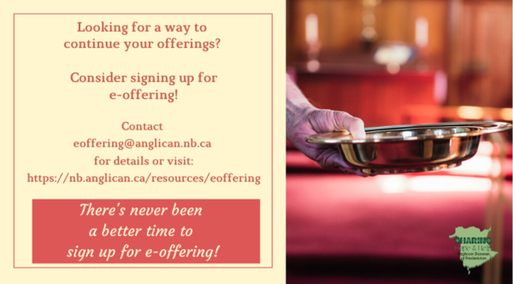
We must continue to meet our monthly expenses too while we are unable to come to our church to meet for worship and fellowship. Since all worship services, meetings and events at our church has been put on hold for the time being, our bulletin has changed. As the situation changes, activities will begin to be re-schedule. Please contact Terry Sleep at 847-7609. He is our Parish E-offering Representative or by mail to St. Luke’s Anglican Church, 12 Quispamsis Road, Quispamsis, New Brunswick, E2E 1M2 or e-transfer. Please contact Terry Sleep at 847-7609 for further information or instructions, thank you.

St. Luke’s is in the process of raising Funds for Restoration repairs of St. Luke’s Anglican Church with the matching of fund coming from a grant we have applied for from the Federal Government. White envelopes for this may be found on the entry table. If you have any questions, please speak with Rev. Rob Montgomery, Rosemarie Kingston, or Terry Sleep. They can help you.

Many of you received the e-news from Gisele McKnight, Diocesan Communications Officer. It contains messages from the Bishop concerning the coronavirus and the resulting procedural changes and cancellations that have been put in place. Bishop David’s message contains links to his earlier messages on the coronavirus, as well as to prayers, on-line worship services and the Book of
Common Prayer. If you did not receive e-news, it may be found at https://nb.anglican.ca/newsletters/102/display A call to prayer has been issued and details may be found in e-news. As well, you can keep up with Diocesan events at https://nb.anglican.ca/
E - News wants subscriber
e-News is the best way to keep up to date on what is going
on in the diocese Click here to subscribe.

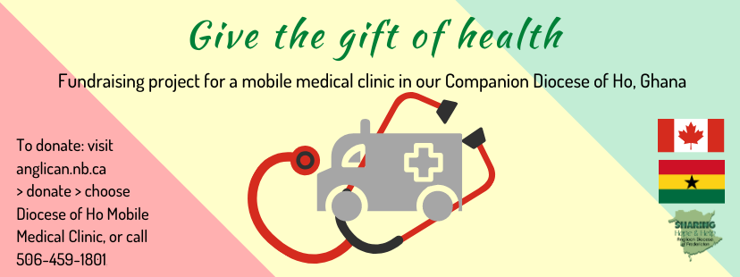

As reported in last week’s eNews the project to provide a mobile medical clinic in the Diocese of Ho has received matching funding from various levels of Rotary, which means that we are now only $16,000 short of the target of $268,000 (with $188,800 from Rotary). It is exciting news and I want to thank everyone in the Diocese who has contributed towards this outcome, especially the Companion Diocese Committee led by Robbie Griffin from Grand Manan.
We now come to the final push, so that we can access the pledged funds and place the vehicle order with Malley Industries of Moncton. The plan is to have the clinic operating in Ghana by the end of the year. My request to individuals and vestries is that we give to get this ball over the line. Diocesan Council pledged $5,000 at its meeting on Saturday.
If by God’s grace and our commitment we exceed the necessary amount that is all to the good. We will be able to provide more equipment and consumables for the clinic.
The aim of the Diocese of Ho, working with partners locally and from here, is to provide medical care for people in the rural areas of the Volta Region. The vehicle will be staffed by medical students and doctors from the regional hospital. In addition, specialists will travel when necessary. It has also been agreed that a member of the clergy will accompany the clinic to provide counsel as needed.
Gifts from vestries and individuals should be sent to Synod Office marked for the Ho Medical Clinic. Donations can also be made online at nb.anglican.ca/donate

