ST. LUKE’S ANGLICAN CHURCH
5th Sunday in lent

Sunday Morning Communion Service

March 17, 2024, at 10:00 a.m.

The Rev. Rob Montgomery- regional dean of the Deanery
of Kingston-Kennebecasis
Priest-In-Charge
The Rev. Canon Cathy Laskey's, honorary assistant

rob.montgomery@anglican.nb.ca / 506-608-1772
https://www.facebook.com/StLukesGP

12, Quispamsis Road, Quispamsis, N.B. E2E 1M2

Readings: Jeremiah 31: 31-34 Psalm 51:1-12 or Psalm 119:9-16

Hebrews 5: 5-10 John 12:20-33

St. Luke’s News

INTERCESSIONS:
- Anglican Communion: The Church in Wales, the Most Rev. Andrew John, Archbishop. Archbishop Linda Nicholls, Anglican Church of Canada. Diocese of Central Newfoundland, Bishop John Watton.
- Missions: The Rev. Canon Paul Jeffries, Bishop McAllister College, in Uganda, fellow missionaries, teachers, volunteers. The Diocese of Ho, Bishop Matthias Meduadues-Badohui, Ghana, West Africa the Companion Diocese of the Diocese of Fredericton
- Fredericton, Archbishop David, retired bishop William and his family, the Miller family, and the Lemmon family. Camp Medley and Camp Brookwood, staff, and campers. Threshold Ministries, The Anglican Diocese of Yukon: our retired clergy, and our fellow Anglicans; Bathurst, the Rev Christopher Tapera; Hampton, the Rev. David Turner; Gondola Point, the Rev. Rob Montgomery, and his family and the Rev. Canon Cathy Laskey and her family. – honorary assistant and Hospital Chaplain
- Gondola Point: Parish Breakfasts Parish family: Richard and Donna Kelly and their family Parish Ministry: sidesmen and stewardship.
- Community Needs: those without work, food, or shelter, and those who serve and care for them. Pray also for those who are travelling.
- Shut-Ins.
- Sick: Barb, Catharine, Danielle, Diane, Donna, Katie, Kyle, Laverne, Shawn, Sarah, Winnie C., James F, Travis B., Jack D., Natalie D., Isaac D., John E., Lisa G., Diane M., Kathy M., Malcolm M., David S., Keaton S., and any others we have been asked to include in our prays….
- Thanksgiving: Beauty and Wonder of Creation.

March 20/24 Wednesday is our next vestry meeting at the hall at 7:00 p.m. If you are not able to attend, please send your regrets to the Rev. Rob Montgomery, the Wardens, or our vestry clerk.

March 24/24 All-Ages Palm Sunday Party – Sunday at St. Luke’s Parish Hall from 4-6PM

March 28/24 St. Luke’s Maundy Thursday Service 7PM.

March 29/24 St. Luke’s Good Friday Service 11AM.
March 31/24 St. Luke’s Easter Lessons, Hymns, & Holy Communion at 10 a.m.

St. Luke’s has expanded Hymn Tortins Coffee Time to include Tuesday mornings at 10:00 a.m. in the hall. Come for coffee and time to chat with friends. We hope to see you there.

Parish Mission Outreach: Parish Mission Outreach: For the next Sundays, we are collecting boxes of Cereal for an Elementary School Breakfast Program. Non-name brands are acceptable of any kind this time. Again, we will collect them at the church and then deliver them to the school.

As the temperature starts to drop, the need for warm dry socks has come up. The need for the socks has started the collection of new warm socks of all sizes to be collected at the church and distributed to the many centers that need them.

++++++++++++++++++++++++++++++++++++++++++++++
The Parish of Riverview Altar Guild is looking for children’s choir gowns and cruets, for purchase or donation. If you can help, contact the Rev. Julian Pillay > shepherdsheartsa@gmail.com

Holy Trinity: SENIORS DROP- IN at Holy Trinity (Trinity Corner Café) - 1st and 3rd Thursday of the month from 1 pm to 3 pm. Coffee & Chats. A great opportunity to meet over coffee and snacks for card games, puzzles, explore the library or just sit and chat!

Parish of Hammond River
Registration is open for events at Holy Trinity, 2 Hammond River Rd. Quispamsis. Call now to register for all programs 506-647-8170.
1. Tai Chi (on a chair) Tuesdays starting Jan. 9 from 1:15 to 2 p.m. (10 weeks at $5 per week)
2. 'Healthy You' Group! Re-starts Jan. 10 and is held weekly on Wednesdays from 6 to 7 p.m. This group focuses on the five basics for leading a healthier life - faith, food, fitness, focus and friends. There is a weekly weigh-in and lots of learning and sharing. No fee to join; however, a donation of $2 per week is appreciated. Enrollment is limited.
Lenten breakfasts: Every Sunday during Lent, following the 8 a.m. service, join us for a Lenten breakfast at the Anglican Parish Hall in St. Andrews. A light breakfast will be served on Easter Sunday, March 31.
Monday April 8, 2-3 p.m. Age Well Program at Holy Trinity, Parish of Hammond River. Eight-week program led by certified personal trainer Paulette Haines. Learn simple ways to improve your balance, strength, flexibility, and cardio health. There will also be talks on mental health and goal setting with a weekly activity plan. There is no fee to attend. Space is limited. To register or for more information call 506-609-9099.

Study “Lent with the Beloved Disciple" - Wednesday, February 21, 2024 Thinking about Lent? Join the diocesan Lenten book study.
We will be looking at Bishop Michael Marshall's, Lent with the Beloved Disciple. About the book: As the only disciple to have stayed close to Jesus at every stage from the Last Supper to the Crucifixion at Calvary, this eagle-eyed eyewitness intentionally records certain subtle details and signs which, when perceived with the eyes of faith, indicate a deeper and far lasting significance. Michael Marshall explores what these signs are and how, with prayerful reflection, they draw us ever more deeply into the personal, eternal, and cosmic significance and awareness of all that Christ accomplished by his death and resurrection – the Paschal Mystery. About the author: Bishop Michael Marshall has authored many books from his earliest days as Vicar of All Saints Margaret Street, London and subsequently when he was appointed Bishop of Woolwich at the age of 39. In 1984, he moved to the USA as the Founding Director of the Anglican Institute. In 1992, he was appointed as one of the Advisors to the Archbishops of York and Canterbury for the Decade of Evangelism. The series starts on Wednesday, February 21, 2024, and runs for 6 sessions (until March 27, 2024) at 6:30PM for 60-90mins. Registration is required for the Zoom link. Participants will receive the reading schedule (about 20pg/wk.). The Synod Office has limited copies which can be purchased when registering. Alternatively, please purchase the book through your favourite book retailer.
ISBN-10‏: ‎ 1399404938 ISBN-13‏: ‎ 978-1399404938
For more information, contact Shawn C. Branch.

Discerning Your Ministry?
Diocesan Vocations Day - Saturday, April 6, 2024
Are you discerning a Christian vocation?
Have you wondered what it means to be an
evangelist, priest, deacon, layreader, parish nurse or pastoral visitor?
Join us for a day with presentations on these important ministries in the diocese and explore what God might be calling you to. Hear from others on how they heard God's call and explore some questions you might be wrestling with.
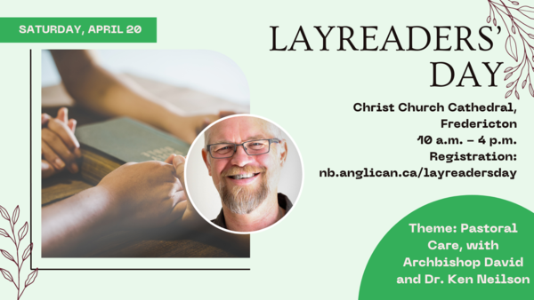

Young Adult Pilgrimage Friday, May 17, 2024
Attention Young Adults, aged 19-30...
Join us on a spiritual expedition to Grand Manan Island, New Brunswick! Connect with the Divine through the island's breathtaking landscapes & hospitable residents. Strengthen your bonds with fellow pilgrims through shared experiences, reflective conversations, and opportunities for prayer & worship together.
Led by Kurt Schmidt, the Rev. David Smith, and companion reflector Alan Hall. Ferry travel days are slated for Friday and Monday, main pilgrimage (hiking) day on Saturday, and worship on Sunday. Preparation period and weekly Sunday-evening Zoom prep sessions to begin on 7 April (the first Sunday after Easter). Online registration fee of $20, with the registration deadline to be 31 March (Easter Sunday).
For more information, contact Kurt Schmidt.

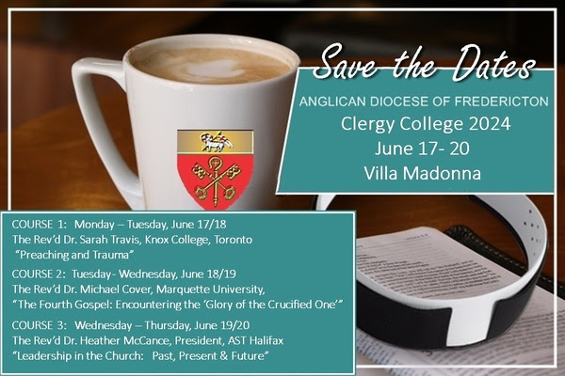

Choristers aged 16 and above are invited to attend this three day choral weekend filled with singing, learning, friendship and fun, culminating, as usual, with a glorious and beautiful Choral Evensong.
Founded in 1957, the Diocese of Fredericton Choir School has brought generations of Christians together through the beautiful spirit of music.
For more information or to register (by May 15), see the choir school website.

++++++++++++++++++++++++++++++++++++++++++++++++++++++

St. Luke’s A.C.W meet every Monday at 10:00 am all are welcome.

The Rev. Montgomery’s Online Bible Study on Tuesday at 3:00 p.m.

St. Luke’s Book Club the last Tuesday of the month at 11:00 a.m. at St. Luke’s Parish Hall. Please contact Heather Hynds for the list of books.

The Rev. Rob Montgomery’s Midweek Contemplative Services from 6:30PM - 7PM St. Luke’s Anglican Church.
Mission Visionary Group – Meet monthly for guidance and direction of out missionary outreach of the Parish. Further details please contact the Rev. Rob Montgomery.

Quarters for A Kilometer: We will be collecting quarters ($0.25) for the distance of a kilometer for the Church Restoration Fund. There will be a container on the back table for the quarters.
Work on our Building Restoration Project is complete. St. Luke’s is in the process of raising funds for re- investments funds used for the Restoration repairs of St. Luke’s Anglican Church. White envelopes for this are on the entry table. If you have any questions, please speak with Rev. Rob Montgomery, Rosemarie Kingston, or Terry Sleep.

Safe Church Trainer and Renewals: Please note a new online safe church training platform has been developed to allow the Diocese to better track who has taken the training, as well as working to make the training more relevant, accessible, and simple to complete. It may be found on https://nb.anglican.ca/safe-church/pages/group-training page. The new training should take 30-45 minutes and the Diocese would appreciate all feedback that you can provide on the entire process to ensure this is the ideal system to roll out to the diocese. Please contact Donna Dobbin for your training, thank you
We are collecting refundable items from the parish for the Restoration Fund for the Church. If you have any you would like picked up, you may call Terry and Susan Sleep on 847-7609, or Darryl.

On this website is also St. Luke's Blog, posting of our Orders of Service and Sermons for Sundays, as well as other resources for us from time to time. Feel free to explore and spread the news if you can.

We must continue to meet our monthly expenses while we are unable to come to our church to meet at times for worship and fellowship. Since all worship services, meetings, and events at our church are on hold at times, our bulletin has changed. As the situation changes, activities will begin to be re-scheduled. Please contact Terry Sleep at 847-7609. He is our Parish E-offering Representative or by mail to St. Luke’s Anglican Church, 12 Quispamsis Road, Quispamsis, New Brunswick, E2E 1M2 or e-transfer. Please contact Terry Sleep at 847-7609 for further information or instructions, thank you.

Many of you received the e-news from Gisele McKnight, Diocesan Communications Officer. It contains messages from the archbishop concerning the coronavirus and the resulting procedural changes and cancellations that have been put in place. Bishop David’s message contains links to his earlier messages on the coronavirus, as well as to prayers, on-line worship services and the Book of
Common Prayer. If you did not receive e-news, it may be found at https://nb.anglican.ca/newsletters/102/display A call to prayer has been issued and details may be found in e-news. As well, you can keep up with Diocesan events at https://nb.anglican.ca/
E - News wants subscriber
e-News is the best way to keep up to date on what is going on in the diocese.
Click here to subscribe.

THE ANGLICAN JOURNAL AND THE NEW BRUNSWICK ANGLICAN: If you are not currently receiving the Anglican Journal and the New Brunswick Anglican and would like to, there are two ways to subscribe: 1. On-line at https://www.anglicanjournal.com/newsubscription/ checking off that you want the Diocesan paper called "Fredericton - New Brunswick Anglican" in the drop-down menu to accompany your subscription to the Anglican Journal, or 2. E-mail circulation@national.anglican.ca indicating.
that you would like to receive both the Anglican Journal and the New Brunswick Anglican. Include the name of your parish and the Diocese.

Donations for Ukraine relief
Donate via PWRDF
PWRDF is supporting Ukrainians forced to flee their homes due to the
Russian invasion. The initial grant of $20,000 issued to an ACT Alliance appeal has been increased to $50,000. The grants will fund the work of
Action by Churches Together (ACT) member Hungarian Interchurch Aid
(HIA). On Feb. 27, HIA set up a 24-hour refugee support point on the Hungarian side of the border at Beregsurány, where the line of refugees trying to cross into Hungary is kilometres long, says an ACT communiqué. HIA is providing hot tea, sandwiches, refreshments, blankets, and basic hygiene items for Ukrainians, including many elderlies and children who are waiting long hours to cross the border into Hungary. How you can help. To donate to this response online, you may also donate by phone at 416-822-9083 or leave a voicemail, toll-free at 1-866-308-7973 and PWRDF will return your call; or mail your cheque to PWRDF, 80 Hayden, 3rd floor, Toronto, Ontario, M4Y 3G2. Please mark Ukraine in the memo field. Apply to be part of Say Yes! To Kids and be on their way to making their projects a reality. The first step is to take a webinar, which are being held throughout March

