ST. LUKE’S ANGLICAN CHURCH

Third Sunday in Lent

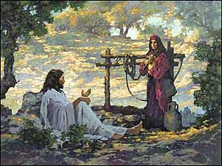

March 12, 2023, at 10:00 a.m.

The Rev. Rob Montgomery
Priest-In-Charge
rob.montgomery@anglican.nb.ca / 506-608-1772
https://www.facebook.com/StLukesGP
12, Quispamsis Road, Quispamsis, N.B. E2E 1M2

Readings: Exodus 17: 1-7 Psalm 95

Romans 5: 1-11 John 4: 5-42

St. Luke’s News

INTERCESSIONS:
- Anglican Communion: The Church of South India (United), the Most Rev Dharmaraj Rasalam, Moderator. Archbishop Linda Nicholls, Anglican Church of Canada. Diocese of Central Newfoundland, Bishop John Watton. Diocese of Eastern Newfoundland and Labrador, Bishop Samuel Rose.
- Missions: The Rev. Canon Paul Jeffries, and his father, Bishop McAllister College, in Uganda, fellow missionaries, teachers, volunteers. The Diocese of Ho, Bishop Matthias Meduadues-Badohui, Ghana, West Africa the Companion Diocese of the Diocese of Fredericton.
- Fredericton, Archbishop David, retired bishops Claude and William, and their families, the Lemmon family. Camp Medley and Camp Brookwood, Threshold Ministries, The Anglican Diocese of Yukon: our retired clergy, and our fellow Anglicans; Riverview, the Rev. Julian Pillay; Rothesay Netherwood, and Gondola Point, the Rev. Rob Montgomery, and his family
- Gondola Point: Hymn Tortins Parish family: Paul and Jennifer Woodrow and their family Parish Ministry: A.C.W. and stewardship.
- Community Needs: those without work, food, or shelter, and those who serve and care for them. Pray also for those who are travelling.
- Shut-Ins, especially if due to COVID-1.9.
- Sick: Alice, Barb, Bev, Catharine, Danielle, Diane, Flora, Janet, Katie, Laverne, Peggy, Shawn, Wanda., James F, Travis B., Jack D., Natalie D., James F., Isaac D. , John E., Lisa G., Diane M., Calvin M., Kathy M., Malcolm M., Donna P., David S., Keaton S., Donna T., Wendy W., and any others we have been asked to include in our prays….
- Thanksgiving: Family, Friends, and Community.

March 15/23 Wednesday is our next vestry meeting at the hall at 7:00 p.m. If you are not able to attend please send regrets to the Rev. Rob Montgomery, the Wardens, or our vestry clerk.

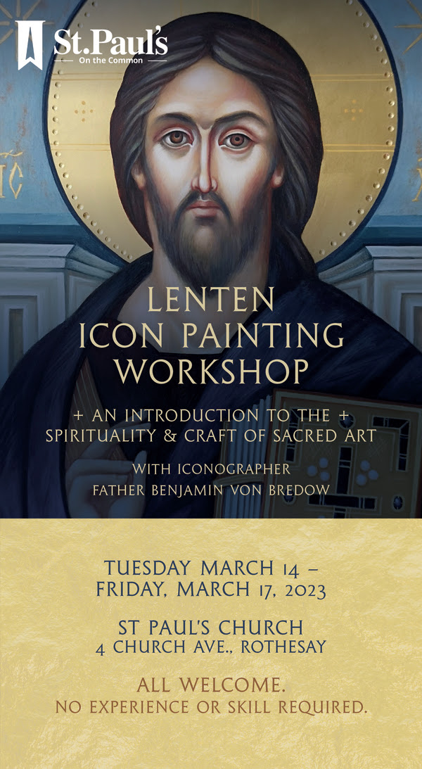

Layreaders' Day - Preaching With Archbishop David Edwards - Saturday, March 18, 2023 10:00 am - 3:00 pm Christ Church Cathedral and Memorial Hall, Fredericton. Save the Date! See Diocesan website to sign-up.
Lunch will be included. No cost to licensed layreaders.
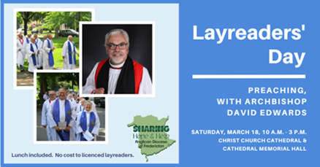

St. Luke’s A.C.W meet every Monday at 10:00 am all are welcome.

The Rev. Montgomery’s Online Bible Study continues as before. Further details please contact the Rev. Rob Montgomery.

The Rev. Rob Montgomery’s Midweek Contemplative Services are on hold until the New Year.

Mission Visionary Group – Meet monthly for guidance and direction of out missionary outreach of the Parish. Further details please contact the Rev. Rob Montgomery.

Quarters for A Kilometer: We will be collecting quarters ($0.25) for the distance of a kilometer for the Church Restoration Fund. There will be a container at the back table for the quarters.

Work on our Building Restoration Project is complete. St. Luke’s is in the process of raising funds for re- investments funds used for the Restoration repairs of St. Luke’s Anglican Church. White envelopes for this are on the entry table. If you have any questions, please speak with Rev. Rob Montgomery, Rosemarie Kingston, or Terry Sleep.

Safe Church Trainer and Renewals: Please note a new online safe church training platform has been developed to allow the Diocese to better track who has taken the training, as well as working to make the training more relevant, accessible, and simple to complete. The new training should take 30-45 minutes and the Diocese would appreciate all feedback that you can provide on the entire process to ensure this is the ideal system to roll out to the diocese. Please contact Donna Dobbin for your training, thank you.

We are collecting refundable items from the parish for the Restoration Fund for the Church. If you have any you would like picked up, you may call Terry and Susan Sleep at 847-7609, or Darryl.

On this website is also St. Luke's Blog, posting of our Orders of Service and Sermons for Sundays, as well as other resources for us from time to time. Feel free to explore and spread the news if you can.

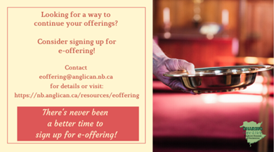
We must continue to meet our monthly expenses while we are unable to come to our church to meet at times for worship and fellowship. Since all worship services, meetings, and events at our church placed are on hold at times, and our bulletin has changed. As the situation changes, activities will begin to be re-scheduled. Please contact Terry Sleep at 847-7609. He is our Parish E-offering Representative or by mail to St. Luke’s Anglican Church, 12 Quispamsis Road, Quispamsis, New Brunswick, E2E 1M2 or e-transfer. Please contact Terry Sleep at 847-7609 for further information or instructions, thank you.

Many of you received the e-news from Gisele McKnight, Diocesan Communications Officer. It contains messages from the archbishop concerning the coronavirus and the resulting procedural changes and cancellations that have been put in place. Bishop David’s message contains links to his earlier messages on the coronavirus, as well as to prayers, on-line worship services and the Book of
Common Prayer. If you did not receive e-news, it may be found at https://nb.anglican.ca/newsletters/102/display A call to prayer has been issued and details may be found in e-news. As well, you can keep up with Diocesan events at https://nb.anglican.ca/

E - News wants subscriber
e-News is the best way to keep up to date on what is going on in the diocese.
Click here to subscribe.

THE ANGLICAN JOURNAL AND THE NEW BRUNSWICK ANGLICAN: If you are not currently receiving the Anglican Journal and the New Brunswick Anglican and would like to, there are two ways to subscribe: 1. On-line at https://www.anglicanjournal.com/newsubscription/ checking off that you want the Diocesan paper called "Fredericton - New Brunswick Anglican" in the drop-down menu to accompany your subscription to the Anglican Journal, or 2. E-mail circulation@national.anglican.ca indicating
that you would like to receive both the Anglican Journal and the New Brunswick Anglican. Include the name of your parish and the Diocese.

Study: "Let Me Go There"
Diocesan Online Lenten Gathering - Monday, February 27, 2023
Join friends from across the diocese during Lent as we read and reflect on Paula Gooder's "Let Me Go There: The Spirit of Lent". In her book, Gooder offers a daily reflection and reading for each day of Lent helping readers to dive deeper into the meaning and significance of the season.
The Bishop's Office will host an online gathering for anyone wishing to take part in sharing their reflections and questions from the readings. If you'd like to join the online gatherings, please click the Register Now button. The online gatherings will be hosted on Mondays at either 12noon or 7PM (February 27 - April 3).
Copies of the book can be purchased ($18/book + shipping) through the Bishop's Office by contacting Cheryl Jacobs or purchase an ePub copy here.
For more information or questions, please contact Cheryl Jacobs or Shawn C. Branch.

Lenten Retreat
Friday, March 31, 2023
Join us for the Diocesan Lenten Retreat, March 31-April 1 at the Villa Madonna Retreat Centre. As we prepare to enter Holy Week and the Easter celebration, join with others in taking 24 hours for teaching, reflection, and praying together.

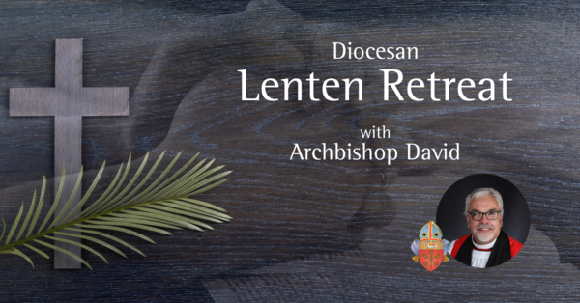

Lenten Retreat
Friday, March 31, 2023
Join us for the Diocesan Lenten Retreat, March 31-April 1 at the Villa Madonna Retreat Centre. As we prepare to enter Holy Week and the Easter celebration, join with others in taking 24 hours for teaching, reflection, and praying together.
Archbishop David will be our retreat leader and will provide teaching helping to prepare us for the journey of the week ahead. All are welcome - pre-registration is required.
Costs - Overnight: $125 | Couples: $200 | Commuter: $75 (meals included).
Registration deadline is March 23, 2023; spaces are limited. (Some bursary funding is available.)
For more information, contact Shawn Branch: 506-459-1801 ext 1008.

Annual Clergy Spouses Retreat
Registration: ceroutledge@yahoo.ca

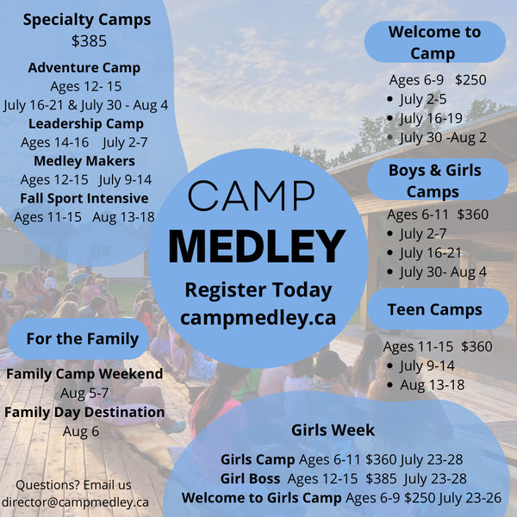

Donations for Ukraine relief
Donate via PWRDF
PWRDF is supporting Ukrainians forced to flee their homes due to the
Russian invasion. The initial grant of $20,000 issued to an ACT Alliance appeal has been increased to $50,000. The grants will fund the work of
Action by Churches Together (ACT) member Hungarian Interchurch Aid
(HIA).
On Feb. 27, HIA set up a 24-hour refugee support point on the Hungarian
side of the border at Beregsurány, where the line of refugees trying to cross into Hungary is kilometres long, says an ACT communiqué. HIA is providing hot tea, sandwiches, refreshments, blankets, and basic hygiene items for Ukrainians, including many elderly and children who are waiting long hours
to cross the border into Hungary.
How you can help. To make a donation to this response online, click here
You may also donate by phone at 416-822-9083 or leave a voicemail
toll-free at 1-866-308-7973 and PWRDF will return your call; or mail your cheque to PWRDF, 80 Hayden, 3rd floor, Toronto, Ontario, M4Y 3G2.
Please mark Ukraine in the memo field.
apply to be part of Say Yes! To Kids and be on their way to making their projects a reality.
The first step is to take a webinar, which are being held throughout March

Catapult Coffee and Studio at 116 Princess Street in Saint John is a happening place. The heritage building exudes character, from its many fireplaces to its beautiful staircase, exposed brick and original floors. Coffee drinkers meet friends, hold meetings and even bring their laptops and work all day at the shop.
As of December, there is more than enough space for everyone, since the shop has more than double the square footage, it began with back in 2018. The entire back half of the building has been refinished and a large, wood-burning fireplace added to give an expansive air to the shop that had operated with just three rooms for seating.
“Opening the back has brought in revenue,” said Jayme Hall, co-executive director of Outflow Ministry, which oversees the shop.
The popular coffee shop’s address might be familiar to readers. It used to be known as Anglican House — the former Synod Office, supply store and bishop’s office.
When the store closed in late 2014, the diocese was left with a building the bishop used only occasionally. It found new life with a $1 a year lease to Outflow Ministry, a non-denominational mission that provides food, shelter, job training and more to some of Saint John’s most marginalized people.
Outflow uses the profits from Catapult to fund its ministry, and it employs people who have difficulty finding or maintaining a job.
But since the coffee shop has a rather low turnover rate, they’ve shed that label to become employees who stay because they love being part of something bigger, said Phil Appleby, the other co-executive director of Outflow.
“They’ve been here since day one,” he said. “They see it as their calling.”
Phil still has days when he can’t quite believe what God had enabled them to build.
“My favourite thing is we can truly say every cup goes further,” he said. “I have these moments where I see everyone with drinks in their hands and I don’t know if they realize they’re helping with food and shelter. I do love it. It’s like an ongoing fundraiser.”
The expansion used the developing skills of their students in a carpentry training program at Catapult Construction, another arm of Outflow, who worked on the floor and the fireplace, as well as the furniture, which is itself an advertisement. Jayme has gotten orders for tables since the expansion opened.
“It’s an emotional story,” said Jayme. “Take the floor. Students who had big time barriers in life created something beautiful.”
Their coffee clientele is varied, from employees at the nearby Irving corporate office to residents of the rooming house across the street. Pastors meet for coffee, students study here, seeds are planted and generosity blooms.
“We actually had this one guy say, ‘I come here every day and have two cups of coffee. I’d like to give back,’” said Jayme, adding the man has offered his graphic design services.
Many customers read the sign outlining Catapult’s mission which often leads to smiles, discussions on faith and requests to ‘tell me more about what you’re all about,’ said Phil.
STUDIO
Catapult has always sold more than coffee. Crafts — beeswax wraps designed to replace plastic sandwich bags, upcycled mats, sewing, knitting and cutting boards — have helped bring in revenue.
Now they can add pottery to the list. Using a grant from the Saint John Community Foundation, they bought a kiln, and Jayme’s wife, Donna, took pottery classes with an established potter. Now they sell plates, bowls, butter dishes, jars and mugs.
Finally, their roof garden provided the shop with lettuce and tomatoes for BLT sandwiches all summer.
This summer, they hope to have outdoor seating in the alleyway, which will add more than a bit of ambiance for diners and coffee drinkers.
For all this coffee shop has, the one thing it doesn’t have is a lease or mortgage payment.
“We could never have done this without the partnership with the Diocese,” said Phil. “It really frees us up to fund ministry.”
PHOTO CAPTIONS
1. Jayme Hall, far right, is one of two co-executive directors of Outflow Ministries in Saint John, which operates Catapult Coffee & Studio. This photo shows the expanded premises, which has more than doubled the size of the coffee shop in what was once known as Anglican House, the site of the diocesan synod office.
2. The main entry and hallway at Catapult Coffee & Studio, 116 Princess Street in Saint John, taken from the staircase.
3. People gather to chat, have meetings, study and work at Catapult Coffee & Studio.
4. Catapult Coffee & Studio serves coffee, other beverages and snacks, but also sells crafts: beeswax wraps, knitting, sewing, cutting boards, and now, pottery.
Photo credit: Gisele McKnight

