ST. LUKE’S ANGLICAN CHURCH
Day of Pentecost

Sunday Communion Service

June 5, 2022, at 10:00 a.m.

The Rev. Robert Montgomery
Priest–in-Charge

rob.montgomery@anglican.nb.ca / (506) 608-1772

https://www.facebook.com/StLukesGP

Readings: Acts 2: 1-21 OR Genesis 11: 1-9 Psalm 104: 24-34, 35b

Romans 8: 14-17 OR Acts 2: 1-21 John 14: 8-17, (25-27)

St. Luke’s News

INTERCESSIONS:
- Anglican Communion: (Pentecost): The Anglican Church of Southern Africa, the Most Rev Dr Thabo Makgoba, Primate.
- Bishop McAllister College, in Uganda, fellow missionaries, teachers, volunteers. The Diocese of Ho, Companion Diocese of the Diocese of Fredericton
- Fredericton, Archbishop David, retired bishops Claude and William, and their families, the Lemmon family. Camp Medley and Camp Brookwood, Threshold Ministries, The Anglican Diocese of Yukon: our retired clergy, and our fellow Anglicans: Hillsborough Riverside, the Rev. Rob Salloum; Rothesay, the Rev. Paul Rideout; Gondola Point, the Rev. Rob Montgomery, and his family
- Gondola Point: Baden Powell Program Parish family: Janet Cunningham and her family Parish Ministry: Parish Hall booking agent and stewardship.
- Community Needs: those without work, food, or shelter, and those who serve and care for them. Pray also for those who are travelling.
- Shut-Ins, especially if due to COVID-1.9.
- Sick: Alex, Alice, Bev, Catharine, Diane, Flora, Janet, Katie, Laverne, Lori, Loie, Peter, Paul, Shawn, Wanda., James F, Joyce G, Travis B., Jack D., Natalie D., James F., Isaac D. , John E., Lisa G., Diane M., Calvin M., Kathy M., Malcolm M., David S., Keaton S., Donna T., Wendy W., and any others we have been asked to include in our prays…
- Thanksgiving: All that reminds us of our dependence upon God.
The Rev Montgomery’s final Online Bible Study for the Summer was this past Tuesday. He will be starting up again in September 2022.

Thank you to everyone who assisted at St. Luke’s Annual Cemetery Clean Up yesterday.

Upcoming Activities and Events at St. Luke’s:

June 7/22 Annual A.C.W. Dinner will be held at St. Luke’s Anglican Church Hall. Assistance would be appreciated from the parish and friends.

June 12/22 St Luke’s Graduation Celebration. We will be celebrating the graduation of 4 students of our parish.

July 21/22 St. Luke’s Annual Strawberry Festival, St. Luke's Parish Hall, 12 Quispamsis Road, Quispamsis, Thursday,
from: 4:30 pm - 6:30 pm Tickets: $17.50 For Tickets: Call Susan at 847-7609 “Drive Through” Take-Out Only. Call Early. Tickets Must Be Picked-Up and Paid for Before Dinner. (Roast Turkey, Baked Potato, Cranberries, Sour Cream, Veggies & Roll, Strawberry Shortcake/Whipped Cream,).

Rev. Rob Montgomery will be on vacation from about July 18/22 to
August 22/22. Our layreaders will be leading Morning Prayer Services with a few additions of speakers and presentations. We hope to see you on Sunday morning.
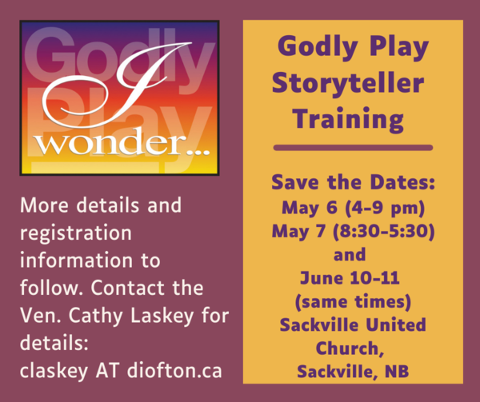

Godly Play training returns
Those interested in becoming Godly Play storytellers have an opportunity
May 7-8 and June 10-11 at Sackville United Church in Sackville, N.B. and at First Baptist in Halifax. Both events will run concurrently.
Each weekend begins with the Friday evening session from 4-9 p.m. The Saturday component runs from 8:30-5:30. Attendance is required at both weekends to qualify for certification.
Archdeacon Cathy Laskey is one of the trainers of the event. She is the only Anglican Goldy Play Canada certified trainer in the Maritimes and a long-time advocate of the program. “The first time I saw a Godly Play story, I immediately said, ‘This is good stuff. This is how I believe faith formation can happen well.’

May 26-June 5/22 THY KINGDOM COME: The “Thy Kingdom Come” global prayer event is happening again this year, from May 26th to June 5th. More information may be found at: https://us06web.zoom.us/webinar/register/tZErdeyqrD4jG9RIId0s1CMSuOLWH6KEvcPB/success ?user_id=fawMFnf4SY6ejr_p4hdHrQ&timezone_id=Europe%2FLondon

June 4/22 TRINITY CHURCH YARD SALE, 115 CHARLOTTE STREET, SATURDAY JUNE 4, 2022, 8:00AM – 12:30PM, Housewares / Books / Dishes / Décor / Toys / Linens / Games / Puzzles / and more!

June 5/22 Sunday, St. Paul's Church on the Rothesay Common will celebrate the Platinum Jubilee of Her Majesty Queen Elizabeth II with a Choral Evensong at 3 p.m., featuring some of the music composed for her Coronation in 1953.
Then at 4 p.m. there will be an English Tea in the Parish Hall, with music by an instrumental trio. No ticket is needed for the service, but admission to the tea is $20, with proceeds going to PWRDF to support humanitarian aid in Ukraine. Our guests for the service and tea will include Her Honour Brenda Murphy, NB Lieutenant Governor and Her Worship Dr. Nancy Grant, Mayor of Rothesay.

!!! WELCOME BACK !!!
JULY 16, 2022 Choir School
July 16, 2022 - 8:00AM to 7:00PM
Hello choristers and our choral friends and colleagues
Choir School will be going ahead this year, however, in a much-abbreviated form. The regular Choir School format was not viable this year, even our shortened version did not receive as many participants as we had hoped. Therefore, we have decided to go to a one day intensive, yet fun, one day workshop. The Choir Directors will be Spencer Belyea and Gibson MacMillan. Nhat-Viet (Toto) Phi will be our accompanist.
When: July 16, 2022
Where: Trinity, Saint John
Registration: 8AM to 9AM
Singing! 9AM to 7PM
Choral Evensong: 7PM with everyone invited!
Cost: $50.00
Includes: Lunch and Dinner, the famous t-shirt, activities for the youth with Mary Louise (MLB) and lots and lots of singing.
Leave your choir gowns and robes at home as we will be wearing our t-shirts for the Choral Evensong.
Please join us for a glorious day of music.

Quarters for A Kilometer: We will be collecting quarters ($0.25) for the distance of a kilometer for the Church Restoration Fund. There will be a container at the back table for the quarters.

Work on our Building Restoration Project was completed. St. Luke’s is in the process of raising funds for replacing investments used for the Restoration repairs of St. Luke’s Anglican Church. White envelopes for this are on the entry table. If you have any questions, please speak with Rev. Rob Montgomery, Rosemarie Kingston, or Terry Sleep.

Safe Church Trainer and Renewals: Please note a new online safe church training platform has been developed to allow the Diocese to better track who has taken the training, as well as working to make the training more relevant, accessible, and simple to complete. The new training should take 30-45 minutes and the Diocese would appreciate all feedback that you can provide on the entire process to ensure this is the ideal system to roll out to the diocese. Please contact Donna Dobbin for your training, thank you.

Mission Visionary Group - Further details to follow by speaking to the Rev. Rob Montgomery.

We are collecting refundable items from the parish for the Restoration Fund for the Church. If you have any you would like picked up, you may call Terry and Susan Sleep at 847-7609, or Darryl.
On this website is also St. Luke's Blog, posting of our Orders of Service and Sermons for Sundays, as well as other resources for us from time to time. Feel free to explore and spread the news if you can.

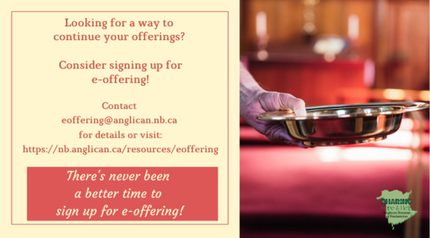
We must continue to meet our monthly expenses too while we are unable to come to our church to meet at times for worship and fellowship. Since all worship services, meetings, and events at our church has been put on hold at times, for the time being, our bulletin has changed. As the situation changes, activities will begin to be re-schedule. Please contact Terry Sleep at 847-7609. He is our Parish E-offering Representative or by mail to St. Luke’s Anglican Church, 12 Quispamsis Road, Quispamsis, New Brunswick, E2E 1M2 or e-transfer. Please contact Terry Sleep at 847-7609 for further information or instructions, thank you.

Many of you received the e-news from Gisele McKnight, Diocesan Communications Officer. It contains messages from the archbishop concerning the coronavirus and the resulting procedural changes and cancellations that have been put in place. Bishop David’s message contains links to his earlier messages on the coronavirus, as well as to prayers, on-line worship services and the Book of
Common Prayer. If you did not receive e-news, it may be found at https://nb.anglican.ca/newsletters/102/display A call to prayer has been issued and details may be found in e-news. As well, you can keep up with Diocesan events at https://nb.anglican.ca/

E - News wants subscriber
e-News is the best way to keep up to date on what is going on in the diocese
Click here to subscribe.

THE ANGLICAN JOURNAL AND THE NEW BRUNSWICK ANGLICAN: If you are not currently receiving the Anglican Journal and the New Brunswick Anglican and would like to, there are two ways to subscribe: 1. On-line at https://www.anglicanjournal.com/newsubscription/ checking off that you want the Diocesan paper called "Fredericton - New Brunswick Anglican" in the drop-down menu to accompany your subscription to the Anglican Journal, or 2. E-mail circulation@national.anglican.ca indicating that you would like to receive both the Anglican Journal and the New Brunswick Anglican. Include the name of your parish and the Diocese.

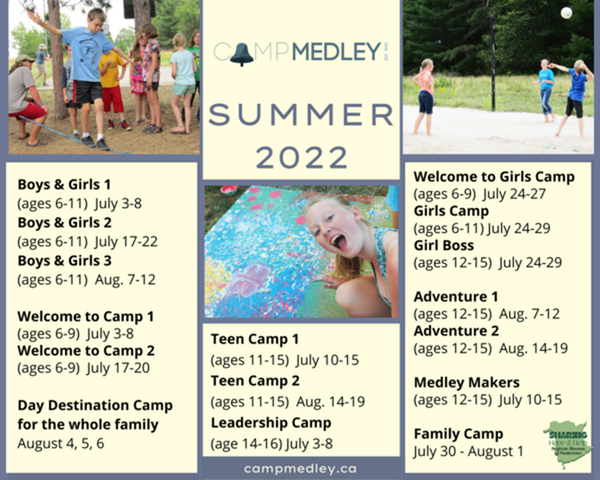

Inner City Youth Ministry green initiative invokes 5th Mark of Mission
Seamstresses needed for lunch bag production
Inner City Youth Ministry has been very busy over the years putting the 3rd Mark of Mission into action: To respond to human need by loving service.
But ICYM’s director, Erin Rideout, believes now is the time to also act on number five: To strive to safeguard the integrity of creation and sustain and renew the life of the earth.
“While we’re working on the 3rd Mark of Mission, we’re also thinking of the 5th,” she said. “It’s an easy and natural thing.”
Read More
Read More

Say Yes! To Kids
During its first year, 2021, the Say Yes! To Kids campaign awarded a grant of $15,000 to Inner City Youth Ministry in Saint John for its Lunch Connection program in city schools. Let us continue the momentum!
This year, the program has changed from the usual application process to peer-to-peer financing, where groups fundraise and keep 60 per cent of the proceeds for their project, with 20 per cent going to their diocese and the remaining 20 per cent to the Anglican Foundation.
The campaign launches April 1 and runs to June 30. Interested groups can a
Donations for Ukraine relief
Donate via PWRDF
PWRDF is supporting Ukrainians forced to flee their homes due to the Russian invasion. The initial grant of $20,000 issued to an ACT Alliance appeal has been increased to $50,000. The grants will fund the work of Action by Churches Together (ACT) member Hungarian Interchurch Aid (HIA).
On Feb. 27, HIA set up a 24-hour refugee support point on the Hungarian side of the border at Beregsurány, where the line of refugees trying to cross into Hungary is kilometres long, says an ACT communiqué. HIA is providing hot tea, sandwiches, refreshments, blankets and basic hygiene items for Ukrainians, including many elderly and children who are waiting long hours to cross the border into Hungary.
How you can help
To make a donation to this response online, click here
You may also donate by phone at 416-822-9083 or leave a voicemail toll-free at 1-866-308-7973 and PWRDF will return your call; or mail your cheque to PWRDF, 80 Hayden, 3rd floor, Toronto, Ontario, M4Y 3G2. Please mark Ukraine in the memo field.
apply to be part of Say Yes! To Kids and be on their way to making their projects a reality.
The first step is to take a webinar, which are being held throughout March.
