ST. LUKE’S ANGLICAN CHURCH

5th Sunday After Pentecost

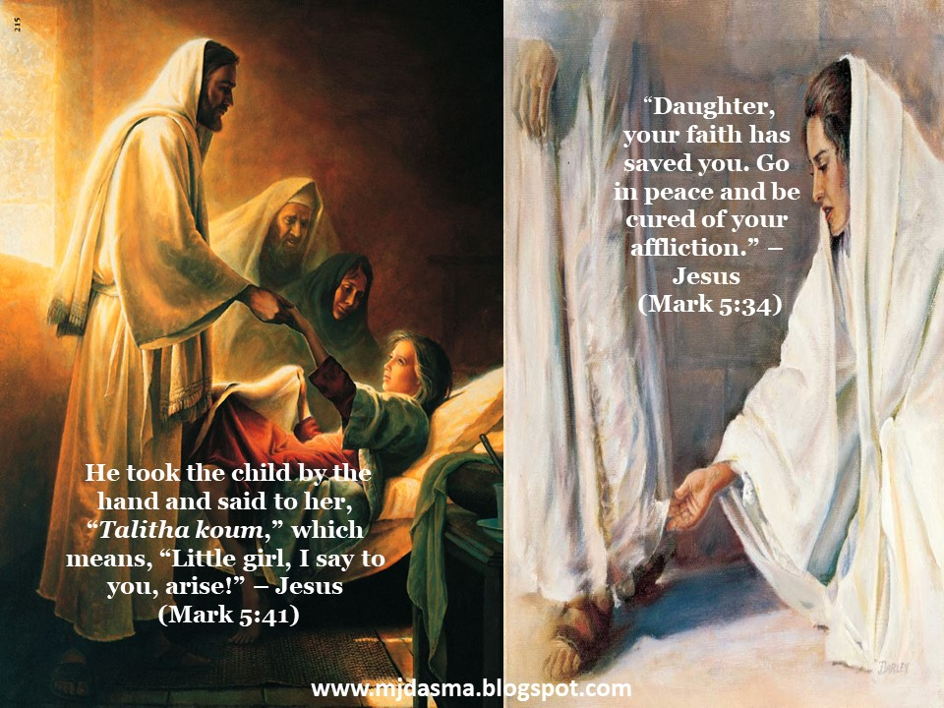

Sunday Service

June 21, 2021, at 10:00 a.m.

The Rev. Robert Montgomery
Priest–in-Charge
rob.montgomery@anglican.nb.ca / (506) 608-1772

Facebook: https://www.facebook.com/StLukesGP
Website: http://www.stlukesgp.ca

Readings: 2 Samuel 1:1, 17-27 Psalm 130

2 Corinthians 8:7-15 Mark 5:21- 43
St. Luke’s News

INTERCESSIONS:
- Anglican Communion: The Church of Pakistan (United). National Indigenous Archbishop Mark MacDonald and the Anglican Council of Indigenous Peoples.
- Bishop McAllister College, in Uganda, fellow missionaries, teachers, volunteers. The Diocese of Ho, Companion Diocese of the Diocese of Fredericton
- Fredericton, Archbishop David Edwards, retired Bishops Claude, William and George, and their families. Camp Medley and Camp Brookwood, Threshold Ministries, The Anglican Diocese of Yukon: our retired clergy, and our fellow Anglicans: Fredericton, the Rev. Canon Wandlyn Snelgrove; Hammond River, the Rev. Michael O’Hara; Gondola Point, the Rev. Rob Montgomery
- Gondola Point: Romero House Parish family: Richard and Pauline Sherwood and their family Parish Ministry: Parish Safe Church Officer and stewardship.
- Community Needs: those without work, food, or shelter, and those who serve and care for them. Pray also for those who are travelling.
- Shut-Ins especially if due to COVID-19.
- Sick: Alan, Flora, Katie, Lori, Melissa, Nicola, Shawn, Wanda., Travis B., Winnie C., Jack D. Isaac D. Doreen E., John E., Lisa G., Sheila H., Calvin M., Malcolm M., Sterling M., Eleri P., Emilie P., David S., Keaton S., John W., Wendy W., and any others we have been asked for prays…
- Thanksgiving: Health and our Health Care System.

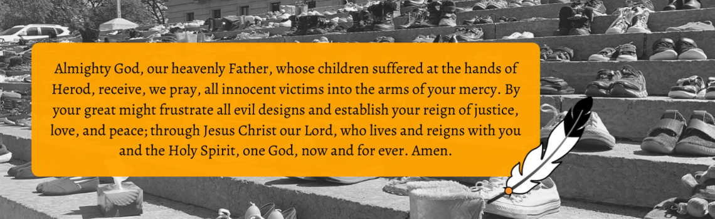
As Bishop of Fredericton, I want to re-emphasize my endorsement of the Primate’s statement (Every Child Matters) concerning recent discoveries about residential schools.
This statement also represents my feelings of shame and horror concerning the activities towards Indigenous peoples, by the New England Company and its agents in parts of our province during the late 18th and early 19th centuries. The article A Comment on the Colonial Perversion of British Benevolence, by Judith Fingard, indicates the involvement of some of the early Anglican settlers in this enterprise.
Please pray for all those affected by these issues past and present across our country.
The Bishop

Happy Canada Day! July 1, 2021

Today is Food Basket Sunday, the last Sunday of the month and we are thankful for the donations to the KV Food Basket.

Today is also Birthday Sunday:

Happy birthday to you.
To our Lord be true.
May God's love and blessings,
Rain down upon you.

Bobae Lee | Bob Perry
Matthew MacLeod | Elliott Pynn
Addie Montgomery | Pauline Sherwood
Robin Patterson | Greg Theobald

And anyone we may have missed.

Soon we will be staring restoration of St. Luke’s Anglican Church.

Restoration Fund: $ 13,823.89 Funds needed: $ 62,500.00.

St. Luke’s A.C.W. will be on holding their meeting on Monday in the hall starting at 10:00 a.m.,

The Rev. Montgomery will be holding St. Luke’s Parish Bible Study on Tuesday, virtually. Please contact Rev. Rob for further instructions.

We are collecting refundable items from the parish for the Restoration Fund for the Church. If you have any you would like picked up, you may call Terry and Susan Sleep at 847-7609, or Darryl.

Upcoming Events:

Mission Visionary Group - Launch Pentecost. Further details to follow by speaking to the Rev. Rob Montgomery.

June 27/21 Fellowship Games Night will be virtual from 7:00 pm to 9:00 pm of games and trivia to enjoy. We hope you can join us.

July 15/21 St. Luke’s Annual Strawberry Festival, St. Luke's Parish Hall, 12 Quispamsis Road, Quispamsis, Thursday, July 15, 2021
3 - 1/2 Hour Pickup Intervals from: 4:30 pm - 5:00 pm; 5:00 pm - 5:30 pm; 5:30 pm - 6:00 pm Tickets: $15.00 For Tickets: Call Susan at 847-7609 “Drive Through” Take-Out Only. Call Early. All ticket sales will end on July 8th. Tickets Must Be Picked-Up and Paid for Before Dinner. (Roast Turkey, Cranberries, Baked Potato, Sour Cream, Veggies & Roll, Strawberry Shortcake/Whipped Cream,)

On this website is also St. Luke's Blog, posting of our Orders of Service and Sermons for Sundays, as well as other resources for us from time to time. Feel free to explore and spread the news if you can.

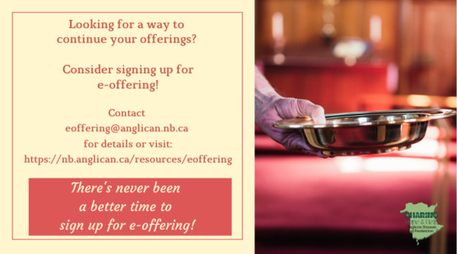
We must continue to meet our monthly expenses too while we are unable to come to our church to meet at times for worship and fellowship. Since all worship services, meetings and events at our church has been put on hold at times, for the time being, our bulletin has changed. As the situation changes, activities will begin to be re-schedule. Please contact Terry Sleep at 847-7609. He is our Parish E-offering Representative or by mail to St. Luke’s Anglican Church, 12 Quispamsis Road, Quispamsis, New Brunswick, E2E 1M2 or e-transfer. Please contact Terry Sleep at 847-7609 for further information or instructions, thank you.

St. Luke’s is in the process of raising Funds for Restoration repairs of St. Luke’s Anglican Church with the matching of fund coming from a grant we have applied for from the Federal Government. White envelopes for this may be found on the entry table. If you have any questions, please speak with Rev. Rob Montgomery, Rosemarie Kingston, or Terry Sleep. They can help you.

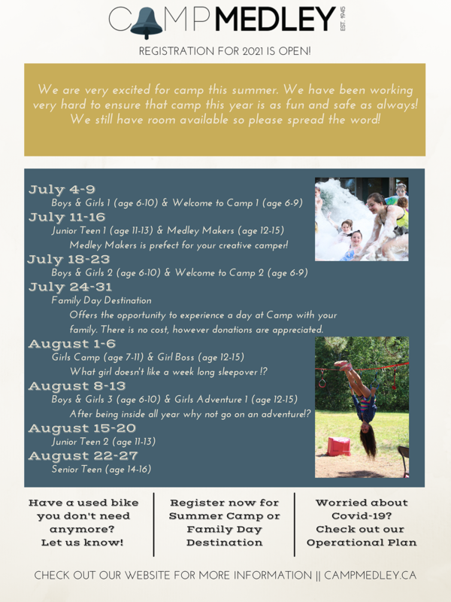
WOODWORKING GROUP: The woodworking group at St. Augustine’s is on-going most days of the week. They welcome new ideas for seasonal craft projects. Please contact Kevin Tupper for more information or if you are interested in joining.

Trinity Church Columbarium the Trinity Columbarium is located inside the Germaine Street entrance at Trinity Anglican Church in Saint John, NB. This beautiful, historical church provides a place of remembrance for families wanting that connection with the church. There are various niche sizes (individual, couples, and family) available for purchase. Inquiries can be directed to the Trinity Parish office at (506) 693-8558 or email: trinsj@nb.aibn.com

Many of you received the e-news from Gisele McKnight, Diocesan Communications Officer. It contains messages from the Bishop concerning the coronavirus and the resulting procedural changes and cancellations that have been put in place. Bishop David’s message contains links to his earlier messages on the coronavirus, as well as to prayers, on-line worship services and the Book of
Common Prayer. If you did not receive e-news, it may be found at https://nb.anglican.ca/newsletters/102/display A call to prayer has been issued and details may be found in e-news. As well, you can keep up with Diocesan events at https://nb.anglican.ca/
E - News wants subscriber
e-News is the best way to keep up to date on what is going
on in the diocese Click here to subscribe.

THE ANGLICAN JOURNAL AND THE NEW BRUNSWICK ANGLICAN: If you are not currently receiving the Anglican Journal and the New Brunswick Anglican and would like to, there are two ways to subscribe: 1. On-line at https://www.anglicanjournal.com/newsubscription/ checking off that you want the Diocesan paper called "Fredericton - New Brunswick Anglican" in the drop-down menu to accompany your subscription to the Anglican Journal, or 2. E-mail circulation@national.anglican.ca indicating that you would like to receive both the Anglican Journal and the New Brunswick Anglican. Include the name of your parish and the Diocese.

Please find attached a ½ page flyer with a request from Archbishop David for your help in completing our fundraising for the Diocese of Ho Mobile Clinic project.
To recap the project budget:
- Project cost: $268,000
- Grants and matching funds from various levels of Rotary Int.: $188,460
- Donated by parishes, parish groups and individuals to the Diocesan Synod: $63,540
- Remaining to be raised: $16,000.

Kings Landing summer services
Under current pandemic regulations, King’s Landing services begin this Sunday, June 13. (Incorrect information appeared in last week’s eNews.) The Rev. Canon Walter Williams will lead the first three Sundays. The rogation service will be on June 20. All are welcome.
Please note that services begin at 2 p.m. this year to help everyone catch the final wagon back to the entrance.
Clerics and layreaders are encouraged to sign up for a Sunday service. Click here to sign up.
Contact the Rev. Canon Walter Williams for more information.

As reported in last week’s eNews the project to provide a mobile medical clinic in the Diocese of Ho has received matching funding from various levels of Rotary, which means that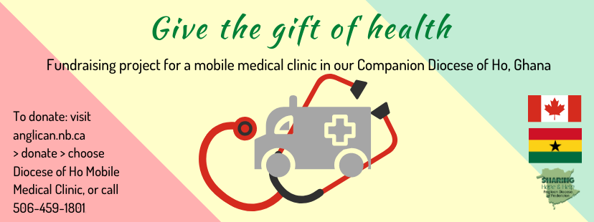at we are now only $16,000 short of the target of $268,000 (with $188,800 from Rotary). It is exciting news and I want to thank everyone in the Diocese who has contributed towards this outcome, especially the Companion Diocese Committee led by Robbie Griffin from Grand Manan.
We now come to the final push, so that we can access the pledged funds and place the vehicle order with Malley Industries of Moncton. The plan is to have the clinic operating in Ghana by the end of the year. My request to individuals and vestries is that we give to get this ball over the line. Diocesan Council pledged $5,000 at its meeting on Saturday.
If by God’s grace and our commitment we exceed the necessary amount that is all to the good. We will be able to provide more equipment and consumables for the clinic.
The aim of the Diocese of Ho, working with partners locally and from here, is to provide medical care for people in the rural areas of the Volta Region. The vehicle will be staffed by medical students and doctors from the regional hospital. In addition, specialists will travel when necessary. It has also been agreed that a member of the clergy will accompany the clinic to provide counsel as needed.
Gifts from vestries and individuals should be sent to Synod Office marked for the Ho Medical Clinic. Donations can also be made online at nb.anglican.ca/donate

