ST. LUKE’S ANGLICAN CHURCH

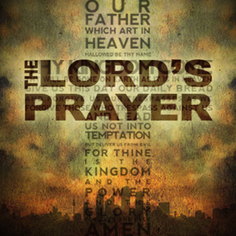

Sunday Service
Morning Prayer

July 24, 2022, at 10:00 a.m.

The Rev. Robert Montgomery
Priest–in-Charge

rob.montgomery@anglican.nb.ca / (506) 608-1772

https://www.facebook.com/StLukesGP

Readings: Genesis 18: 20-32 Psalm 138

Colossians 2: 6-15, (16-19) Luke 11: 1-13

St. Luke’s News

INTERCESSIONS:
- Anglican Communion: The Church in Wales, the Most Rev. Andrew John, Archbishop
- Missions: The Rev. Canon Paul Jeffries, Bishop McAllister College, in Uganda, fellow missionaries, teachers, volunteers. The Diocese of Ho, Companion Diocese of the Diocese of Fredericton.
- Fredericton, Archbishop David, retired bishops Claude and William, and their families, the Lemmon family. Camp Medley and Camp Brookwood, Threshold Ministries, The Anglican Diocese of Yukon: our retired clergy, and our fellow Anglicans: St. Peter. The Rev. Brenda McKnight (retired); Sussex Corner, the Rev. Dr. Sean Davidson; Gondola Point, the Rev. Rob Montgomery, and his family
- Gondola Point: Hymn Tortins Parish family: Fred and Heather Hynds and their family Parish Ministry: parish communications officer and stewardship.
- Community Needs: those without work, food, or shelter, and those who serve and care for them. Pray also for those who are travelling.
- Shut-Ins, especially if due to COVID-1.9.
- Sick: Alex, Alice, Barb, Bev, Catharine, Diane, Flora, Janet, Katie, Laverne, Lori, Loie, Peter, Paul, Shawn, Wanda., James F, Travis B., Jack D., Natalie D., James F., Isaac D. , John E., Lisa G., Diane M., Calvin M., Kathy M., Malcolm M., David S., Keaton S., Donna T., Wendy W., and any others we have been asked to include in our prays…
- Thanksgiving: Beauty and Wonder of Creation.

The Rev Montgomery’s Online Bible Study in on hold for the Summer. He will be starting up again in September 2022.

Thank you to everyone who assisted and supported St. Luke’s Annual Strawberry Festival, at St. Luke's Parish Hall, 12 Quispamsis Road, Quispamsis, on July 21/22.

Upcoming Activities and Events at St. Luke’s:

Rev. Rob Montgomery will be on vacation from about July 18/22 to
August 22/22. Our layreaders will be leading Morning Prayer Services with a few additions of speakers and presentations. We hope to see you on Sunday morning.

St. Luke’s Annual Roast Beef Dinner
St. Luke's Parish Hall
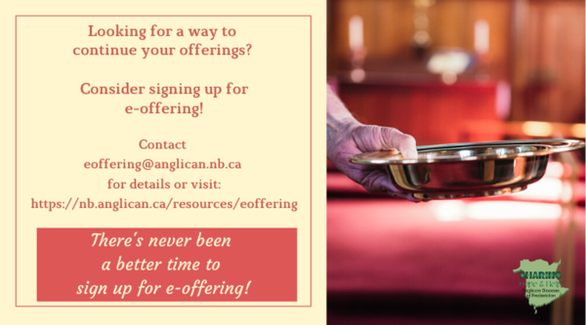
Sept. 24/22 St. Luke’s Annual Roast Beef Dinner, St. Luke's Parish Hall, 12 Quispamsis Road, Quispamsis, Saturday, September 24, 2022. Further detail to follow.
Tickets: $17.50 For Tickets: Call Susan at 847-7609 “Drive Through” Take-Out Only. Call Early. Tickets Must Be Picked-Up and Paid for Before Dinner. Tickets Are Limited So Call Early. Join us for delicious roast beef, potato, gravy, veggies & roll, and dessert.

Oct. 15/22 Girls Day Out Further details to come. Contact Caroline Britten.

Quarters for A Kilometer: We will be collecting quarters ($0.25) for the distance of a kilometer for the Church Restoration Fund. There will be a container at the back table for the quarters.

Work on our Building Restoration Project is complete. St. Luke’s is in the process of raising funds for re- investments funds used for the Restoration repairs of St. Luke’s Anglican Church. White envelopes for this are on the entry table. If you have any questions, please speak with Rev. Rob Montgomery, Rosemarie Kingston, or Terry Sleep.

Safe Church Trainer and Renewals: Please note a new online safe church training platform has been developed to allow the Diocese to better track who has taken the training, as well as working to make the training more relevant, accessible, and simple to complete. The new training should take 30-45 minutes and the Diocese would appreciate all feedback that you can provide on the entire process to ensure this is the ideal system to roll out to the diocese. Please contact Donna Dobbin for your training, thank you.

Mission Visionary Group – Meet monthly for guidance and direction of out missionary outreach of the Parish. Further details please contact the Rev. Rob Montgomery.

We are collecting refundable items from the parish for the Restoration Fund for the Church. If you have any you would like picked up, you may call Terry and Susan Sleep at 847-7609, or Darryl.

On this website is also St. Luke's Blog, posting of our Orders of Service and Sermons for Sundays, as well as other resources for us from time to time. Feel free to explore and spread the news if you can.

We must continue to meet our monthly expenses while we are unable to come to our church to meet at times for worship and fellowship. Since all worship services, meetings, and events at our church have been placed on hold at times, for the time being, our bulletin has changed. As the situation changes, activities will begin to be re-scheduled. Please contact Terry Sleep at 847-7609. He is our Parish E-offering Representative or by mail to St. Luke’s Anglican Church, 12 Quispamsis Road, Quispamsis, New Brunswick, E2E 1M2 or e-transfer. Please contact Terry Sleep at 847-7609 for further information or instructions, thank you.

Many of you received the e-news from Gisele McKnight, Diocesan Communications Officer. It contains messages from the archbishop concerning the coronavirus and the resulting procedural changes and cancellations that have been put in place. Bishop David’s message contains links to his earlier messages on the coronavirus, as well as to prayers, on-line worship services and the Book of
Common Prayer. If you did not receive e-news, it may be found at https://nb.anglican.ca/newsletters/102/display A call to prayer has been issued and details may be found in e-news. As well, you can keep up with Diocesan events at https://nb.anglican.ca/

E - News wants subscriber
e-News is the best way to keep up to date on what is going on in the diocese
Click here to subscribe.

THE ANGLICAN JOURNAL AND THE NEW BRUNSWICK ANGLICAN: If you are not currently receiving the Anglican Journal and the New Brunswick Anglican and would like to, there are two ways to subscribe: 1. On-line at https://www.anglicanjournal.com/newsubscription/ checking off that you want the Diocesan paper called "Fredericton - New Brunswick Anglican" in the drop-down menu to accompany your subscription to the Anglican Journal, or 2. E-mail circulation@national.anglican.ca indicating that you would like to receive both the Anglican Journal and the New Brunswick Anglican. Include the name of your parish and the Diocese.

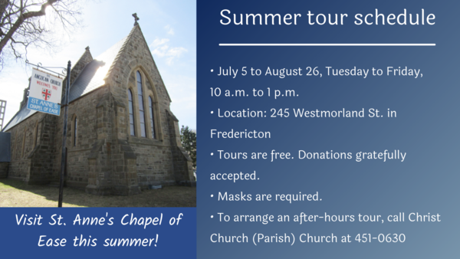

SUMMER SOUNDS 2022 at Historic
TRINITY Church
115 Charlotte Street, Saint John
Monday nights in June - July & Thursday nights in August
All Monday programs begin at 7:15 PM and are about one hour in
length. Free will offering for all events to be shared with the
presenters. Co-ordinated by David Goss at
gosswalk@nbnet.nb.ca.

July 25: Campfire Songs with their Stories led by David Goss.
David has delved into his past as a leader of Scouting and
campfires, and will share his favorite sing-a-long pieces. We will
hear stories of their origin and use over the years, with guitar
accompaniment.
The 7:00PM August Thursday’s programs will feature
artists on the Phoenix Digital Organ, recently installed
in Trinity, as well as VOCAL treats. (More information
before August). The program co-coordinator is Spencer Belyea.

August 4 Organist - Gibson MacMillan
August 11 Soprano - Maureen Paras & Friends
August 18 Vocalists - Mary Louise Belyea & Shane Scott
August 25 Organist - Richard Kidd

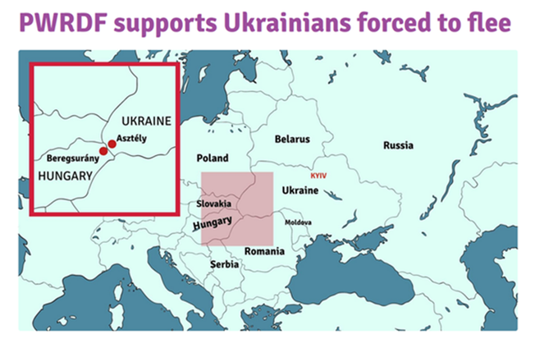
Donations for Ukraine relief
Donate via PWRDF
PWRDF is supporting Ukrainians forced to flee their homes due to the Russian invasion. The initial grant of $20,000 issued to an ACT Alliance appeal has been increased to $50,000. The grants will fund the work of Action by Churches Together (ACT) member Hungarian Interchurch Aid (HIA).
On Feb. 27, HIA set up a 24-hour refugee support point on the Hungarian side of the border at Beregsurány, where the line of refugees trying to cross into Hungary is kilometres long, says an ACT communiqué. HIA is providing hot tea, sandwiches, refreshments, blankets and basic hygiene items for Ukrainians, including many elderly and children who are waiting long hours to cross the border into Hungary.
How you can help
To make a donation to this response online, click here
You may also donate by phone at 416-822-9083 or leave a voicemail toll-free at 1-866-308-7973 and PWRDF will return your call; or mail your cheque to PWRDF, 80 Hayden, 3rd floor, Toronto, Ontario, M4Y 3G2. Please mark Ukraine in the memo field.
apply to be part of Say Yes! To Kids and be on their way to making their projects a reality.
The first step is to take a webinar, which are being held throughout March.

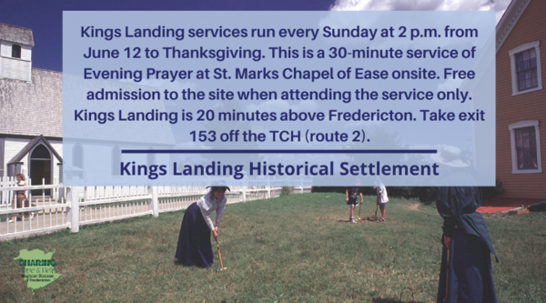

Visit Kings Landing

Sunday service @ 2 p.m.

Clergy Spouses' Retreat

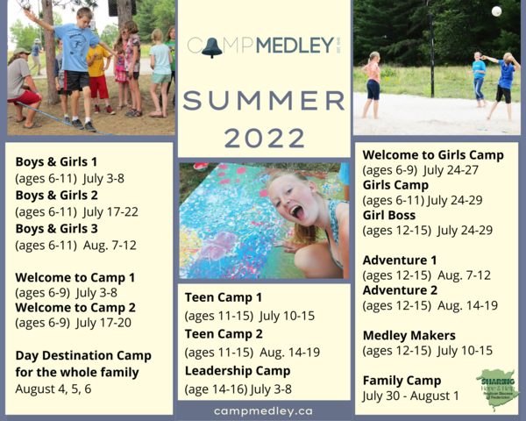

What's your favourite camp?
campmedley.ca

Godly Play training
Fall dates have changed
https://godlyplaymaritimes.com/

