St. Luke’s Anglican Church

July 12, 2020

At 10:00 a.m.
The Rev. Rob Montgomery
Priest-In-Charge
Parish of Gondola Point in Quispamsis, N.B.
rob.montgomery@anglican.nb.ca / 506-608-1772
https://www.facebook.com/StLukesGP
Website - www.stlukesgp.ca

Parish Telephone: (506) 847-3670

Reading: Isaiah 55:10–13 Psalm 65:1–13

Romans 8:1–11 Matthew 13:1–9, 18–23

INTERCESSIONS:
- Anglican Communion: The Anglican Church of Papua New Guinea, the Most Rev. Allan Migi
- Missions: The Rev. Canon Paul Jeffries, Bishop McAllister College, in Uganda, fellow missionaries, teachers, volunteers. The Diocese of Ho, Companion Diocese of the Diocese of Fredericton.
- Fredericton, Bishop David Edwards, retired Bishops Claude, William and George, and their families. Camp Medley and Camp Brookwood, Threshold Ministries, The Anglican Diocese of Yukon: our retired clergy, and our fellow Anglicans: Westmorland, the Rev. Lidvald Haugen-Strand; Sussex Corner, the Rev. Dr. Sean Davidson; Gondola Point, the Rev. Rob Montgomery
- Gondola Point: Baden Powell Program Parish family: Fred and Heather Hynds Parish Ministry: parish communications officer and stewardship.
- Community Needs: those without work, food, or shelter, and those who serve and care for them. Pray also for those who are travelling.
- Sick: Clare, Diane, Flora, Katie, Melissa, Nicola, Shawn, Wanda., Caroline B., Travis B., ,Winnie C., Jack D., John D., Sarah D., Doreen E., John E., Rebecca K., Susan L., Barb M., Karen M., Audrey M. Calvin M., Malcom M., Alice P., Eleri P., Emilie P., Paul P., David S., Keaton S., Robert W. and any others we have been asked for prays…
- Thanksgiving: Employment and financial blessings.

St. Luke’s has developed our COVID-19 Plan to allow us to return to having Sunday Services. If you have not done so, please check out our COVID-19 Plan page on our St. Luke's GP website for more information on what to expect, and how to stay safe: http://www.stlukesgp.ca/covid-19-plan.html

July 30/20 St. Luke’s Annual Strawberry Festival, St. Luke's Parish Hall, 12 Quispamsis Road, Quispamsis, Thursday, July 30, 2020
3 - 1/2 Hour Pickup Intervals from: 4:30 pm - 5:00 pm; 5:00 pm - 5:30 pm; 5:30 pm - 6:00 pm Tickets: $15.00 For Tickets: Call Susan at 847-7609 “Drive Through” Take-Out Only. Call Early. All ticket sales will end on July 26th. Tickets Must Be Picked-Up and Paid for Before Dinner. (Roast Turkey, Cranberries, Baked Potato, Sour Cream, Veggies & Roll, Strawberry Shortcake/Whipped Cream,)

Because of COVID-19, we were not able to have our annual cemetery clean-up and gardening around the church patio this year. If parish members have a spare 1/2 hr - hour to help brighten up the area and can help with cemetery clean-up, please call Terry at 847-7609. Please contact Donna Dobbin by email to say you will be there at dmdobbin50@gmail.com. Thankyou in advance!

The Rev. Montgomery has put our Parish Bible Study on Tuesday, on hold for the summer.

Please contacted Rev. Montgomery to sign up for our service next week at 10:00 a.m. He would encourage you to do so in preparation for our services. Please see the detail on our website, https://www.facebook.com/StLukesGP or you may contact him by email at rob.montgomery@anglican.nb.ca

As of May 2020 income: Bank balance: $18,572.74

May 2020 Receipts: $ 10,906.34 Expenses: $ 1,143.83

Difference: $ 9762.51 Restoration Fund $ 6,922.88

On this website is also St. Luke's Blog, posting of our Orders of Service and Sermons for Sundays, as well as other resources for us from time to time. Feel free to explore and spread the news if you can.

We must continue to meet our monthly expenses too while we are unable to come to our church to meet for worship and fellowship. Since all worship services, meetings and events at our church has been put on hold for the time being, our bulletin has changed. As the situation changes, activities will begin to be re-scheduled.
Please contact Terry Sleep at 847-7609. He is our Parish E-offering Representative or by mail to St. Luke’s Anglican Church, 12 Quispamsis Road, Quispamsis, New Brunswick, E2E 1M2 or e-transfer. Please contact Terry Sleep at 847-7609 for further information or instructions, thank you.

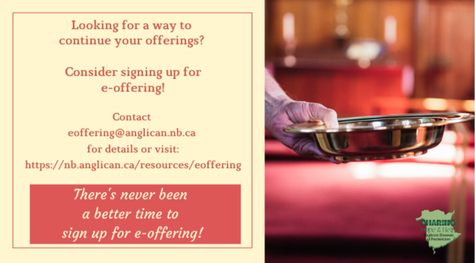

St. Luke’s is in the process of raising Funds for Restoration repairs of St. Luke’s Anglican Church with the matching of fund coming from a grant we have applied for from the Federal Government. White envelopes for this may be found on the entry table. If you have any questions, please speak with Rev. Rob Montgomery, Rosemarie Kingston, or Terry Sleep. We how you can help.

Many of you received the e-news from Gisele McKnight, Diocesan Communications Officer. It contains messages from the Bishop concerning the coronavirus and the resulting procedural changes and cancellations that have been put in place. Bishop David’s message contains links to his earlier messages on the coronavirus, as well as to prayers, on-line worship services and the Book of
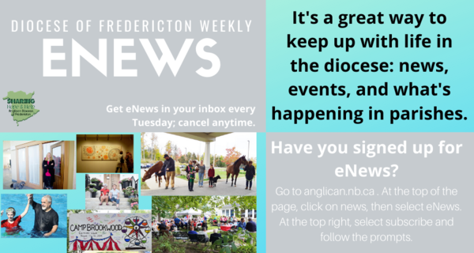
Common Prayer. If you did not receive e-news, it may be found at https://nb.anglican.ca/newsletters/102/display A call to prayer has been issued and details may be found in e-news. As well, you can keep up with Diocesan events at https://nb.anglican.ca/

E-News wants subscriber
e-News is the best way to keep up to date on what is going
on in the diocese.
Click here to subscribe.

YIG leaders meet on Wednesdays at 11 am- 12:30 pm Here is your Zoom meeting connection.
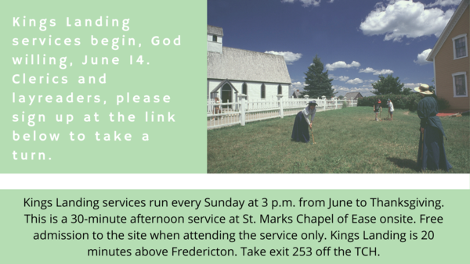
Kings Landing Summer Services

Sign up to take a turn at this link.

Summer schedule
eNews is now on its summer schedule, publishing every other week. The next eNews will be July 14. If you have upcoming parish events, send them in for publication: gmcknight@diofton.ca

Thank You Letters to the Frontline Workers:
During these unparalleled, and honestly scary times, most of us have a social responsibility to help stop the spread of COVID-19 by staying home and staying safe; but not everyone. Doctors, nurses, and other medical staff, as well as police, firefighters, grocery store employees, postal/delivery workers, gas station attendants, public transportation workers, mental health and social services workers, farmers, and countless other “essential workers” are putting themselves in harm’s way daily so the rest of us can stay safe. We want to thank you for all the hard work you are doing to keep our community safe during this time. Thank you for being so dedicated, courageous and selfless as we continue to work together to overcome this challenge we are currently facing. We are all trying to do our part by staying at home. You are inspiring us to take care of our community, and in the future, we will continue to take care of it. Your efforts, sacrifices, commitment, and leadership during these uncertain times is greatly appreciated! We are all in this together. Thank you again!

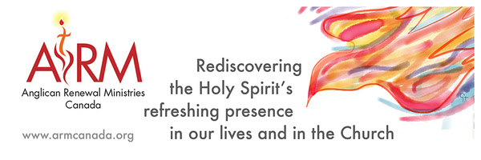 Anglican Renewal Ministries
Anglican Renewal Ministries is dedicated to bringing the life and power of the Holy Spirit to all Christians. ARM has been serving the Anglican Church of Canada for over 30 years. In addition to workshops, we offer a quarterly magazine with articles to uplift and encourage people in their walk with Christ. We hope it will be a source of encouragement to all in these difficult times. Sample articles and a free copy of the magazine are available on our website.

National Survey on COVID-19
The Halo Project seeks to assess the impact of religious communities within the wider society that is often unrecognized or valued. They ask participants to complete a survey which assesses the impact of COVID-19 on volunteer and donor activity during the past few months. Click here for access.

The Parish Development Officer and Council Spiritual Development Team, on behalf of Bishop David, are coordinating some diocesan-wide initiatives to recognize this time. We ask you to share these with your parishioners.

We certainly also encourage you in any parish or church events you are planning - and would be happy to publicize these on our diocesan event page.

Links to join and for resources are being added here: https://nb.anglican.ca/events/thy-kingdom-come

Shawn offers a video summary of all of this at: https://youtu.be/qCTgUSaIS-0

1. Video Testimonies
Jesus talking with the disciples asked, “Who do you say that I am?” (Matthew 16) That’s a great and important question! Who do you say Jesus is? We’re inviting you to share your response to this question. Record a 2-minute video and post it to your social media, tagging it with #ThyKingdomCome #NBAnglicans .

2. 24-7 Prayer Vigil
Everyone is invited to sign up for one or more 1-hour time slots and pray in their own space for God's Kingdom to come, for their church, and for family, friends and neighbours. Prayer guidelines will be available.
Daily Morning and Evening Prayer Offices using the Thy Kingdom Come prayer booklet (text will be provided) at 8:00 am and 6:00 pm (temporarily replacing the Litany@6)

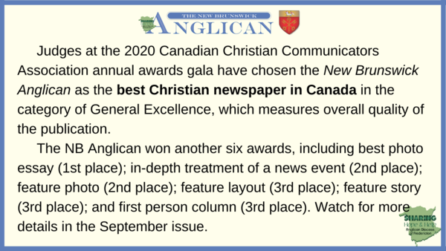

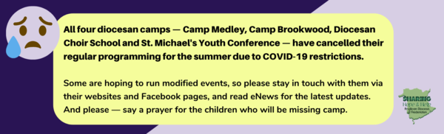

Camps cancelled

Keep in touch with your favourite summer camps using the links below.
St. Michael’s Youth Conference
https://smyc.ca/
https://www.facebook.com/SMYCAtlantic/
Diocesan Choir School
http://www.anglicanchoirschool.com/
https://www.facebook.com/groups/121354914558579/
Camp Brookwood
http://www.campbrookwood.ca/
camp.brookwood@outlook.com
http://campmedley.ca/
https://www.facebook.com/camp.medley/

