ST. LUKE’S ANGLICAN Church

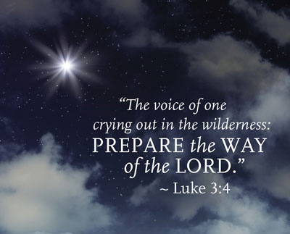

2nd Sunday in Advent

Sunday Service

December 5, 2021, at 10:00 a.m.
The Rev. Robert Montgomery
Priest–in-Charge
rob.montgomery@anglican.nb.ca / (506) 608-1772

Facebook: https://www.facebook.com/StLukesGP
Website: http://www.stlukesgp.ca

Readings: Malachi 3: 1-4 Luke 1: 68-79

Philippians 1: 3-11 Luke 3: 1

Peace

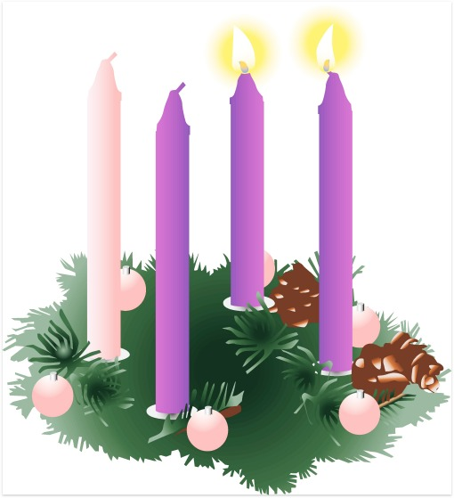

St. Luke’s News

INTERCESSIONS:
- Anglican Communion: The Anglican Church of Burundi. Council of the North, Diocese of Athabasca, Bishop David Greenwood, clergy, and people, as they seek to make the Anglican presence in Northern Alberta a vibrant and living one.
- Bishop McAllister College, in Uganda, fellow missionaries, teachers, volunteers. The Diocese of Ho, Companion Diocese of the Diocese of Fredericton
- Fredericton, Archbishop David Edwards, retired Bishops Claude, William and George, and their families. Camp Medley and Camp Brookwood, Threshold Ministries, The Anglican Diocese of Yukon: our retired clergy, and our fellow Anglicans: Chatham, the Ven. Perry Cooper; Rothesay Netherwood, the Rev. Rob Montgomery; Gondola Point, the Rev. Rob Montgomery, and his family
- Gondola Point: Bible Studies Parish family: Ken and Diane Mason Parish Ministry: Parish Safe Church Officer and stewardship.
- Community Needs: those without work, food, or shelter, and those who serve and care for them. Pray also for those who are travelling.
- Shut-Ins, especially if due to COVID-19.
- Sick: Flora, Katie, Lori, Shawn, Wanda., James F, Travis B., Jack D., James F., Isaac D. Doreen E., John E., Lisa G., Laverne L., Diane M., Calvin M., Kathy M., Malcolm M., David S., Keaton S., John W., Wendy W., and any others we have been asked to include in our prays…
- Thanksgiving: Tasks which demand our best efforts.
Advent Readings
Second Candle - The Candle of Peace

Leader: Today is the Second Sunday of Advent and we will light the Candle of Peace.

Last Sunday we lit the First Candle in our Advent Wreath and celebrated the faith of the people in the Old Testament, who looked forward to God’s blessing, hope in Christ. We light it again as we remember our Saviour, born a king in the line of King David. Jesus was born in Bethlehem, and we believe that he will come again to fulfill all of God's promises to us, to rule the world wisely and bless all nations.

(A person lights the First Candle, the Candle of Hope)

Today we light the Second Candle of Advent, the Candle of Peace. We remember the prophets who spoke of the coming of Christ, of how a Saviour would be born, a king in the line of King David.

Isaiah wrote, “The people who walk in darkness will see a great light. For those who live in a land of deep darkness, a light will shine. For a child is born to us, a son is given to us. The government will rest on his shoulders. And he will be called: Wonderful Counselor, Mighty God, Everlasting Father, Prince of Peace.”

When Jesus came, he taught people the importance of being peacemakers. He said that those who make peace shall be called the children of God. When Christ comes to us, he brings us peace and he will bring everlasting peace when he comes again. We light the Candle of Peace to remind us that Jesus is the Prince of Peace and that through him peace is found.

(A person lights Second Candle, the Candle of Peace)

Peace is like a light shining in a dark place. As we look at this candle, we celebrate the peace we find in Jesus Christ.

Leader: Let us pray:

All: Lord Jesus, Light of the World, the prophets said you would bring peace and save your people from trouble. Give peace in our hearts this year. We ask that as we wait for you to come again, that you would remain present with us. Help us today, and everyday to worship you, to hear your word, and to do your will by sharing your peace with each other. We ask it in the name of the one who was born in Bethlehem. Amen.

Dec. 8/21 Wednesday is our next vestry meeting at 7:00 p.m. If you are not able to attend, please send regrets to Rev. Rob Montgomery, the Wardens, or our vestry clerk.

St. Luke’s Blue Christmas Service has been rescheduled until after Christmas.

CHRISTMAS FAMILIES: St. Luke’s Christmas Families project will be collecting cash donations again this year to be used to purchase gift cards for needy families. If you would like to help, please place cash or a cheque in an envelope marked “Christmas Families” in the collection plate and be sure to note your offering envelope number. All money donations must be in by Sun Dec 5th

Quarters for A Kilometer: We will be collecting quarters ($0.25) for the distance of a kilometer for the Church Restoration Fund. There will be a container at the back table for the quarters.

Work continues on our Building Restoration Project and will continue throughout this Fall. Stay tuned for more updates on our Building Restoration Project progress and funds raised towards it so far.

Restoration of St. Luke’s Anglican Church: As of October 31/21

Funds needed: $ 62,500.00. Funds on hand: $ 24,061.94

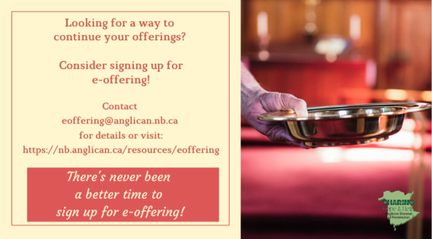
Safe Church Trainer and Renewals: Please note a new online safe church training platform has been developed to allow the Diocese to better track who has taken the training, as well as working to make the training more relevant, accessible, and simple to complete. The new training should take roughly 30-45 minutes and the Diocese would appreciate all feedback that you can provide on the entire process to ensure this is the ideal system to roll out to the diocese. Please contact Donna Dobbin for your training, thank you.

PWRDF's 2021 World of Gifts
The 2021 World of Gifts is officially here. This year's guide will bring new opportunities and hope for communities across the world as our PWRDF partners strive to build a truly just, healthy and peaceful world.
Click here to start shopping our secure, online guide today!
There are lots of ways to order! Copies of the World of Gifts Guide are included in issues of the Anglican Journal. You can also download the PDF version by clicking here.
Prefer to speak with us? Give us a call toll-free at 1-877- 936-9199, between 9 a.m. and 5 p.m. EST and make your order over the phone

Mission Visionary Group - Further details to follow by speaking to the Rev. Rob Montgomery.
St. Luke’s A.C.W. will be on holding their meeting on Monday in the hall starting at 10:00 a.m.,

The Rev. Montgomery leads St. Luke’s Parish Bible Study online on Tuesdays at 3:00 pm. Please contact Rev. Rob for further instructions.

We are collecting refundable items from the parish for the Restoration Fund for the Church. If you have any you would like picked up, you may call Terry and Susan Sleep at 847-7609, or Darryl.

On this website is also St. Luke's Blog, posting of our Orders of Service and Sermons for Sundays, as well as other resources for us from time to time. Feel free to explore and spread the news if you can.

We must continue to meet our monthly expenses too while we are unable to come to our church to meet at times for worship and fellowship. Since all worship services, meetings, and events at our church has been put on hold at times, for the time being, our bulletin has changed. As the situation changes, activities will begin to be re-schedule. Please contact Terry Sleep at 847-7609. He is our Parish E-offering Representative or by mail to St. Luke’s Anglican Church, 12 Quispamsis Road, Quispamsis, New Brunswick, E2E 1M2 or e-transfer. Please contact Terry Sleep at 847-7609 for further information or instructions, thank you.

St. Luke’s is in the process of raising Funds for Restoration repairs of St. Luke’s Anglican Church with the matching of fund coming from a grant we have applied for from the Federal Government. White envelopes for this may be found on the entry table. If you have any questions, please speak with Rev. Rob Montgomery, Rosemarie Kingston, or Terry Sleep. They can help you.

Many of you received the e-news from Gisele McKnight, Diocesan Communications Officer. It contains messages from the Bishop concerning the coronavirus and the resulting procedural changes and cancellations that have been put in place. Bishop David’s message contains links to his earlier messages on the coronavirus, as well as to prayers, on-line worship services and the Book of
Common Prayer. If you did not receive e-news, it may be found at https://nb.anglican.ca/newsletters/102/display A call to prayer has been issued and details may be found in e-news. As well, you can keep up with Diocesan events at https://nb.anglican.ca/

WOODWORKING GROUP: The woodworking group at St. Augustine’s is on-going most days of the week. They welcome new ideas for seasonal craft projects. Please contact Kevin Tupper for more information or if you are interested in joining.

Trinity Church Columbarium the Trinity Columbarium is located inside the Germaine Street entrance at Trinity Anglican Church in Saint John, NB. This beautiful, historical church provides a place of remembrance for families wanting that connection with the church. There are various niche sizes (individual, couples, and family) available for purchase. Inquiries can be directed to the Trinity Parish office at (506) 693-8558 or email: trinsj@nb.aibn.com

E - News wants subscriber
e-News is the best way to keep up to date on what is going
on in the diocese Click here to subscribe.

THE ANGLICAN JOURNAL AND THE NEW BRUNSWICK ANGLICAN: If you are not currently receiving the Anglican Journal and the New Brunswick Anglican and would like to, there are two ways to subscribe: 1. On-line at https://www.anglicanjournal.com/newsubscription/ checking off that you want the Diocesan paper called "Fredericton - New Brunswick Anglican" in the drop-down menu to accompany your subscription to the Anglican Journal, or 2. E-mail circulation@national.anglican.ca indicating that you would like to receive both the Anglican Journal and the New Brunswick Anglican. Include the name of your parish and the Diocese.

