ST. LUKE’S ANGLICAN CHURCH
1st Sunday of Advent

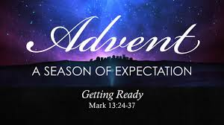

Sunday Morning Communion Service

December 3, 2023, at 10:00 a.m.

The Rev. Rob Montgomery- regional dean of the Deanery
of Kingston-Kennebecasis
Priest-In-Charge
The Ven. Cathy Laskey's, honorary assistant

rob.montgomery@anglican.nb.ca / 506-608-1772
https://www.facebook.com/StLukesGP

12, Quispamsis Road, Quispamsis, N.B. E2E 1M2

Readings: Isaiah 64: 1 - 9 Psalm 80: 1-7, 17- 19

1 Corinthians 1: 3-9 Mark 13: 24-37

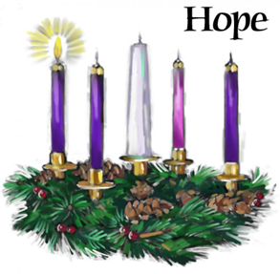

St. Luke’s News
INTERCESSIONS:
- Anglican Communion: The Church of Nigeria (Anglican Communion), the Most Rev Henry Ndukuba, Metropolitan and Primate. Archbishop Linda Nicholls, Anglican Church of Canada. Ecclesiastical Province of British Columbia and Yukon, Archbishop Lynne McNaughton, and the Provincial Council.
- Missions: The Rev. Canon Paul Jeffries, Bishop McAllister College, in Uganda, fellow missionaries, teachers, volunteers. The Diocese of Ho, Bishop Matthias Meduadues-Badohui, Ghana, West Africa the Companion Diocese of the Diocese of Fredericton
- Fredericton, Archbishop David, retired bishop William and his family, the Miller, and the Lemmon family. Camp Medley and Camp Brookwood, staff, and campers. Threshold Ministries, The Anglican Diocese of Yukon: our retired clergy, and our fellow Anglicans; Saint John, the Rev. Steven Scribner; Central Kings; the Ven. Robert Marsh; Gondola Point, the Rev. Rob Montgomery, and his family and the Ven. Cathy Laskey's, honorary assistant and her family.
- Gondola Point: Wednesday Night Contemplative Prayer Services
Parish family: Chris, Laura, Harison and Duncan Wilson and their family Parish Ministry: envelope secretary and stewardship.
- Community Needs: those without work, food, or shelter, and those who serve and care for them. Pray also for those who are travelling.
- Shut-Ins.
- Sick: Barb, Bev, Catharine, Danielle, Diane, Donna, Katie, Laverne, Shawn, Wanda., Winnie C., James F, Travis B., Jack D., Natalie D., Isaac D. , John E., Lisa G., Diane M., Kathy M., Malcolm M., David S., Keaton S., Donna T., and any others we have been asked to include in our prays….
- Thanksgiving: All that reminds us of our dependence upon God.

First Sunday of Advent

Celebrant: “Today we light the first candle of the Advent wreath. Each candle has a meaning. This first candle is HOPE.”

The candle is lit.

Scripture: “Psalm 33:20 – We wait in hope for the LORD; he is our help and our shield.”

Prayer: “Eternal God, as we await the coming of our savior, give us the courage to hope. Give us grace to see your plans of redemption for our lives, for this community, and for the world. Through Jesus Christ, the source of our redemption and hope. Amen.”

Advent Hymn: O come, O come, Emmanuel (Verse 1),
O come, O come, Emmanuel / and ransom captive Israel,
That mourns in lonely exile here/ until the Son of God appear.
Rejoice! Rejoice! / Emmanuel
Shall come to thee/ O Israel.
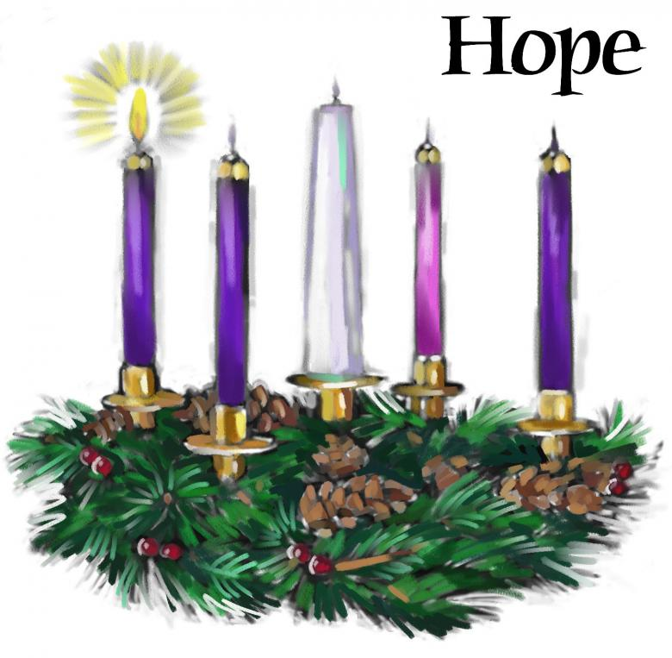

Parish Mission Outreach: Parish Mission Outreach: For the next Sundays, we are collecting boxes of “Cheerios” Cereal for an Elementary School Breakfast Program. Non-name brands are acceptable if there are no nuts (peanuts, peanut oil) in the ingredients or facilities in which they are made. Again, we will collect them at the church and then deliver them to the school.

As the temperature starts to drop, the need for warm dry socks has come up. The need for the socks has started the collection of new warm socks of all sizes to be collected at the church and distributed to the many centers that need them.

Dec.3/23 ST. LUKE’S GONDOLA POINT All-Ages Advent Event – Sunday Dec. 3 from 4-6 PM with tree trimming, finger foods, an Advent story, music, etc.

Dec. 10/23 St. Luke’s, Gondola Point - Blue Christmas Service
Sunday at at 6pm.

Dec 24/23 St. Luke’s, Gondola Point - Sunday Morning Service at 10.00 am.
Dec 24/23 St. Luke’s, Gondola Point - Christmas Eve Service at 6.00 pm
Dec 25/23 St. Luke’s, Gondola Point Monday Christmas Day Service at 11.00 am.
++++++++++++++++++++++++++++++++++++++++++++++
The Parish of Riverview Altar Guild is looking for children’s choir gowns and cruets, for purchase or donation. If you can help, contact the Rev. Julian Pillay > shepherdsheartsa@gmail.com
Clergy Conference

Happenings at Holy Trinity:

SENIORS DROP- IN at Holy Trinity (Trinity Corner Café) - 1st and 3rd Thursday of the month from 1 pm to 3 pm. Coffee & Chats. A great opportunity to meet over coffee and snacks for card games, puzzles, explore the library or just sit and chat!

Christmas Stockings - Denise Arseneau is once again co-ordinating the Christmas Stockings drive for Romero House. You may bring in your items starting on Nov 19th with delivery of all donations to take place in December. Romero House is including children ages 12-18 again this year so items for that age group would be appreciated. The schedule for donations is as follows: December 3rd – toothbrushes, toothpaste, dental floss, key chains, decks of cards, hand sanitizer, ear buds; December 10th – shampoo, conditioner, shaving cream, razors, deodorant, body wash, puzzle books, USBs. If you miss a week and wish to bring your donations in the following week that is OK. Contact Denise for more information at chrismeg3@yahoo.ca

Saturday, December 2/23 7pm The SAINT JOHN CHORALE... New Brunswick's National Award-winning Choir proudly presents the 28th annual C H R I S T M A S G A L A Saturday, December 2nd, 7pm St. Mark' s Church, Dexter Dr, West. Come support the first-place winner of the National Music Festival as they host: The 3rd Field Regiment Band Forest Hills Elementary School Choir High School Senior String Ensemble Christmas SING-ALONG with the Band and Scott "ELF" Thomas... Master of Ceremonies with the SAINT JOHN CHORALE $25. Adult, $5. Student, Children Free. THANK YOU and Merry Christmas! Start YOUR Christmas Season with the CHRISTMAS GALA

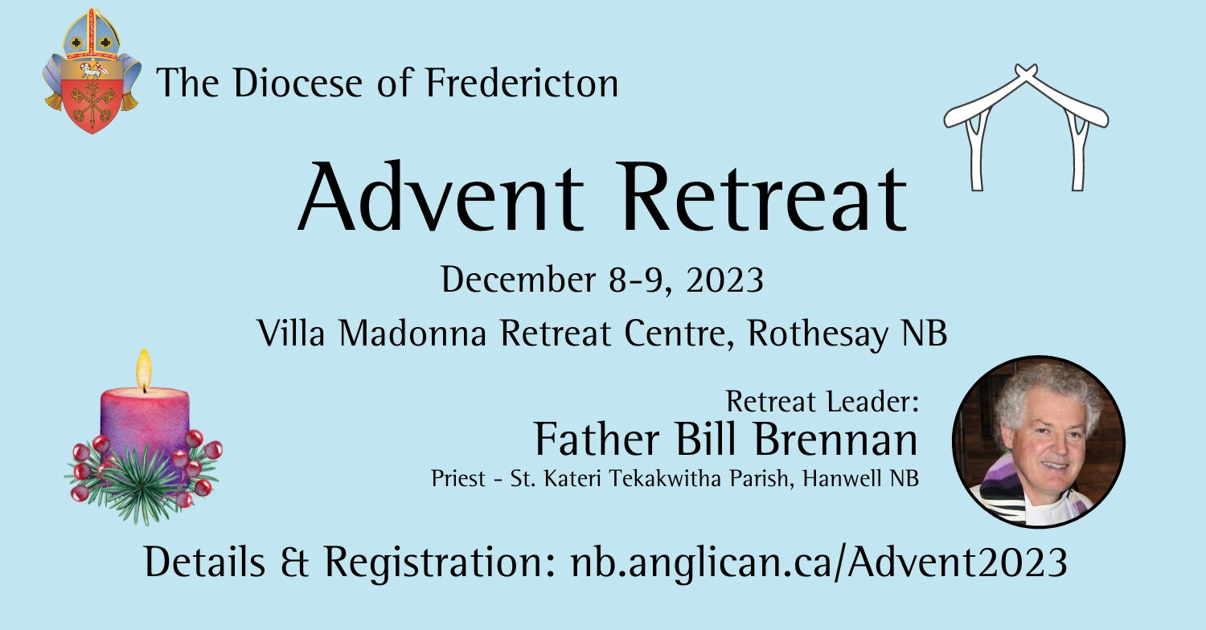

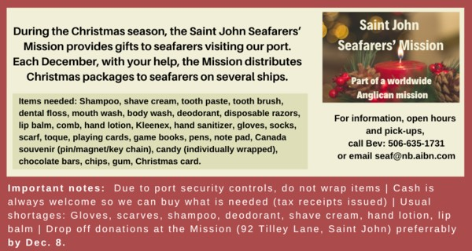

++++++++++++++++++++++++++++++++++++++++++++++++++++++

St. Luke’s A.C.W meet every Monday at 10:00 am all are welcome.

The Rev. Montgomery’s Online Bible Study on Tuesday at 3:00 p.m.

St. Luke’s Book Club the last Tuesday of the month at 10:00 a.m. at St. Luke’s Parish Hall. Please contact Heather Hynds for the list of books.

The Rev. Rob Montgomery’s Midweek Contemplative Services from 6:30PM - 7PM St. Luke’s Anglican Church.
Mission Visionary Group – Meet monthly for guidance and direction of out missionary outreach of the Parish. Further details please contact the Rev. Rob Montgomery.

Quarters for A Kilometer: We will be collecting quarters ($0.25) for the distance of a kilometer for the Church Restoration Fund. There will be a container on the back table for the quarters. Work on our Building Restoration Project is complete. St. Luke’s is in the process of raising funds for re- investments funds used for the Restoration repairs of St. Luke’s Anglican Church. White envelopes for this are on the entry table. If you have any questions, please speak with Rev. Rob Montgomery, Rosemarie Kingston, or Terry Sleep.

Safe Church Trainer and Renewals: Please note a new online safe church training platform has been developed to allow the Diocese to better track who has taken the training, as well as working to make the training more relevant, accessible, and simple to complete. The new training should take 30-45 minutes and the Diocese would appreciate all feedback that you can provide on the entire process to ensure this is the ideal system to roll out to the diocese. Please contact Donna Dobbin for your training, thank you.

We are collecting refundable items from the parish for the Restoration Fund for the Church. If you have any you would like picked up, you may call Terry and Susan Sleep on 847-7609, or Darryl.

On this website is also St. Luke's Blog, posting of our Orders of Service and Sermons for Sundays, as well as other resources for us from time to time. Feel free to explore and spread the news if you can.

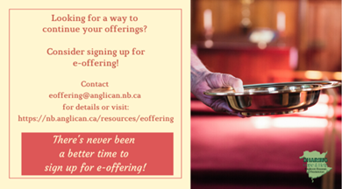
We must continue to meet our monthly expenses while we are unable to come to our church to meet at times for worship and fellowship. Since all worship services, meetings, and events at our church are on hold at times, our bulletin has changed. As the situation changes, activities will begin to be re-scheduled. Please contact Terry Sleep at 847-7609. He is our Parish E-offering Representative or by mail to St. Luke’s Anglican Church, 12 Quispamsis Road, Quispamsis, New Brunswick, E2E 1M2 or e-transfer. Please contact Terry Sleep at 847-7609 for further information or instructions, thank you.

Many of you received the e-news from Gisele McKnight, Diocesan Communications Officer. It contains messages from the archbishop concerning the coronavirus and the resulting procedural changes and cancellations that have been put in place. Bishop David’s message contains links to his earlier messages on the coronavirus, as well as to prayers, on-line worship services and the Book of
Common Prayer. If you did not receive e-news, it may be found at https://nb.anglican.ca/newsletters/102/display A call to prayer has been issued and details may be found in e-news. As well, you can keep up with Diocesan events at https://nb.anglican.ca/
E - News wants subscriber
e-News is the best way to keep up to date on what is going on in the diocese.
Click here to subscribe.

THE ANGLICAN JOURNAL AND THE NEW BRUNSWICK ANGLICAN: If you are not currently receiving the Anglican Journal and the New Brunswick Anglican and would like to, there are two ways to subscribe: 1. On-line at https://www.anglicanjournal.com/newsubscription/ checking off that you want the Diocesan paper called "Fredericton - New Brunswick Anglican" in the drop-down menu to accompany your subscription to the Anglican Journal, or 2. E-mail circulation@national.anglican.ca indicating.
that you would like to receive both the Anglican Journal and the New Brunswick Anglican. Include the name of your parish and the Diocese.

Donations for Ukraine relief
Donate via PWRDF
PWRDF is supporting Ukrainians forced to flee their homes due to the
Russian invasion. The initial grant of $20,000 issued to an ACT Alliance appeal has been increased to $50,000. The grants will fund the work of
Action by Churches Together (ACT) member Hungarian Interchurch Aid
(HIA). On Feb. 27, HIA set up a 24-hour refugee support point on the Hungarian side of the border at Beregsurány, where the line of refugees trying to cross into Hungary is kilometres long, says an ACT communiqué. HIA is providing hot tea, sandwiches, refreshments, blankets, and basic hygiene items for Ukrainians, including many elderlies and children who are waiting long hours to cross the border into Hungary. How you can help. To donate to this response online, you may also donate by phone at 416-822-9083 or leave a voicemail, toll-free at 1-866-308-7973 and PWRDF will return your call; or mail your cheque to PWRDF, 80 Hayden, 3rd floor, Toronto, Ontario, M4Y 3G2. Please mark Ukraine in the memo field. Apply to be part of Say Yes! To Kids and be on their way to making their projects a reality. The first step is to take a webinar, which are being held throughout March

