ST. LUKE’S ANGLICAN CHURCH
4th Sunday of Advent
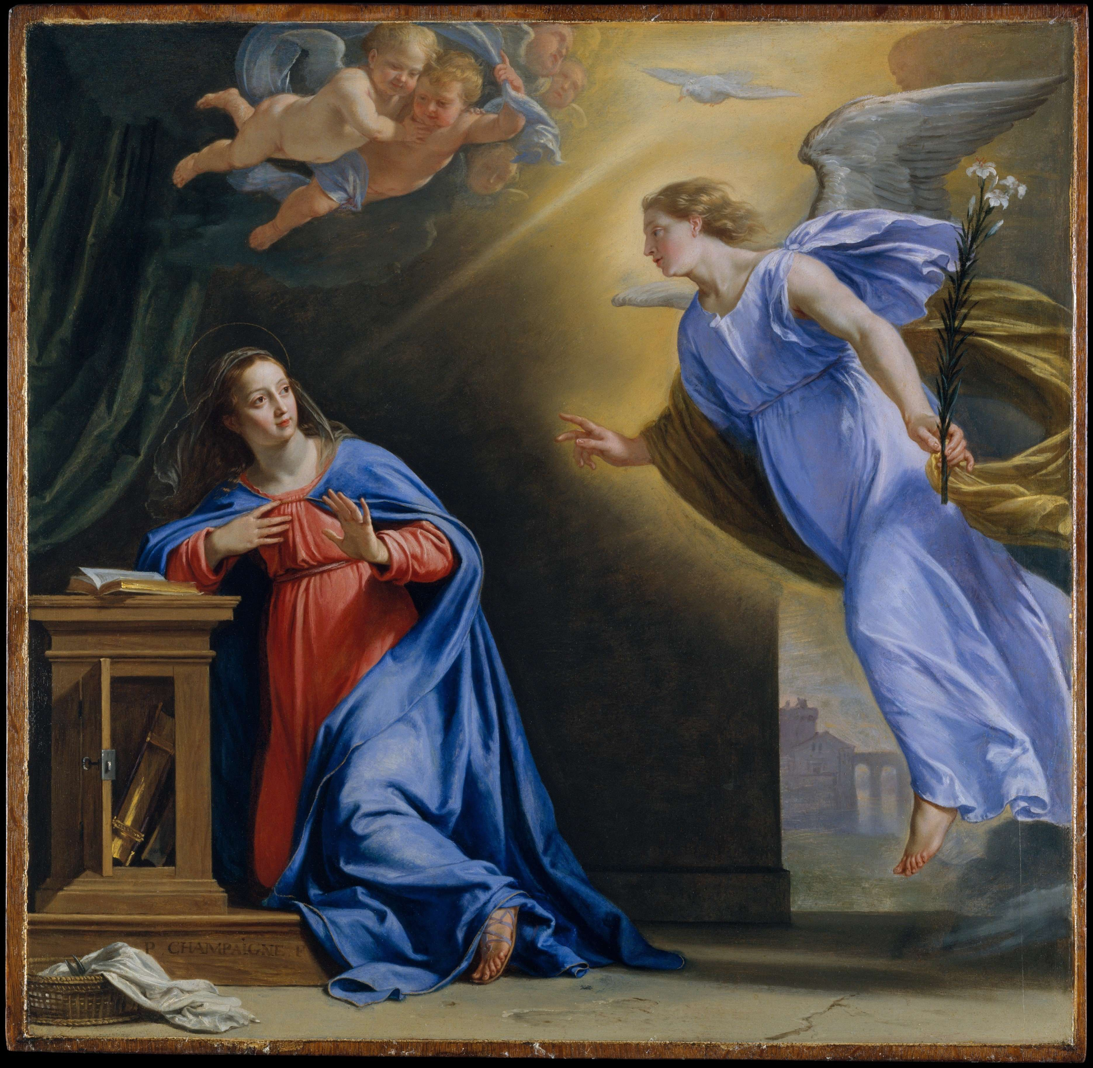

Sunday Morning Communion Service

December 24, 2023, at 10:00 a.m.

The Rev. Rob Montgomery- regional dean of the Deanery
of Kingston-Kennebecasis
Priest-In-Charge
The Rev. Canon. Cathy Laskey's, honorary assistant

rob.montgomery@anglican.nb.ca / 506-608-1772
https://www.facebook.com/StLukesGP
12, Quispamsis Road, Quispamsis, N.B. E2E 1M2

Readings: 2 Samuel 7:1-11, 16 Luke 1: 46b-5 OR

Psalm 89: 1-4, 19-26

Romans 16: 25-27 Luke 1: 26-38
Love

St. Luke’s News
INTERCESSIONS:
- Anglican Communion: The Episcopal Church in the Philippines, the Most Rev Brent Alawas, Prime Bishop. Archbishop Linda Nicholls, Anglican Church of Canada. National Indigenous Archbishop Chris Harper and The Anglican Council of Indigenous Peoples.
- Missions: The Rev. Canon Paul Jeffries, Bishop McAllister College, in Uganda, fellow missionaries, teachers, volunteers. The Diocese of Ho, Bishop Matthias Meduadues-Badohui, Ghana, West Africa the Companion Diocese of the Diocese of Fredericton
- Fredericton, Archbishop David, retired bishop William and his family, the Miller, and the Lemmon family. Camp Medley and Camp Brookwood, staff, and campers. Threshold Ministries, The Anglican Diocese of Yukon: our retired clergy, and our fellow Anglicans; Bathurst, the Rev. Christopher Tapera; Hampton, the Rev. David Turner; Gondola Point, the Rev. Rob Montgomery, and his family and the Rev. Canon Cathy Laskey – Hospital Chaplain and honorary assistant and her family.
- Gondola Point: Christmas Family Support Parish family: Wade and Kim Beaman and their family Parish Ministry: standing committee and stewardship.
- Community Needs: those without work, food, or shelter, and those who serve and care for them. Pray also for those who are travelling.
- Shut-Ins.
- Sick: Barb, Bev, Catharine, Danielle, Diane, Donna, Katie, Laverne, Shawn, Wanda., Winnie C., James F, Travis B., Jack D., Natalie D., Isaac D., John E., Lisa G., Diane M., Kathy M., Malcolm M., David S., Keaton S., Donna T., and any others we have been asked to include in our prays….
- Thanksgiving: Family, Friends, and Community.

Fourth Sunday of Advent

Celebrant: “Today we light the first, second, third, and fourth candles of the Advent wreath. Each candle has a meaning. The first candle is HOPE, the second candle is PEACE, the third candle is JOY, and the fourth candle is LOVE.”

The candles are lit.

Scripture: “John 13:34 – Jesus said to them, I give you a new commandment, that you love one another. Just as I have loved you, you also should love one another. By this everyone will know that you are my disciples, if you have love for one another."

Prayer: “Loving God, your mercy and compassion endure forever. Open our hearts, that we may receive your love; and following the example of your Son, spread that love to a love-starved world. Through Jesus Christ, who loved us to the end. Amen.”

Advent Hymn: O come, O come, Emmanuel (Verse 5),

O Come, O Key of David, come/and open wide our heavenly home
Make safe the way that leads on high/and close the path to misery
Rejoice! Rejoice! / Emmanuel
Shall come to thee / O Israel.

Love

Today is Food Basket Sunday, the last Sunday of the month and we are thankful for the donations to the KV Food Basket.

Today is also Birthday Sunday:

Happy birthday to you.
To our Lord be true.
May God's love and blessings,
Rain down upon you.

Caroline Britten | Terry Sleep
Craig McDermott | Christopher Wilson
And Anyone we may have missed.

Parish Mission Outreach: Parish Mission Outreach: For the next Sundays, we are collecting boxes of “Cheerios” Cereal for an Elementary School Breakfast Program. Non-name brands are acceptable if there are no nuts (peanuts, peanut oil) in the ingredients or facilities in which they are made. Again, we will collect them at the church and then deliver them to the school.

As the temperature starts to drop, the need for warm dry socks has come up. The need for the socks has started the collection of new warm socks of all sizes to be collected at the church and distributed to the many centers that need them.

Dec. 24/23 St. Luke’s, Gondola Point - Christmas Eve Service at 6.00 pm
Dec. 25/23 St. Luke’s, Gondola Point Monday Christmas Day Service at 11.00 am.
++++++++++++++++++++++++++++++++++++++++++++++
The Parish of Riverview Altar Guild is looking for children’s choir gowns and cruets, for purchase or donation. If you can help, contact the Rev. Julian Pillay > shepherdsheartsa@gmail.com
Clergy Conference

Happenings at Holy Trinity:

SENIORS DROP- IN at Holy Trinity (Trinity Corner Café) - 1st and 3rd Thursday of the month from 1 pm to 3 pm. Coffee & Chats. A great opportunity to meet over coffee and snacks for card games, puzzles, explore the library or just sit and chat!
++++++++++++++++++++++++++++++++++++++++++++++++++++++

St. Luke’s A.C.W meet every Monday at 10:00 am all are welcome.

The Rev. Montgomery’s Online Bible Study on Tuesday at 3:00 p.m. will be suspended until the new year.

St. Luke’s Book Club the last Tuesday of the month at 10:00 a.m. at St. Luke’s Parish Hall. Please contact Heather Hynds for the list of books.

The Rev. Rob Montgomery’s Midweek Contemplative Services from 6:30PM - 7PM St. Luke’s Anglican Church will be suspended until the new year.
Mission Visionary Group – Meet monthly for guidance and direction of out missionary outreach of the Parish. Further details please contact the Rev. Rob Montgomery.

Quarters for A Kilometer: We will be collecting quarters ($0.25) for the distance of a kilometer for the Church Restoration Fund. There will be a container on the back table for the quarters. Work on our Building Restoration Project is complete. St. Luke’s is in the process of raising funds for re- investments funds used for the Restoration repairs of St. Luke’s Anglican Church. White envelopes for this are on the entry table. If you have any questions, please speak with Rev. Rob Montgomery, Rosemarie Kingston, or Terry Sleep.

Safe Church Trainer and Renewals: Please note a new online safe church training platform has been developed to allow the Diocese to better track who has taken the training, as well as working to make the training more relevant, accessible, and simple to complete. The new training should take 30-45 minutes and the Diocese would appreciate all feedback that you can provide on the entire process to ensure this is the ideal system to roll out to the diocese. Please contact Donna Dobbin for your training, thank you.

We are collecting refundable items from the parish for the Restoration Fund for the Church. If you have any you would like picked up, you may call Terry and Susan Sleep on 847-7609, or Darryl.

On this website is also St. Luke's Blog, posting of our Orders of Service and Sermons for Sundays, as well as other resources for us from time to time. Feel free to explore and spread the news if you can.

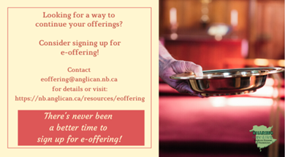
We must continue to meet our monthly expenses while we are unable to come to our church to meet at times for worship and fellowship. Since all worship services, meetings, and events at our church are on hold at times, our bulletin has changed. As the situation changes, activities will begin to be re-scheduled. Please contact Terry Sleep at 847-7609. He is our Parish E-offering Representative or by mail to St. Luke’s Anglican Church, 12 Quispamsis Road, Quispamsis, New Brunswick, E2E 1M2 or e-transfer. Please contact Terry Sleep at 847-7609 for further information or instructions, thank you.

Many of you received the e-news from Gisele McKnight, Diocesan Communications Officer. It contains messages from the archbishop concerning the coronavirus and the resulting procedural changes and cancellations that have been put in place. Bishop David’s message contains links to his earlier messages on the coronavirus, as well as to prayers, on-line worship services and the Book of
Common Prayer. If you did not receive e-news, it may be found at https://nb.anglican.ca/newsletters/102/display A call to prayer has been issued and details may be found in e-news. As well, you can keep up with Diocesan events at https://nb.anglican.ca/
E - News wants subscriber
e-News is the best way to keep up to date on what is going on in the diocese.
Click here to subscribe.

THE ANGLICAN JOURNAL AND THE NEW BRUNSWICK ANGLICAN: If you are not currently receiving the Anglican Journal and the New Brunswick Anglican and would like to, there are two ways to subscribe: 1. On-line at https://www.anglicanjournal.com/newsubscription/ checking off that you want the Diocesan paper called "Fredericton - New Brunswick Anglican" in the drop-down menu to accompany your subscription to the Anglican Journal, or 2. E-mail circulation@national.anglican.ca indicating.
that you would like to receive both the Anglican Journal and the New Brunswick Anglican. Include the name of your parish and the Diocese.

Donations for Ukraine relief
Donate via PWRDF
PWRDF is supporting Ukrainians forced to flee their homes due to the
Russian invasion. The initial grant of $20,000 issued to an ACT Alliance appeal has been increased to $50,000. The grants will fund the work of
Action by Churches Together (ACT) member Hungarian Interchurch Aid
(HIA). On Feb. 27, HIA set up a 24-hour refugee support point on the Hungarian side of the border at Beregsurány, where the line of refugees trying to cross into Hungary is kilometres long, says an ACT communiqué. HIA is providing hot tea, sandwiches, refreshments, blankets, and basic hygiene items for Ukrainians, including many elderlies and children who are waiting long hours to cross the border into Hungary. How you can help. To donate to this response online, you may also donate by phone at 416-822-9083 or leave a voicemail, toll-free at 1-866-308-7973 and PWRDF will return your call; or mail your cheque to PWRDF, 80 Hayden, 3rd floor, Toronto, Ontario, M4Y 3G2. Please mark Ukraine in the memo field. Apply to be part of Say Yes! To Kids and be on their way to making their projects a reality. The first step is to take a webinar, which are being held throughout March

