St. Luke’s Anglican Church

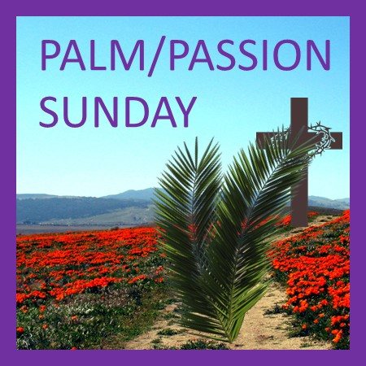

April 5, 2020
The Rev. Rob Montgomery
Priest-In-Charge
Parish of Gondola Point in Quispamsis, N.B.
rob.montgomery@anglican.nb.ca / 506-608-1772
https://www.facebook.com/StLukesGP
Parish Telephone: (506) 847-3670

Reading: Liturgy of the Palms
- First reading
  - Matthew 21:1-11

Liturgy of the Passion
- First reading
  - Isaiah 50:4-9a
- Psalm
  - Psalm 31:9-16
- Second reading
  - Philippians 2:5-11
- Gospel
  - Matthew 26:14-27:66

St. Luke’s News
INTERCESSIONS:
- Anglican Communion: The Church of the Province of the Indian Ocean, the Most Rev. James Richard Wong Yin Song
- Missions: The Rev. Canon Paul Jeffries, Bishop McAllister College, in Uganda, fellow missionaries, teachers, volunteers. The Diocese of Ho, Companion Diocese of the Diocese of Fredericton.
- Fredericton, Bishop David Edwards, retired Bishops Claude, William and George, and their families. Camp Medley and Camp Brookwood, Threshold Ministries, The Anglican Diocese of Yukon: our retired clergy, and our fellow Anglicans: St. David and St. Patrick, the Ven. John Matheson; Sussex Corner, the Rev. Dr. Sean Davidson; Gondola Point, the Rev. Rob Montgomery
- Gondola Point: Food Bank Meals Parish family: Parish Ministry: care and preservation committee cemetery and stewardship.
- Community Needs: those without work, food, or shelter, and those who serve and care for them. Pray also for those who are travelling.
- Shut-Ins: Martha M.
- Sick: Clare, Diane, Flora, Katie, Melissa, Nicola, Shawn, Wanda., Caroline B., Travis B., ,Winnie C., Jack D., John D., Doreen E., John E., Susan L., Barb M., Karen M., Audrey M. Calvin M., Malcom M., Alice P., Eleri P., Emilie P., Paul P., David S., Keaton S., Robert W. and any others we have been asked for prays…
- Thanksgiving: Our Church Family and Freedom to Worship

We have just launched our new Parish Website, and you can check it out at www.stlukesgp.ca

On this website is also St. Luke's Blog, posting of our Orders of Service and Sermons for Sundays, as well as other resources for us from time to time.

Feel free to explore, and spread the news if you can

-We have developed a Website which is available, and it will cost $180.00. Donations for this will allow us to reach a wider number of people.

Please contact Terry Sleep at 847-7609. He is our Parish E-offering Representative.
Or
By mail to St. Luke’s Anglican Church, 12 Quispamsis Road, Quispamsis, New Brunswick, E2E 1M2

We must continue to meet our monthly expenses too while we are unable to come to our church to meet for worship and fellowship.
Since all worship services, meetings and events at our church has been put on hold for the time being, our bulletin has changed . As the situation changes, activities will begin to be re-scheduled.

-Old eyeglasses are being collected in a box on the table at the back of the church when we return.

-In June 2020, St. Luke’s hopes to plan an Auction of Time, Talents and Treasures. Please start collecting any treasures you may have. Further details to follow

Rev. Montgomery has put our Parish Bible Study on Tuesday, on hold for now at the church but please keep involved by email.

St. Luke’s is in the process of raising Funds for Restoration repairs of St. Luke’s Anglican Church with the matching of fund coming from a grant we have applied for from the Federal Government. White envelopes for this may be found on the entry table. If you have any questions, please speak with Rev. Rob Montgomery, Rosemarie Kingston or Terry Sleep. We how you can help.

Many of you received the e-news from Gisele McKnight, Diocesan Communications Officer. It contains messages from the Bishop concerning the coronavirus and the resulting procedural changes and cancellations that have been put in place. Bishop David’s message contains links to his earlier messages on the coronavirus, as well as to prayers, on-line worship services and the Book of Common Prayer. If you did not receive e-news, it may be found at https://nb.anglican.ca/newsletters/102/display A call to prayer has been issued and details may be found in e-news. As well, you can keep up with Diocesan events at https://nb.anglican.ca/

POSTPONED: DIOCESAN ACW ANNUAL MEETING: This year’s meeting will be held on Tues May 5th and Wed May 6th at St. James the Less Church, 1760 Rothesay Road in Renforth. Registration is $6 for the meetings and $20 for the banquet, which will be held on May 5th at St. Luke’s Church in Quispamsis. Banquet money is due to Paula Adams by Apr 14th. For more information please contact Gail Eastwood (832-4602) or Paula Adams (849-3874) or visit: https://nb.anglican.ca/events/diocesan-acw-annual-meeting--319/2020-05-05

