ST. LUKE’S ANGLICAN CHURCH

15th Sunday After Pentecost

Sunday Service

September 5, 2021, at 10:00 a.m.

The Rev. Robert Montgomery
Priest–in-Charge
rob.montgomery@anglican.nb.ca / (506) 608-1772

Facebook: https://www.facebook.com/StLukesGP
Website: http://www.stlukesgp.ca

Readings: Proverbs 22: 1-2, 8-9, 22-23 Psalm 125

James 2: 1-17 Mark 7: 24-37

St. Luke’s News

INTERCESSIONS:
- Anglican Communion: Province of the Episcopal Church of Sudan. Council of the North, Indigenous Spiritual Ministry of Mishamikoweesh, Bishop Lydia Mamakwa
- Bishop McAllister College, in Uganda, fellow missionaries, teachers, volunteers. The Diocese of Ho, Companion Diocese of the Diocese of Fredericton
- Fredericton, Archbishop David Edwards, retired Bishops Claude, William and George, and their families. Camp Medley and Camp Brookwood, Threshold Ministries, The Anglican Diocese of Yukon: our retired clergy, and our fellow Anglicans: Andover, the Rev. Harold Boomer; Upham, the Ven, Rob Marsh; Gondola Point, the Rev. Rob Montgomery, and his family
- Gondola Point: Romero House Parish family: Ann Chappell and her family Parish Ministry: Baden Powell liaison and stewardship.
- Community Needs: those without work, food, or shelter, and those who serve and care for them. Pray also for those who are travelling.
- Shut-Ins especially if due to COVID-19.
- Sick: Flora, Jack, Katie, Lori, Melissa, Rebecca, Sarah, Shawn, Wanda., Travis B., Jack D. Isaac D. Doreen E., John E., Lisa G., Sheila H., Calvin M., Malcolm M., Sterling M., David S., Keaton S., John W., Wendy W., and any others we have been asked for prays…
- Thanksgiving: Our Church Family and Freedom to Worship.

Parish Mission Outreach: For the next few Sundays, we are collecting boxes of “Cheerios” Cereal for an Elementary School Breakfast Program. Non-name brand is acceptable if there are no nuts (peanuts, peanut oil) in the ingredients or facilities they are made in. Again, we will collect them at the church and then deliver them to the school.

Quarters for A Kilometer: We will be collecting quarters ($0.25) for the distance of a kilometer for the Church Restoration Fund. There will be a container at the back table for the quarters.

Safe Church Trainer and Renewals: Please note a new online safe church training platform has been developed to allow the Diocese to better track who has taken the training, as well as working to make the training more relevant, accessible, and simple to complete. The new training should take roughly 30-45 minutes and the Diocese would sincerely appreciate all feedback that you can provide on the entire process to ensure this is the ideal system to roll out to the diocese. Please contact Donna Dobbin for your training, thank you.

Upcoming Events:
Sept.8/21 NEW...."FOOD FOR LIFE" group starting at Holy Trinity Hammond River on Wednesday September 8th with well-known leader Natalie Treadwell!
Whether you have some COVID weight to lose or simply want to learn more about healthy lifestyles and eating habits, this new "Food for Life" group may be just what you need to get started.
Weekly sessions will be held in the Holy Trinity church hall at 2 Hammond River Rd., Quispamsis, each Wednesday starting on September 8th from 6 pm to 6:45 pm.
There is a one-time (lifetime) fee of $65 which includes a cookbook, a personal journal book and other literature.
The cost for 10 weeks is $50 ($5 per week).
To register, or if you want more information, please call Cleo Cyr, Parish Nurse, at 506-647-8170 or email at cleocyr1@gmail.com

Sept. 18/21. St. Augustine’s in Quispamsis is having a takeout chicken BBQ supper on Saturday, Meal will include potato salad and pasta salad, roll, and strawberry shortcake for dessert. Tickets are $15 and there will be three pick-up times: 4:30-5 pm, 5-5:30 pm, and 5:30-6 pm. Please call Art Scott at 849-2430 for more information and to reserve your tickets. This notice will also be included in Happenings starting in early September.

Sept. 25/21 St. Luke’s Roast Beef Supper at the hall. 12 Quispamsis Road, Quispamsis. There will be 4 - 1/2 Hour Pickup Intervals from: 4:00pm – 4:30 pm. 4:30 pm - 5:00 pm; 5:00 pm - 5:30 pm; 5:30 pm - 6:00 pm Tickets: $15.00 For Tickets: Call Susan at 847-7609 “Drive Through” Take-Out Only. Call Early. All ticket sales will end on September 18/21 Tickets Must Be Picked-Up and Paid for Before Dinner. Tickets Are Limited So Call Early. Join us for delicious roast beef, potato, gravy, veggies & roll, and dessert.

Mission Visionary Group - Launch Pentecost. Further details to follow by speaking to the Rev. Rob Montgomery.

As Bishop of Fredericton, I want to re-emphasize my endorsement of the Primate’s statement (Every Child Matters) concerning recent discoveries about residential schools.
This statement also represents my feelings of shame and horror concerning the activities towards Indigenous peoples, by the New England Company and its agents in parts of our province during the late 18th and early 19th centuries. The article A Comment on the Colonial Perversion of British Benevolence, by Judith Fingard, indicates the involvement of some of the early Anglican settlers in this enterprise.
Please pray for all those affected by these issues past and present across our country.
The Bishop

Soon we will be staring restoration of St. Luke’s Anglican Church.
Funds needed: $ 62,500.00.

St. Luke’s A.C.W. will be on holding their meeting on Monday in the hall starting at 10:00 a.m.,

The Rev. Montgomery will be putting St. Luke’s Parish Bible Study on hold for the summer. Please contact Rev. Rob for further instructions.

We are collecting refundable items from the parish for the Restoration Fund for the Church. If you have any you would like picked up, you may call Terry and Susan Sleep at 847-7609, or Darryl.

On this website is also St. Luke's Blog, posting of our Orders of Service and Sermons for Sundays, as well as other resources for us from time to time. Feel free to explore and spread the news if you can.

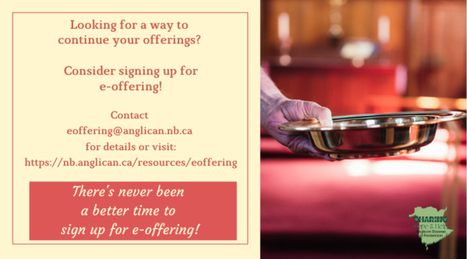
We must continue to meet our monthly expenses too while we are unable to come to our church to meet at times for worship and fellowship. Since all worship services, meetings, and events at our church has been put on hold at times, for the time being, our bulletin has changed. As the situation changes, activities will begin to be re-schedule. Please contact Terry Sleep at 847-7609. He is our Parish E-offering Representative or by mail to St. Luke’s Anglican Church, 12 Quispamsis Road, Quispamsis, New Brunswick, E2E 1M2 or e-transfer. Please contact Terry Sleep at 847-7609 for further information or instructions, thank you.

St. Luke’s is in the process of raising Funds for Restoration repairs of St. Luke’s Anglican Church with the matching of fund coming from a grant we have applied for from the Federal Government. White envelopes for this may be found on the entry table. If you have any questions, please speak with Rev. Rob Montgomery, Rosemarie Kingston, or Terry Sleep. They can help you.

Many of you received the e-news from Gisele McKnight, Diocesan Communications Officer. It contains messages from the Bishop concerning the coronavirus and the resulting procedural changes and cancellations that have been put in place. Bishop David’s message contains links to his earlier messages on the coronavirus, as well as to prayers, on-line worship services and the Book of
Common Prayer. If you did not receive e-news, it may be found at https://nb.anglican.ca/newsletters/102/display A call to prayer has been issued and details may be found in e-news. As well, you can keep up with Diocesan events at https://nb.anglican.ca/

WOODWORKING GROUP: The woodworking group at St. Augustine’s is on-going most days of the week. They welcome new ideas for seasonal craft projects. Please contact Kevin Tupper for more information or if you are interested in joining.

Trinity Church Columbarium the Trinity Columbarium is located inside the Germaine Street entrance at Trinity Anglican Church in Saint John, NB. This beautiful, historical church provides a place of remembrance for families wanting that connection with the church. There are various niche sizes (individual, couples, and family) available for purchase. Inquiries can be directed to the Trinity Parish office at (506) 693-8558 or email: trinsj@nb.aibn.com

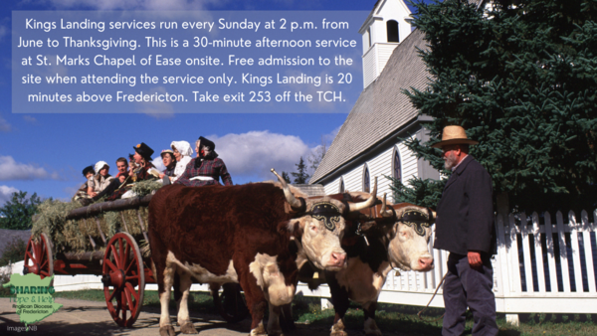
You are welcome to attend!
Kings Landing's weekly service

E - News wants subscriber
e-News is the best way to keep up to date on what is going
on in the diocese Click here to subscribe.

THE ANGLICAN JOURNAL AND THE NEW BRUNSWICK ANGLICAN: If you are not currently receiving the Anglican Journal and the New Brunswick Anglican and would like to, there are two ways to subscribe: 1. On-line at https://www.anglicanjournal.com/newsubscription/ checking off that you want the Diocesan paper called "Fredericton - New Brunswick Anglican" in the drop-down menu to accompany your subscription to the Anglican Journal, or 2. E-mail circulation@national.anglican.ca indicating that you would like to receive both the Anglican Journal and the New Brunswick Anglican. Include the name of your parish and the Diocese.

Please note that services begin at 2 p.m. this year to help everyone catch the final wagon back to the entrance.
Clerics and layreaders are encouraged to sign up for a Sunday service. Click here to sign up.
Contact the Rev. Canon Walter Williams for more information.

