ST. LUKE’S ANGLICAN CHURCH

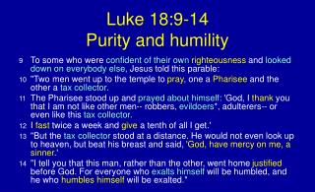

Sunday Communion Service

October 23, 2022, at 10:00 a.m.
The Rev. Robert Montgomery
Priest–in-Charge

rob.montgomery@anglican.nb.ca / (506) 608-1772

https://www.facebook.com/StLukesGP

Readings: Jeremiah 14: 7-10, 19-22 Psalm 84: 1-7

2 Timothy 4:6-8, 16-18 Luke 18: 9-14

St. Luke’s News

INTERCESSIONS:
- Anglican Communion: Province de L'Eglise Anglicane Du Congo, the Most Rev. Titre Ande Georges, Archbishop. Archbishop Linda Nicholls, Anglican Church of Canada.
- Missions: The Rev. Canon Paul Jeffries, Bishop McAllister College, in Uganda, fellow missionaries, teachers, volunteers. The Diocese of Ho, Companion Diocese of the Diocese of Fredericton.
- Fredericton, Archbishop David, retired bishops Claude and William, and their families, the Lemmon family. Camp Medley and Camp Brookwood, Threshold Ministries, The Anglican Diocese of Yukon: our retired clergy, and our fellow Anglicans: Westmorland, the Rev. Lidvald Haugen-Strand; Rothesay. the Rev. Paul Rideout: Gondola Point, the Rev. Rob Montgomery, and his family
- Gondola Point: Fellowship of Prayer Parish family: Barb McDermott and her family Parish Ministry: A.C.W. and stewardship.
- Community Needs: those without work, food, or shelter, and those who serve and care for them. Pray also for those who are travelling.
- Shut-Ins, especially if due to COVID-1.9.
- Sick: Alice, Barb, Bev, Catharine, Diane, Flora, Janet, Katie, Laverne, Loie, Peter, Paul, Peggy, Shawn, Wanda., James F, Travis B., Jack D., Natalie D., James F., Isaac D. , John E., Lisa G., Diane M., Calvin M., Kathy M., Malcolm M., Donna P., David S., Keaton S., Donna T., Wendy W., and any others we have been asked to include in our prays…
- Thanksgiving: Canada, New Brunswick, and political freedom.

We would like to thank the Rev. Rob Montgomery for his leadership and guidance. We appreciated everything he does for our parish. We would like to congratulate the Rev Montgomery for being nominated as the clergy representative for the Archdeaconry of Kingston and the Kennebecasis at the 138th Session of the Diocesan Synod of Fredericton and on the Diocesan Council.

We are collecting donations for the Saint John Community Christmas Exchange for the month of October 2022 until November 7, 2022. You will find small white envelopes marked Saint John Christmas Exchange on the back table. Thank you. The Saint John Community Christmas Exchange serves the areas of Browns Flat; Grand Bay - Westfield; Hampton; Quispamsis; Rothesay; St John County; Welsford; and Kingston Peninsula.
Parish Mission Outreach: For the next Sundays, we are collecting boxes of “Cheerios” Cereal for an Elementary School Breakfast Program. Non-name brand is acceptable if there are no nuts (peanuts, peanut oil) in the ingredients or facilities in which they are made. Again, we will collect them at the church and then deliver them to the school.

St. Luke’s A.C.W meets every Monday at 10:00 am all are welcome.

The Rev. Montgomery’s Online Bible Study is on Tuesday’s at 3:30 p.m.

The Rev. Rob Montgomery invited everyone to our Midweek Contemplative Services in the church on Wednesday evenings, from 6:30-7PM.

Upcoming Activities and Events at St. Luke’s:

Oct. 25/22 St. Luke’s ACW ‘s Soup Luncheon Takeout.
12 Quispamsis Road. Menu: hamburger soup, biscuit, and dessert. Tickets $10 each. For Tickets call 847-4105
Time 12 -1 pm.

November 5, 2022, 138th Session of the Diocesan Synod of Fredericton at Christ Church Cathedral, Fredericton
8:00am Registration Opens | 8:50 am Synod Convenes - 4:00 pm Adjournment
https://nb.anglican.ca/synod/sessions/pages/138th-session-2022

Nov. 19/22 St. Luke’s Christmas Bazaar at the Parish Hall. Further details to come.

Nov. 26/22 Seafarers’ Mission -St. Luke’s will be collecting boxes for the Seafarers’ Mission on Sunday, November 26, 2022, wrapped in white paper.
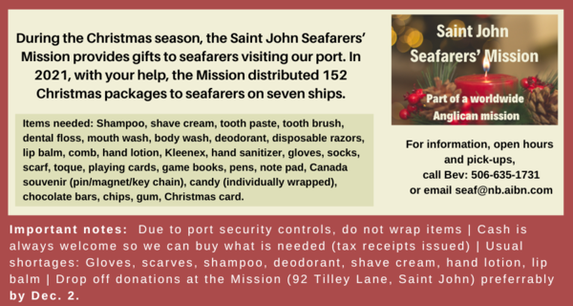

OTHERS:

December 3/ 22 St. Paul’s Rothesay, after 2 years, St. Paul’s, (4 Church Ave., Rothesay) is bringing back their famous Christmas Bazaar fundraiser. Come and celebrate the beginning of the season with us on Saturday, Dec. 3 from 9 a.m. until noon. We will again have Santa’s Café to enjoy and then shop at our Christmas Table and Bake Table.
We will also have Jewelry, Books, Music, Movies, Toys, Board Games and Puzzles. We are selling a fewer variety of items to give more room for browsing. Hope you and your family and friends will join us.

December 23/22 Spencer Belyea will be conducting Handel’s MESSIAH at Trinity Church, Saint John on December 23rd with the Symphony Chorus, operatic soloists and chamber orchestra. The Symphony Chorus will soon be looking for Patrons and Supporters to assist in mounting this professional production. The first Messiah Symphony Chorus REHEARSAL is today (Oct.23) 2:30 pm at Trinity, 115 Charlotte St. Good music readers/learners are most welcome!

Mission Visionary Group – Meet monthly for guidance and direction of out missionary outreach of the Parish. Further details please contact the Rev. Rob Montgomery.

Quarters for A Kilometer: We will be collecting quarters ($0.25) for the distance of a kilometer for the Church Restoration Fund. There will be a container at the back table for the quarters.

Work on our Building Restoration Project is complete. St. Luke’s is in the process of raising funds for re- investments funds used for the Restoration repairs of St. Luke’s Anglican Church. White envelopes for this are on the entry table. If you have any questions, please speak with Rev. Rob Montgomery, Rosemarie Kingston, or Terry Sleep.

Safe Church Trainer and Renewals: Please note a new online safe church training platform has been developed to allow the Diocese to better track who has taken the training, as well as working to make the training more relevant, accessible, and simple to complete. The new training should take 30-45 minutes and the Diocese would appreciate all feedback that you can provide on the entire process to ensure this is the ideal system to roll out to the diocese. Please contact Donna Dobbin for your training, thank you.

We are collecting refundable items from the parish for the Restoration Fund for the Church. If you have any you would like picked up, you may call Terry and Susan Sleep at 847-7609, or Darryl.

On this website is also St. Luke's Blog, posting of our Orders of Service and Sermons for Sundays, as well as other resources for us from time to time. Feel free to explore and spread the news if you can.

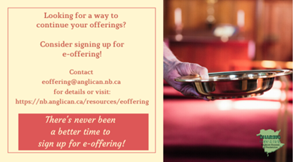
We must continue to meet our monthly expenses while we are unable to come to our church to meet at times for worship and fellowship. Since all worship services, meetings, and events at our church placed are on hold at times, and our bulletin has changed. As the situation changes, activities will begin to be re-scheduled. Please contact Terry Sleep at 847-7609. He is our Parish E-offering Representative or by mail to St. Luke’s Anglican Church, 12 Quispamsis Road, Quispamsis, New Brunswick, E2E 1M2 or e-transfer. Please contact Terry Sleep at 847-7609 for further information or instructions, thank you.

Many of you received the e-news from Gisele McKnight, Diocesan Communications Officer. It contains messages from the archbishop concerning the coronavirus and the resulting procedural changes and cancellations that have been put in place. Bishop David’s message contains links to his earlier messages on the coronavirus, as well as to prayers, on-line worship services and the Book of
Common Prayer. If you did not receive e-news, it may be found at https://nb.anglican.ca/newsletters/102/display A call to prayer has been issued and details may be found in e-news. As well, you can keep up with Diocesan events at https://nb.anglican.ca/

E - News wants subscriber
e-News is the best way to keep up to date on what is going on in the diocese
Click here to subscribe.

THE ANGLICAN JOURNAL AND THE NEW BRUNSWICK ANGLICAN: If you are not currently receiving the Anglican Journal and the New Brunswick Anglican and would like to, there are two ways to subscribe: 1. On-line at https://www.anglicanjournal.com/newsubscription/ checking off that you want the Diocesan paper called "Fredericton - New Brunswick Anglican" in the drop-down menu to accompany your subscription to the Anglican Journal, or 2. E-mail circulation@national.anglican.ca indicating that you would like to receive both the Anglican Journal and the New Brunswick Anglican. Include the name of your parish and the Diocese.

Donations for Ukraine relief
Donate via PWRDF
PWRDF is supporting Ukrainians forced to flee their homes due to the
Russian invasion. The initial grant of $20,000 issued to an ACT Alliance appeal has been increased to $50,000. The grants will fund the work of
Action by Churches Together (ACT) member Hungarian Interchurch Aid
(HIA).
On Feb. 27, HIA set up a 24-hour refugee support point on the Hungarian
side of the border at Beregsurány, where the line of refugees trying to cross into Hungary is kilometres long, says an ACT communiqué. HIA is providing hot tea, sandwiches, refreshments, blankets, and basic hygiene items for Ukrainians, including many elderly and children who are waiting long hours
to cross the border into Hungary.
How you can help. To make a donation to this response online, click here
You may also donate by phone at 416-822-9083 or leave a voicemail
toll-free at 1-866-308-7973 and PWRDF will return your call; or mail your cheque to PWRDF, 80 Hayden, 3rd floor, Toronto, Ontario, M4Y 3G2.
Please mark Ukraine in the memo field.
apply to be part of Say Yes! To Kids and be on their way to making their projects a reality.
The first step is to take a webinar, which are being held throughout March

.

https://godlyplaymaritimes.com/

Humility Project
Diocesan vice-chancellor Kelly VanBuskirk is organizing a webinar on humility and has secured Justin Brierley of the Unbelievable? Podcast as the guest speaker.
Please share as you can.
To register: sarah@infopoweredsolutions.com
