ST. LUKE’S ANGLICAN Church

Remembrance Day Service

Book of Alternative Services -Morning Prayer

Sunday Service

November 7, 2021, at 10:00 a.m.
The Rev. Robert Montgomery
Priest–in-Charge
rob.montgomery@anglican.nb.ca / (506) 608-1772

Facebook: https://www.facebook.com/StLukesGP
Website: http://www.stlukesgp.ca

Readings: Micah 4: 1-5 Psalm 46

Romans 8: 31-39 John 20: 19-22

Honour Roll

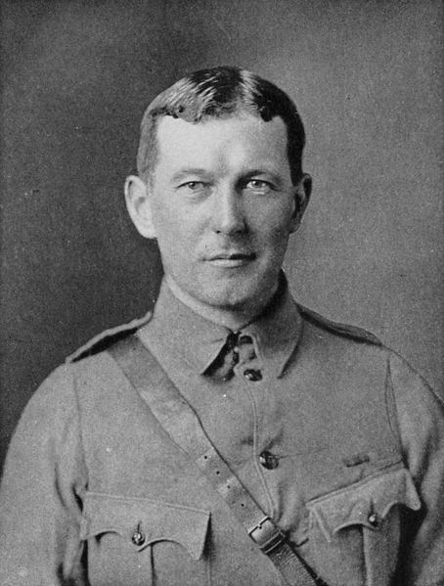

We continue to remember our Veterans of W.W. I, W.W. II, Korea, and Afghanistan for those who served our country to allow us the freedoms we enjoy. We remember:
W.W. I W.W.II
Edward Kirkpatrick Lorenzo Carpenter Harold Roberts
Ernest Saunders* Albert Gorton Walter Roberts
Isaac Saunders Bruce Hamilton Edward Saunders*
Percy Saunders* Hugh Kirkpatrick Cecil Sleep
William Saunders John Lee Hugh Smith
Frederick Whitlock Gerald McCully Charles Smith
Allan Roberts Thomas Smith* Walter Whitlock
Guilford Roberts

paid the supreme sacrifice*

Peacekeepers: Those Presently Serving:
Eugene Legge John Legge
Christopher Saunders* Dustin Oliver
Christopher Sleep David McElman
Lisa McElman
Carol Tynski

And for any we may have missed and for all those
who are presently serving in the armed forces.
We also remember and prayer for their families at home & abroad.

St. Luke’s News

INTERCESSIONS:
- Anglican Communion: The Anglican Church in Aotearoa, New Zealand, and Polynesia. Council of the North, Diocese of Caledonia, Bishop David Lehmann, the people, and clergy.
- Bishop McAllister College, in Uganda, fellow missionaries, teachers, volunteers. The Diocese of Ho, Companion Diocese of the Diocese of Fredericton
- Fredericton, Archbishop David Edwards, retired Bishops Claude, William and George, and their families. Camp Medley and Camp Brookwood, Threshold Ministries, The Anglican Diocese of Yukon: our retired clergy, and our fellow Anglicans: St. David and St. Patrick, the Ven. John Matheson; Quispamsis, the Rev. Michael O’Hara; Gondola Point, the Rev. Rob Montgomery, and his family
- Gondola Point: Parish Breakfasts Parish family: Charles, Vicki, Bobae, and Elijah Lee Parish Ministry: event convening committee and stewardship.
- Community Needs: those without work, food, or shelter, and those who serve and care for them. Pray also for those who are travelling.
- Shut-Ins, especially if due to COVID-19.
- Sick: Flora, Katie, Lori, Shawn, Wanda., James F, Travis B., Jack D., James F., Isaac D. Doreen E., John E., Lisa G., Sheila H., Calvin M., Malcolm M., David S., Keaton S., John W., Wendy W., and any others we have been asked to include in our prays…
- Thanksgiving: Health and our Health Care System

Work continues on our Building Restoration Project and will continue throughout this Fall. Stay tuned for more updates on our Building Restoration Project progress and funds raised towards it so far.

Restoration of St. Luke’s Anglican Church:

Funds needed: $ 62,500.00. Funds on hand: $ 20,603.22

Parish Mission Outreach: For the next few Sundays, we are collecting boxes of “Cheerios” Cereal for an Elementary School Breakfast Program. Non-name brand is acceptable if there are no nuts (peanuts, peanut oil) in the ingredients or facilities in which they are made. Again, we will collect them at the church and then deliver them to the school.

Quarters for A Kilometer: We will be collecting quarters ($0.25) for the distance of a kilometer for the Church Restoration Fund. There will be a container at the back table for the quarters.

Safe Church Trainer and Renewals: Please note a new online safe church training platform has been developed to allow the Diocese to better track who has taken the training, as well as working to make the training more relevant, accessible, and simple to complete. The new training should take roughly 30-45 minutes and the Diocese would appreciate all feedback that you can provide on the entire process to ensure this is the ideal system to roll out to the diocese. Please contact Donna Dobbin for your training, thank you.

Upcoming Events:

Nov. 7/21 Sounds for Sigowet benefit concert
Sunday, Nov. 7, 2:30 p.m. 13th annual Sounds for Sigowet benefit concert and silent auction at St. Paul’s Anglican Church, Rothesay, featuring John Buckley on cello, Chris Buckley on viola, Danielle Sametz on violin and Carlos Avila on oboe. Tickets are $20 for adults, $10 for students. Limited seating; call 847-1812 or 849-2414 for tickets.
To attend by live stream, visit www.stpaulsonthecommon.com/sigowet for details.
Silent auction information is also found on the website.

Nov. 20/21 PORK LOIN TAKE-OUT SUPPER: St. Augustine’s will be having a pork loin take-out supper on Sat Nov 20th. Also on the menu will be potatoes, peas, carrots, gravy, roll and carrot cake for dessert. Cost is $15 per person. Please call Art Scott at 849-2430 for tickets

Nov. 23/21 Ham and Corn Chowder lunch at ST. LUKE’S ANGLICAN CHURCH, St. Luke's Parish Hall, 12 Quispamsis Road, Quispamsis.; tickets must be paid for in advance. Do not delay - only 100 tickets will be sold! Pick-up is from 11:30 to 12:30. For more information or tickets please call 849-9551.

Saint John Seafarers’ Mission – Christmas 2021
During the Christmas season, the Saint John Seafarers’ Mission provides gifts — necessities and a little extra — to seafarers far from home visiting our port.
In 2020, with help from many groups and individuals, the Mission distributed 146 Christmas packages to 7 ships.
Ideas for giving:
Toiletries: shampoo, shave cream, tooth paste, tooth brush, dental floss, mouth wash, body wash, deodorant, disposable razors, lip balm, comb, hand lotion, Kleenex
Warm Items: gloves, socks, scarf, toque
Something Extra: playing cards, game book, pen, Canada souvenir (pin/magnet/key chain), candy (individually wrapped), chocolate bars, chips, gum, Christmas card
Note: We generally have a shortage of gloves, scarves, shampoo, deodorant, shave cream, hand lotion, lip balm.
Note: Please do not wrap anything due to port security controls.
Ways to give: You can fill a gift bag (10 1/2” (h), 8 3/4” (w) and 4 1/2” (d)); give some items listed above; or make a donation (tax receipts issued).
Drop off at the Mission (92 Tilley Lane, Saint John) by Dec. 3, but
late donations are gratefully accepted. To ensure the Mission is open or if you need someone to pick up your items, please contact Bev at 506-635-1731 or email seaf@nb.aibn.com .

PWRDF's 2021 World of Gifts
The 2021 World of Gifts is officially here. This year's guide will bring new opportunities and hope for communities across the world as our PWRDF partners strive to build a truly just, healthy and peaceful world.
Click here to start shopping our secure, online guide today!
There are lots of ways to order! Copies of the World of Gifts Guide are included in issues of the Anglican Journal. You can also download the PDF version by clicking here.
Prefer to speak with us? Give us a call toll-free at 1-877- 936-9199, between 9 a.m. and 5 p.m. EST and make your order over the phone
Mission Visionary Group - Further details to follow by speaking to the Rev. Rob Montgomery.
St. Luke’s A.C.W. will be on holding their meeting on Monday in the hall starting at 10:00 a.m.,

The Rev. Montgomery leads St. Luke’s Parish Bible Study online on Tuesdays at 3:00 pm. Please contact Rev. Rob for further instructions.

We are collecting refundable items from the parish for the Restoration Fund for the Church. If you have any you would like picked up, you may call Terry and Susan Sleep at 847-7609, or Darryl.

On this website is also St. Luke's Blog, posting of our Orders of Service and Sermons for Sundays, as well as other resources for us from time to time. Feel free to explore and spread the news if you can.

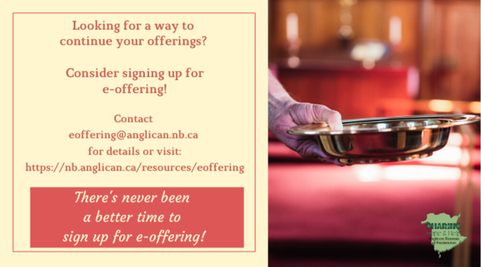
We must continue to meet our monthly expenses too while we are unable to come to our church to meet at times for worship and fellowship. Since all worship services, meetings, and events at our church has been put on hold at times, for the time being, our bulletin has changed. As the situation changes, activities will begin to be re-schedule. Please contact Terry Sleep at 847-7609. He is our Parish E-offering Representative or by mail to St. Luke’s Anglican Church, 12 Quispamsis Road, Quispamsis, New Brunswick, E2E 1M2 or e-transfer. Please contact Terry Sleep at 847-7609 for further information or instructions, thank you.

St. Luke’s is in the process of raising Funds for Restoration repairs of St. Luke’s Anglican Church with the matching of fund coming from a grant we have applied for from the Federal Government. White envelopes for this may be found on the entry table. If you have any questions, please speak with Rev. Rob Montgomery, Rosemarie Kingston, or Terry Sleep. They can help you.

Many of you received the e-news from Gisele McKnight, Diocesan Communications Officer. It contains messages from the Bishop concerning the coronavirus and the resulting procedural changes and cancellations that have been put in place. Bishop David’s message contains links to his earlier messages on the coronavirus, as well as to prayers, on-line worship services and the Book of
Common Prayer. If you did not receive e-news, it may be found at https://nb.anglican.ca/newsletters/102/display A call to prayer has been issued and details may be found in e-news. As well, you can keep up with Diocesan events at https://nb.anglican.ca/

WOODWORKING GROUP: The woodworking group at St. Augustine’s is on-going most days of the week. They welcome new ideas for seasonal craft projects. Please contact Kevin Tupper for more information or if you are interested in joining.

Trinity Church Columbarium the Trinity Columbarium is located inside the Germaine Street entrance at Trinity Anglican Church in Saint John, NB. This beautiful, historical church provides a place of remembrance for families wanting that connection with the church. There are various niche sizes (individual, couples, and family) available for purchase. Inquiries can be directed to the Trinity Parish office at (506) 693-8558 or email: trinsj@nb.aibn.com

E - News wants subscriber
e-News is the best way to keep up to date on what is going
on in the diocese Click here to subscribe.

THE ANGLICAN JOURNAL AND THE NEW BRUNSWICK ANGLICAN: If you are not currently receiving the Anglican Journal and the New Brunswick Anglican and would like to, there are two ways to subscribe: 1. On-line at https://www.anglicanjournal.com/newsubscription/ checking off that you want the Diocesan paper called "Fredericton - New Brunswick Anglican" in the drop-down menu to accompany your subscription to the Anglican Journal, or 2. E-mail circulation@national.anglican.ca indicating that you would like to receive both the Anglican Journal and the New Brunswick Anglican. Include the name of your parish and the Diocese.

In Flanders Fields
BY JOHN MCCRAE
In Flanders fields the poppies blow
Between the crosses, row on row,
That mark our place; and in the sky
The larks, still bravely singing, fly
Scarce heard amid the guns below.

We are the Dead. Short days ago
We lived, felt dawn, saw sunset glow,
Loved and were loved, and now we lie,
In Flanders fields.

Take up our quarrel with the foe:
To you from failing hands we throw
The torch; be yours to hold it high.
If ye break faith with us who die
We shall not sleep, though poppies grow
In Flanders fields.

