ST. LUKE’S ANGLICAN CHURCH

4th Sunday In Lent

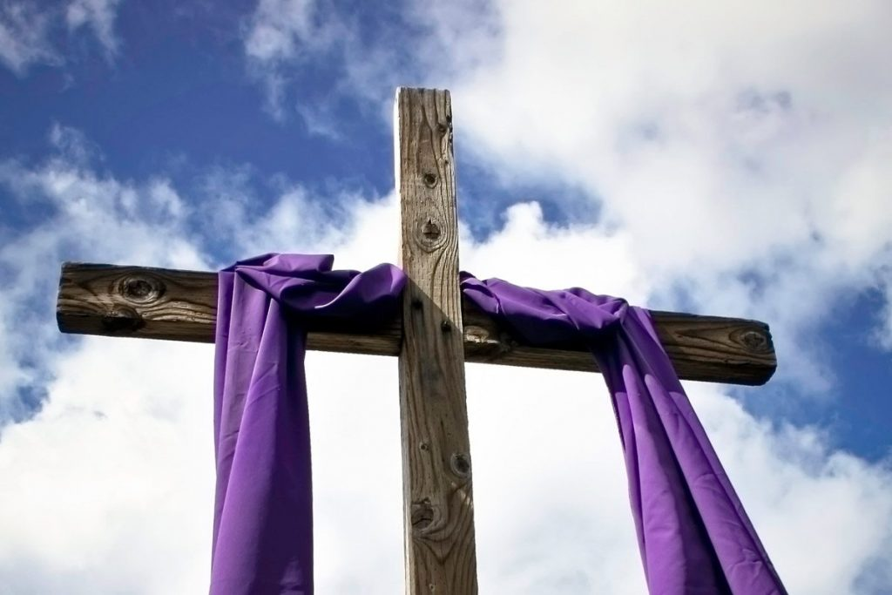

Sunday Morning Service

March 14, 2021 at 10:00 a.m.

The Rev. Robert Montgomery
Priest–in-Charge
rob.montgomery@anglican.nb.ca / (506) 608-1772
https://www.facebook.com/StLukesGP

Readings: Numbers 21:4-9 Psalm 107:1-3, 17-22
Ephesians 2:1-10 John 3:14-21

St. Luke’s News

INTERCESSIONS:
- Anglican Communion: Iglesia Anglicana de Chile. Archbishop Linda Nicholls, Anglican Church of Canada. Diocese of Central Newfoundland, Bishop John Watton.
- Bishop McAllister College, in Uganda, fellow missionaries, teachers, volunteers. The Diocese of Ho, Companion Diocese of the Diocese of Fredericton
- Fredericton, Archbishop David Edwards, retired Bishops Claude, William and George, and their families. Camp Medley and Camp Brookwood, Threshold Ministries, The Anglican Diocese of Yukon: our retired clergy, and our fellow Anglicans: Westmorland, the Rev. Lidvald Haugen-Strand; Upham, The Ven, Rob Marsh; Gondola Point, the Rev. Rob Montgomery
- Gondola Point: Meals on Wheels Parish family: Rick and Donna Kelly and their family Parish Ministry: hall booking agent and stewardship.
- Community Needs: those without work, food, or shelter, and those who serve and care for them. Pray also for those who are travelling.
- Shut-Ins especially if due to COVID-19.
- Sick: Flora, Katie, Lori, Melissa, Shawn, Wanda., Travis B., Winnie C., Jack D. Isaac D. Doreen E., John E., Lisa G., Calvin M., Malcolm M., Sterling M., Eleri P., Emilie P., David S., Keaton S., John W., and any others we have been asked for prays…
- Thanksgiving: Beauty and Wonder of Creation.

Soon we will be staring the Restoration of St. Luke’s

Restoration Fund: $ 11,003.89 Funds needed: $ 62,500.00.
Parish Mission Outreach: For the next few Sundays, we are collecting boxes of “Cheerios” Cereal for an Elementary School Breakfast Program. Non-name brand is acceptable if there are no nuts (peanuts, peanut oil) in the ingredients or facilities they are made in. Again, we will collect them at the church and then deliver them to the school.

March 27/21 St. Luke’s A.C.W. Seafood Chowder Lunch Take-Out at 12 noon Call Heather Hynds for tickets at 847-4105. Tickets Limited.

Please find attached a ½ page flyer with a request from Archbishop David for your help in completing our fundraising for the Diocese of Ho Mobile Clinic project.
To recap the project budget:
- Project cost: $268,000
- Grants and matching funds from various levels of Rotary Int.: $188,460
- Donated by parishes, parish groups and individuals to the Diocesan Synod: $63,540
- Remaining to be raised: $16,000.

We are collecting refundable items from the parish for the Restoration Fund for the Church. If you have any you would like picked up, you may call Terry and Susan Sleep at 847-7609, or Darryl.

St. Luke’s A.C.W. will be holding their meeting on Monday in the hall starting at 10:00 a.m.,

The Rev. Montgomery will be holding St. Luke’s Parish Bible Study on Tuesday, virtually. Please contact Rev. Rob for further instructions.

Trinity Church Columbarium the Trinity Columbarium is located inside the Germaine Street entrance at Trinity Anglican Church in Saint John, NB. This beautiful, historical church provides a place of remembrance for families wanting that connection with the church. There are various niche sizes (individual, couples, and family) available for purchase. Inquiries can be directed to the Trinity Parish office at (506) 693-8558 or email: trinsj@nb.aibn.com

On this website is also St. Luke's Blog, posting of our Orders of Service and Sermons for Sundays, as well as other resources for us from time to time. Feel free to explore and spread the news if you can.

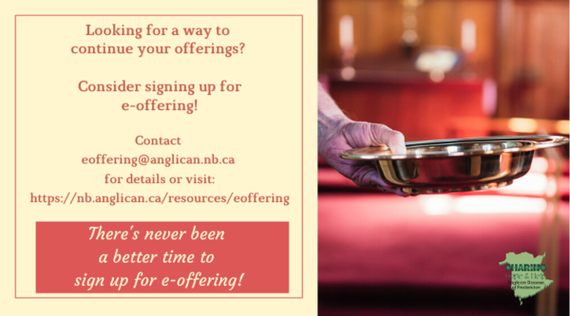
We must continue to meet our monthly expenses too while we are unable to come to our church to meet for worship and fellowship. Since all worship services, meetings and events at our church has been put on hold for the time being, our bulletin has changed. As the situation changes, activities will begin to be re-schedule. Please contact Terry Sleep at 847-7609. He is our Parish E-offering Representative or by mail to St. Luke’s Anglican Church, 12 Quispamsis Road, Quispamsis, New Brunswick, E2E 1M2 or e-transfer. Please contact Terry Sleep at 847-7609 for further information or instructions, thank you.

St. Luke’s is in the process of raising Funds for Restoration repairs of St. Luke’s Anglican Church with the matching of fund coming from a grant we have applied for from the Federal Government. White envelopes for this may be found on the entry table. If you have any questions, please speak with Rev. Rob Montgomery, Rosemarie Kingston, or Terry Sleep. They can help you.

Many of you received the e-news from Gisele McKnight, Diocesan Communications Officer. It contains messages from the Bishop concerning the coronavirus and the resulting procedural changes and cancellations that have been put in place. Bishop David’s message contains links to his earlier messages on the coronavirus, as well as to prayers, on-line worship services and the Book of
Common Prayer. If you did not receive e-news, it may be found at https://nb.anglican.ca/newsletters/102/display A call to prayer has been issued and details may be found in e-news. As well, you can keep up with Diocesan events at https://nb.anglican.ca/
E - News wants subscriber
e-News is the best way to keep up to date on what is going
on in the diocese Click here to subscribe.

Town of Quispamsis
Phone 506-849-5778 Fax 506-849-5799

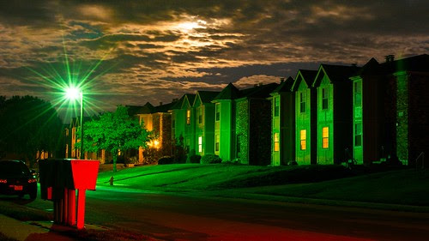

Celebrate St. Patrick's Day!
Two unique week-long events for you to enjoy:
An Emerald Town – LIGHTS and more LIGHTS! Would you like to win a super St. Patrick’s Day prize bag? If so, decorate your Quispamsis home, property or business with green lighting and email your property address to mlucas@quispamsis.ca. You will then be entered in the random draw to win some costume attire, treats and a $100 gift card for some delicious Irish food. Register (FREE) anytime from now until midnight on March 14th. No display is too big or too small. So give those green Christmas lights another use, pop in a green light bulb, reflect white lights off a green background, etc. to create a green night-time display. Displays are to be available for viewing through March 17th. www.facebook.com for more details.
St. Patrick’s Days Parade – Decorate your vehicle, get dressed in green, join friends/family in your bubble and take an evening drive along Randy Jones Way in Quispamsis from March 8th through 17th. There is some twinkling green along the way and a sweet wee spot to visit to take a quick night-time selfie! The lights will be on each evening until 10pm. Visitors must wear facemasks and follow all Public Health instructions. www.facebook.com for more details.

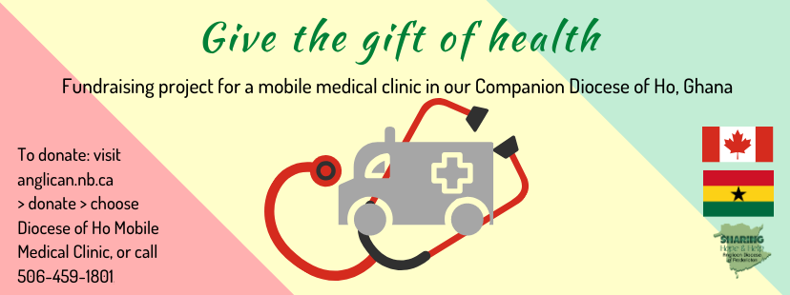

As reported in last week’s eNews the project to provide a mobile medical clinic in the Diocese of Ho has received matching funding from various levels of Rotary, which means that we are now only $16,000 short of the target of $268,000 (with $188,800 from Rotary). It is exciting news and I want to thank everyone in the Diocese who has contributed towards this outcome, especially the Companion Diocese Committee led by Robbie Griffin from Grand Manan.
We now come to the final push, so that we can access the pledged funds and place the vehicle order with Malley Industries of Moncton. The plan is to have the clinic operating in Ghana by the end of the year. My request to individuals and vestries is that we give to get this ball over the line. Diocesan Council pledged $5,000 at its meeting on Saturday.
If by God’s grace and our commitment we exceed the necessary amount that is all to the good. We will be able to provide more equipment and consumables for the clinic.
The aim of the Diocese of Ho, working with partners locally and from here, is to provide medical care for people in the rural areas of the Volta Region. The vehicle will be staffed by medical students and doctors from the regional hospital. In addition, specialists will travel when necessary. It has also been agreed that a member of the clergy will accompany the clinic to provide counsel as needed.
Gifts from vestries and individuals should be sent to Synod Office marked for the Ho Medical Clinic. Donations can also be made online at nb.anglican.ca/donate

