St. Luke’s Anglican Church

Trinity Sunday
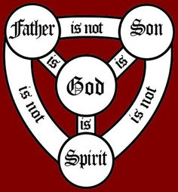

June 7, 2020

At 9:30 a.m. & 11:00 a.m.
The Rev. Rob Montgomery
Priest-In-Charge
Parish of Gondola Point in Quispamsis, N.B.
rob.montgomery@anglican.nb.ca / 506-608-1772
https://www.facebook.com/StLukesGP
Parish Telephone: (506) 847-3670

Reading: Genesis 1:1-2:4a Psalm 8

2 Corinthians 13:11-13 Matthew 28:16-20

St. Luke’s News

INTERCESSIONS:
- Anglican Communion: La Iglesia Anglicana de Mexico, the Most Rev. Francisco Moreno, Presiding Bishop
- Missions: The Rev. Canon Paul Jeffries, Bishop McAllister College, in Uganda, fellow missionaries, teachers, volunteers. The Diocese of Ho, Companion Diocese of the Diocese of Fredericton.
- Fredericton, Bishop David Edwards, retired Bishops Claude, William and George, and their families. Camp Medley and Camp Brookwood, Threshold Ministries, The Anglican Diocese of Yukon: our retired clergy, and our fellow Anglicans: Pennfield, the Rev. Caleb Twinamatsiko; Renforth, The Rev. Jonathan Hallewell; Gondola Point, the Rev. Rob Montgomery
- Gondola Point: Meals on Wheels Parish family: and he family Parish Ministry: hall booking agent and stewardship.
- Community Needs: those without work, food, or shelter, and those who serve and care for them. Pray also for those who are travelling.
- Sick: Clare, Diane, Flora, Katie, Melissa, Nicola, Shawn, Wanda., Caroline B., Travis B., ,Winnie C., Jack D., John D., Sarah D., Doreen E., John E., Rebecca K., Susan L., Barb M., Karen M., Audrey M. Calvin M., Malcom M., Alice P., Eleri P., Emilie P., Paul P., David S., Keaton S., Robert W. and any others we have been asked for prays…
- Thanksgiving: Beauty and Wonder of Creation.

Please contacted Rev. Montgomery to sign up for our two services next week at 9:30 a.m. or 11:00 a.m. He would encourage you to do so in preparation for our services on June 7/2020. Please see the detail on our website, https://www.facebook.com/StLukesGP or you may contact him by email at rob.montgomery@anglican.nb.ca

As of April 2020 income: Bank balance: $ 8,824.48

April 2020 Receipts: $ 2,843.33 Expenses: $ 4,053.52
difference ($1,210.19) Restoration Fund $ 2,397.88

Thank you to everyone who donated their items to St. Luke’s, bottle drive collection at the Parish Hall Friday. We are still interested in receiving further donations at anytime or they may be picked up, please call Susan Sleep at 847-7609.

June 10/202/20 Wednesday is our next vestry meeting at the hall at 7:00 p.m. If you are not able to attend please send regrets to Rev. Rob Montgomery, the Wardens, or our vestry clerk.

Our Parish Bible Study is taking place online (Zoom) every Tuesday at 3 PM. For more info, please contact Rev. Rob Montgomery.

We have launched our new Parish Website, and you can check it out at www.stlukesgp.ca

On this website is also St. Luke's Blog, posting of our Orders of Service and Sermons for Sundays, as well as other resources for us from time to time. Feel free to explore and spread the news if you can.

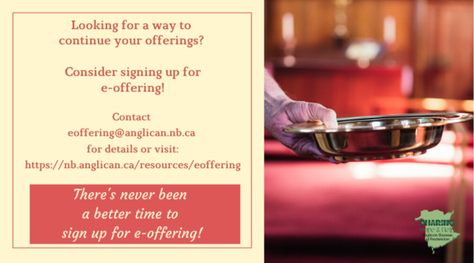
We must continue to meet our monthly expenses too while we are unable to come to our church to meet for worship and fellowship. Since all worship services, meetings and events at our church has been put on hold for the time being, our bulletin has changed. As the situation changes, activities will begin to be re-scheduled.
Please contact Terry Sleep at 847-7609. He is our Parish E-offering Representative or by mail to St. Luke’s Anglican Church, 12 Quispamsis Road, Quispamsis, New Brunswick, E2E 1M2 or e-transfer. Please contact Terry Sleep at 847-7609 for further information or instructions, thank you.

Thank You Letters to the Frontline Workers:
During these unparalleled, and honestly scary times, most of us have a social responsibility to help stop the spread of COVID-19 by staying home and staying safe; but not everyone. Doctors, nurses, and other medical staff, as well as police, firefighters, grocery store employees, postal/delivery workers, gas station attendants, public transportation workers, mental health and social services workers, farmers, and countless other “essential workers” are putting themselves in harm’s way daily so the rest of us can stay safe. We want to thank you for all the hard work you are doing to keep our community safe during this time. Thank you for being so dedicated, courageous and selfless as we continue to work together to overcome this challenge we are currently facing. We are all trying to do our part by staying at home. You are inspiring us to take care of our community, and in the future, we will continue to take care of it. Your efforts, sacrifices, commitment, and leadership during these uncertain times is greatly appreciated! We are all in this together. Thank you again!

St. Luke’s is in the process of raising Funds for Restoration repairs of St. Luke’s Anglican Church with the matching of fund coming from a grant we have applied for from the Federal Government. White envelopes for this may be found on the entry table. If you have any questions, please speak with Rev. Rob Montgomery, Rosemarie Kingston or Terry Sleep. We how you can help.

-Old eyeglasses are being collected in a box on the table at the back of the church when we return

The Parish Development Officer and Council Spiritual Development Team, on behalf of Bishop David, are coordinating some diocesan-wide initiatives to recognize this time. We ask you to share these with your parishioners.

We certainly also encourage you in any parish or church events you are planning - and would be happy to publicize these on our diocesan event page.

Links to join and for resources are being added here: https://nb.anglican.ca/events/thy-kingdom-come

Shawn offers a video summary of all of this at: https://youtu.be/qCTgUSaIS-0

1. Video Testimonies
Jesus talking with the disciples asked, “Who do you say that I am?” (Matthew 16) That’s a great and important question! Who do you say Jesus is? We’re inviting you to share your response to this question. Record a 2-minute video and post it to your social media, tagging it with #ThyKingdomCome #NBAnglicans .

2. 24-7 Prayer Vigil
Everyone is invited to sign up for one or more 1-hour time slots and pray in their own space for God's Kingdom to come, for their church, and for family, friends and neighbours. Prayer guidelines will be available.
Daily Morning and Evening Prayer Offices using the Thy Kingdom Come prayer booklet (text will be provided) at 8:00 am and 6:00 pm (temporarily replacing the Litany@6)

Listening ear and prayer line
Click here for your link to the prayer line.

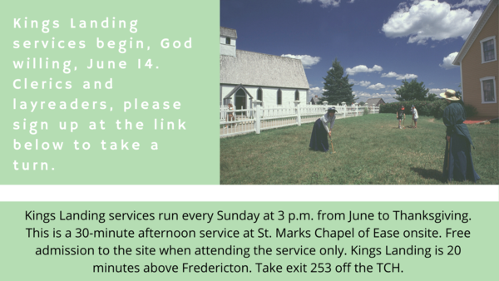

Kings Landing Summer Services
Sign up to take a turn at this link.

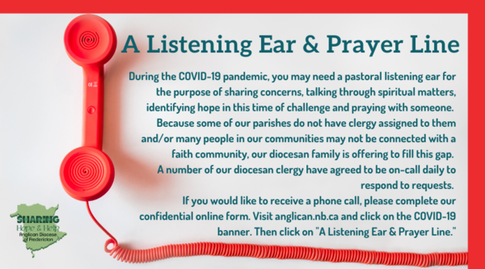
Many of you received the e-news from Gisele McKnight, Diocesan Communications Officer. It contains messages from the Bishop concerning the coronavirus and the resulting procedural changes and cancellations that have been put in place. Bishop David’s message contains links to his earlier messages on the coronavirus, as well as to prayers, on-line worship services and the Book of Common Prayer. If you did not receive e-news, it may be found at https://nb.anglican.ca/newsletters/102/display A call to prayer has been issued and details may be found in e-news. As well, you can keep up with Diocesan events at https://nb.anglican.ca/

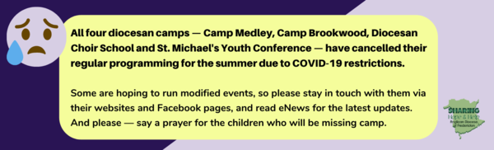

Camps cancelled
Keep in touch with your favourite summer camps using the links below.
St. Michael’s Youth Conference
https://smyc.ca/
https://www.facebook.com/SMYCAtlantic/
Diocesan Choir School
http://www.anglicanchoirschool.com/
https://www.facebook.com/groups/121354914558579/
Camp Brookwood
http://www.campbrookwood.ca/
camp.brookwood@outlook.com
http://campmedley.ca/
https://www.facebook.com/camp.medley/

