ST. LUKE’S ANGLICAN CHURCH
Sunday Service with Holy Communion
January 17, 2021 at 10:00 a.m.

The Rev. Robert Montgomery
Priest–in-Charge
rob.montgomery@anglican.nb.ca / (506) 608-1772
https://www.facebook.com/StLukesGP

Mrs. Caroline Britten Mrs. Susan Sleep Organist and Choir Director Sunday School Director

Readings: 1 Samuel 3:1-10, (11-20) Psalm 139:1-6, 13-18
1 Corinthians 6:12-20 John 1:43-51

St. Luke’s News

INTERCESSIONS:
- Anglican Communion: The Anglican Church of Australia. Archbishop Linda Nicholls
- Missions: The Rev. Canon Paul Jeffries, Bishop McAllister College, in Uganda, fellow missionaries, teachers, volunteers. The Diocese of Ho, Companion Diocese of the Diocese of Fredericton
- Fredericton, Archbishop David Edwards, retired Bishops Claude, William and George, and their families. Camp Medley and Camp Brookwood, Threshold Ministries, The Anglican Diocese of Yukon: our retired clergy, and our fellow Anglicans: Fundy and the Lakes, the Rev. Canon Leo Martin Fredericton; Sussex, the Rev. Tom Stradwick; Gondola Point, the Rev. Rob Montgomery
- Gondola Point: Christmas Family Support Parish family: Donnie and Caroline Britten and their family Parish Ministry: envelope secretary and stewardship.
- Community Needs: those without work, food, or shelter, and those who serve and care for them. Pray also for those who are travelling.
- Shut Ins due to COVID-19
- Sick: Flora, Katie, Lori, Melissa, Shawn, Wanda., Travis B., Jack D. Isaac D. Doreen E., John E., Lisa G., Calvin M., Eleri P., Emilie P., David S., Keaton S., and any others we have been asked for prays…
- Thanksgiving: Police, Firefighters, Teachers, Public Servants.

Welcome to everyone who is attending St. Luke’s Sunday Morning Service this today virtually.

We are collecting refundable items from the parish for the Restoration Fund for the Church. If you have any you would like picked up, you may call Terry and Susan Sleep at 847-7609.

St. Luke’s A.C.W. will be on hold on Monday in the hall until after the Orange level has been returned to yellow.

Rev. Montgomery will be putting on St. Luke’s Parish Bible Study on Tuesday, virtually. Please contact Rev. Rob for further instructions.

The Nominating Committee are looking for nominations of 1- 2-year term for warden; and 3- 3-year terms for vestry. We also require 3 synod delegates and 3 alternate synod delegates and 1 convening committee member. Rosemarie Kingston, Joyce McElman, Donna Dobbin, Bob Perry, and Craig McDermott are members of The Nominating Committee.

January 31/21 will be our Annual General Meeting, rescheduling date of February 7, 2021 if needed, and all reports are asked to be sent to Wendy Wilson by January 15, 2021.

Parish Mission Outreach: For the next 2 Sundays, we are collecting boxes of “Cheerios” Cereal for a School Breakfast Program. Non-name brand is acceptable if there are no nuts (peanuts, peanut oil) in the ingredients or facilities they are made in. Again, we will collect them at the church and then deliver them to the school.

Trinity Church Columbarium the Trinity Columbarium is located inside the Germaine Street entrance at Trinity Anglican Church in Saint John, NB. This beautiful, historical church provides a place of remembrance for families wanting that connection with the church. There are various niche sizes (individual, couples, and family) available for purchase. Inquiries can be directed to the Trinity Parish office at (506) 693-8558 or email: trinsj@nb.aibn.com

On this website is also St. Luke's Blog, posting of our Orders of Service and Sermons for Sundays, as well as other resources for us from time to time. Feel free to explore and spread the news if you can.

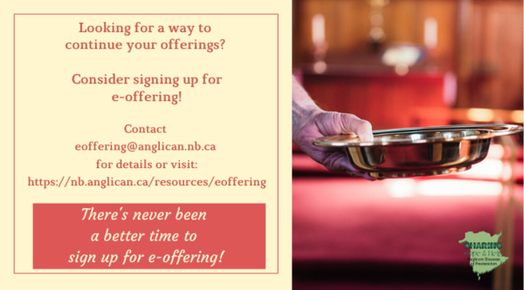
We must continue to meet our monthly expenses too while we are unable to come to our church to meet for worship and fellowship. Since all worship services, meetings and events at our church has been put on hold for the time being, our bulletin has changed. As the situation changes, activities will begin to be re-schedule. Please contact Terry Sleep at 847-7609. He is our Parish E-offering Representative or by mail to St. Luke’s Anglican Church, 12 Quispamsis Road, Quispamsis, New Brunswick, E2E 1M2 or e-transfer. Please contact Terry Sleep at 847-7609 for further information or instructions, thank you.

St. Luke’s is in the process of raising Funds for Restoration repairs of St. Luke’s Anglican Church with the matching of fund coming from a grant we have applied for from the Federal Government. White envelopes for this may be found on the entry table. If you have any questions, please speak with Rev. Rob Montgomery, Rosemarie Kingston, or Terry Sleep. They can help you.

Many of you received the e-news from Gisele McKnight, Diocesan Communications Officer. It contains messages from the Bishop concerning the coronavirus and the resulting procedural changes and cancellations that have been put in place. Bishop David’s message contains links to his earlier messages on the coronavirus, as well as to prayers, on-line worship services and the Book of
Common Prayer. If you did not receive e-news, it may be found at https://nb.anglican.ca/newsletters/102/display A call to prayer has been issued and details may be found in e-news. As well, you can keep up with Diocesan events at https://nb.anglican.ca/
E - News wants subscriber
e-News is the best way to keep up to date on what is going
on in the diocese Click here to subscribe.

