ST. LUKE’S ANGLICAN CHURCH

Christmas Day Service with Holy Communion

“The Book of Common Prayer
December 25, 2021, at 11:00 a.m.

The Rev. Robert Montgomery
Priest–in-Charge
rob.montgomery@anglican.nb.ca / (506) 608-1772
https://www.facebook.com/StLukesGP

Mrs. Caroline Britten Mrs. Susan Sleep Organist and Choir Director Sunday School Director

118 CP “O Come All Ye Faithful”

We will be using
The Book of Common Prayer

Isaiah 62: 6-12 Psalm 97 Titus 3: 4-7 Luke 2:1-20

Sermon

138 CP “Hark the Herald Angels Sing”

Communion

154 CP “Joy to The World”

Lighting of Advent Wreath: The Last Candle - The Birth of Christ

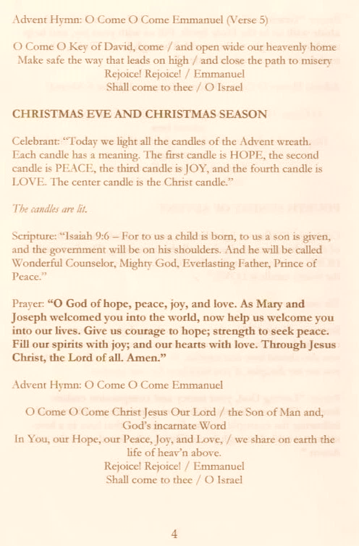

Our pastor, Rev. Rob Montgomery and his family wish you a very Merry Christmas and a joyful holiday season. May the good news of Jesus Christ, who is and remains God-with-us, fill us with hope, peace, joy, and love throughout the coming year. Amen.

Merry Christmas
One and All!

St. Luke’s News

INTERCESSIONS:
- Anglican Communion: Mission agencies and their ministry throughout the Anglican Communion
- Bishop McAllister College, in Uganda, fellow missionaries, teachers, volunteers. The Diocese of Ho, Companion Diocese of the Diocese of Fredericton
- Fredericton, Archbishop David Edwards, retired Bishops Claude, William and George, and their families. Camp Medley and Camp Brookwood, Threshold Ministries, The Anglican Diocese of Yukon: our retired clergy, and our fellow Anglicans: Parish of Kent, the Rev. Christopher Ketch; Upham, the Ven, Rob Marsh; Gondola Point, the Rev. Rob Montgomery, and his family
- Gondola Point: Food Bank Parish family: Barbara McDermott and her family Parish Ministry: A.C.W. and stewardship.
- Community Needs: those without work, food, or shelter, and those who serve and care for them. Pray also for those who are travelling.
- Shut-Ins, especially if due to COVID-19.
- Sick: Alex, Bev, Flora, Katie, Lori, Shawn, Wanda., James F, Travis B., Jack D., James F., Isaac D. Doreen E., John E., Lisa G., Laverne L., Diane M., Calvin M., Kathy M., Malcolm M., David S., Keaton S., John W., Wendy W., and any others we have been asked to include in our prays…
- Thanksgiving: Employment and financial blessings.

PLEASE NOTE: Due to limited space and social distancing while still under Covid 19 restrictions, it will be necessary to register at https://mailchi.mp/8c460962d4b0/st-lukes-gp-christmas-2021-newsletter-15565935 if you wish to attend these services. When registering, please specify how many will be attending with you as you will have assigned seating or speak with Mary Smith or the Rev. Rob Montgomery. For any visitors, proof of double vaccination is required. Masks are mandatory. St. Luke’s can seat 50 people/service so please register early.
Parish event

Christmas Services: You mut Register for Christmas Services

December 26/21 Sunday at 10AM - Contemporary BAS Service of Holy Communion

January 2/22 Blue Christmas Service of Mourning, Comfort, & Prayer, on Sunday at 6:00 p.m.

January 25/22 Seafood Chowder lunch at ST. LUKE’S ANGLICAN CHURCH, St. Luke's Parish Hall, 12 Quispamsis Road, Quispamsis.; tickets $15 must be paid for in advance. Do not delay - only 100 tickets will be sold! Pick-up is from 11:30 to 12:30.

January 30/22 St. Luke’s Annual Meeting after our morning service. All reports are to be in be by January 15/22 to Wendy Wilson.

Quarters for A Kilometer: We will be collecting quarters ($0.25) for the distance of a kilometer for the Church Restoration Fund. There will be a container at the back table for the quarters.

Work continues on our Building Restoration Project and will continue throughout this Fall. Stay tuned for more updates on our Building Restoration Project progress and funds raised towards it so far.

Restoration of St. Luke’s Anglican Church: As of November 30/21

Funds needed: $ 62,500.00. Funds on hand: $ 24,205.19

Safe Church Trainer and Renewals: Please note a new online safe church training platform has been developed to allow the Diocese to better track who has taken the training, as well as working to make the training more relevant, accessible, and simple to complete. The new training should take roughly 30-45 minutes and the Diocese would appreciate all feedback that you can provide on the entire process to ensure this is the ideal system to roll out to the diocese. Please contact Donna Dobbin for your training, thank you.

Mission Visionary Group - Further details to follow by speaking to the Rev. Rob Montgomery.

St. Luke’s A.C.W. will be on holding their meeting on Monday in the hall starting at 10:00 a.m.,

The Rev. Montgomery’s St. Luke’s Parish Bible Study is postponed now until the new year.

We are collecting refundable items from the parish for the Restoration Fund for the Church. If you have any you would like picked up, you may call Terry and Susan Sleep at 847-7609, or Darryl.

On this website is also St. Luke's Blog, posting of our Orders of Service and Sermons for Sundays, as well as other resources for us from time to time. Feel free to explore and spread the news if you can.

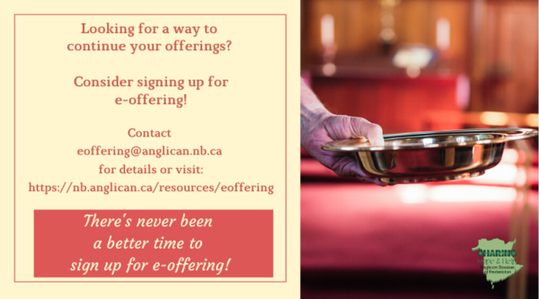
We must continue to meet our monthly expenses too while we are unable to come to our church to meet at times for worship and fellowship. Since all worship services, meetings, and events at our church has been put on hold at times, for the time being, our bulletin has changed. As the situation changes, activities will begin to be re-schedule. Please contact Terry Sleep at 847-7609. He is our Parish E-offering Representative or by mail to St. Luke’s Anglican Church, 12 Quispamsis Road, Quispamsis, New Brunswick, E2E 1M2 or e-transfer. Please contact Terry Sleep at 847-7609 for further information or instructions, thank you.

St. Luke’s is in the process of raising Funds for Restoration repairs of St. Luke’s Anglican Church with the matching of fund coming from a grant we have applied for from the Federal Government. White envelopes for this may be found on the entry table. If you have any questions, please speak with Rev. Rob Montgomery, Rosemarie Kingston, or Terry Sleep. They can help you.

Many of you received the e-news from Gisele McKnight, Diocesan Communications Officer. It contains messages from the Bishop concerning the coronavirus and the resulting procedural changes and cancellations that have been put in place. Bishop David’s message contains links to his earlier messages on the coronavirus, as well as to prayers, on-line worship services and the Book of
Common Prayer. If you did not receive e-news, it may be found at https://nb.anglican.ca/newsletters/102/display A call to prayer has been issued and details may be found in e-news. As well, you can keep up with Diocesan events at https://nb.anglican.ca/

WOODWORKING GROUP: The woodworking group at St. Augustine’s is on-going most days of the week. They welcome innovative ideas for seasonal craft projects. Please contact Kevin Tupper for more information or if you are interested in joining.

Trinity Church Columbarium the Trinity Columbarium is located inside the Germaine Street entrance at Trinity Anglican Church in Saint John, NB. This beautiful, historical church provides a place of remembrance for families wanting that connection with the church. There are various niche sizes (individual, couples, and family) available for purchase. Inquiries can be directed to the Trinity Parish office at (506) 693-8558 or email: trinsj@nb.aibn.com

E - News wants subscriber
e-News is the best way to keep up to date on what is going
on in the diocese Click here to subscribe.

THE ANGLICAN JOURNAL AND THE NEW BRUNSWICK ANGLICAN: If you are not currently receiving the Anglican Journal and the New Brunswick Anglican and would like to, there are two ways to subscribe: 1. On-line at https://www.anglicanjournal.com/newsubscription/ checking off that you want the Diocesan paper called "Fredericton - New Brunswick Anglican" in the drop-down menu to accompany your subscription to the Anglican Journal, or 2. E-mail circulation@national.anglican.ca indicating that you would like to receive both the Anglican Journal and the New Brunswick Anglican. Include the name of your parish and the Diocese.

