The Rev. Rob Montgomery and his family wishes you a Merry Christmas and a Happy New Year, and hopes you experience the Gift of the Lord Jesus this Season. May the Hope of the season rest upon you. Amen.

ST. LUKE’S ANGLICAN CHURCH

Service of Lessons and Carols

Christmas Eve Service with Holy Communion

December 24, 2022, at 6:00 p.m.
The Rev. Rob Montgomery
Priest-In-Charge
rob.montgomery@anglican.nb.ca / 506-608-1772
https://www.facebook.com/StLukesGP

Mrs. Caroline Britten Mrs. Susan Sleep Organist and Choir Director Sunday School Director

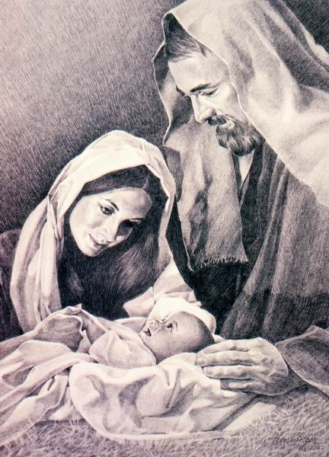

Christmas Eve Lessons & Carols
Welcome | Introduction | Rev. Rob
Advent Candles | Advent Litany Booklet | Rev. Rob
Carol | O Come O Come Emmanuel - Booklet | Congregation
Bidding Prayers |  | Rev. Rob/Craig McDermott
Reader 1 | Genesis 2:4–9,15–25 | Rev. Wally Collett
Reader 2 | Genesis 3:1–21 | Heather Hynds
First Prayer of Response |  | Rev. Rob
Carol | God Rest Ye Merry Gentlemen (v.1-5) | Congregation
Reader 3 | Isaiah 40:1–11 | Ann Chappell
Reader 4 | Luke 1:5–25 | Donna Dobbin
Second Prayer of Response |  | Rev. Rob
Carol | Once In Royal David's City (CP #123) | Congregation
Reader 5 | Luke 1:26–38 | Katherine Lee
Reader 6 | Luke 39-56 | Anne Lee
Third Prayer of Response |  | Rev. Rob
Carol | O Little Town of Bethlehem (CP #120) | Congregation
Reader 7 | Luke 1:57-80 | Craig McDermott
Fourth Prayer of Response |  | Rev. Rob
Gospel Reading | Luke 2:1-20 | Rev. Rob
Offertory Hymn | O Come All Ye Faithful (CP #118, v.1-4) | Congregation
Eucharistic Prayer 6 |  | Rev. Rob
Hymns During Communion | Silent Night (CP#119), Away In A Manger (CP#126), Infant Holy, Infant Lowly(CP#125), What Child Is This (CP#137), Still A Bach Christmas | Choir
Blessing |  | Rev. Rob
Recessional Hymn | Hark! The Herald Angels Sing (CP #138) | Congregation

God Rest Ye Merry Gentlemen
1. God rest ye merry, gentlemen, let nothing you dismay.
Remember, Christ, our Saviour was born on Christmas Day;
To save us all from Satan’s power when we were gone astray.
O tidings of comfort and joy, comfort, and joy;
O tidings of comfort and joy.
2. In Bethlehem, in Israel, this blessed Babe was born.
And laid within a manger upon this blessed morn
The which His Mother Mary did nothing take in scorn
O tidings of comfort and joy, comfort and joy;
O tidings of comfort and joy.
3. From God our Heavenly Father a blessed Angel came;
And unto certain Shepherds brought tidings of the same:
How that in Bethlehem was born the Son of God by name.
O tidings of comfort and joy, comfort, and joy;
O tidings of comfort and joy.
4. “Fear not then,” said the Angel, “Let nothing you affright,
This day is born a Saviour of a pure Virgin bright,
To free all those who trust in Him from Satan’s pow’r and might.”
O tidings of comfort and joy, comfort, and joy;
O tidings of comfort and joy.
5. The shepherds at those tidings rejoiced much in mind,
And left their flocks a-feeding in tempest, storm, and wind:
And went to Bethl’em straight-away this blessed Babe to find.
O tidings of comfort and joy, comfort, and joy;
O tidings of comfort and joy.

First Sunday of Advent

Celebrant: “Today we light the first candle of the Advent wreath. Each candle has a meaning. This first candle is HOPE.”

The candle is lit.

Scripture: “Psalm 33:20 – We wait in hope for the LORD; he is our help and our shield.”

Prayer: “Eternal God, as we await the coming of our savior, give us the courage to hope. Give us grace to see your plans of redemption for our lives, for this community, and for the world. Through Jesus Christ, the source of our redemption and hope. Amen.”

Advent Hymn: O come, O come, Emmanuel (Verse 1),

O come, O come, Emmanuel / and ransom captive Israel,
That mourns in lonely exile here/ until the Son of God appear.
Rejoice! Rejoice! / Emmanuel
Shall come to thee/ O Israel.
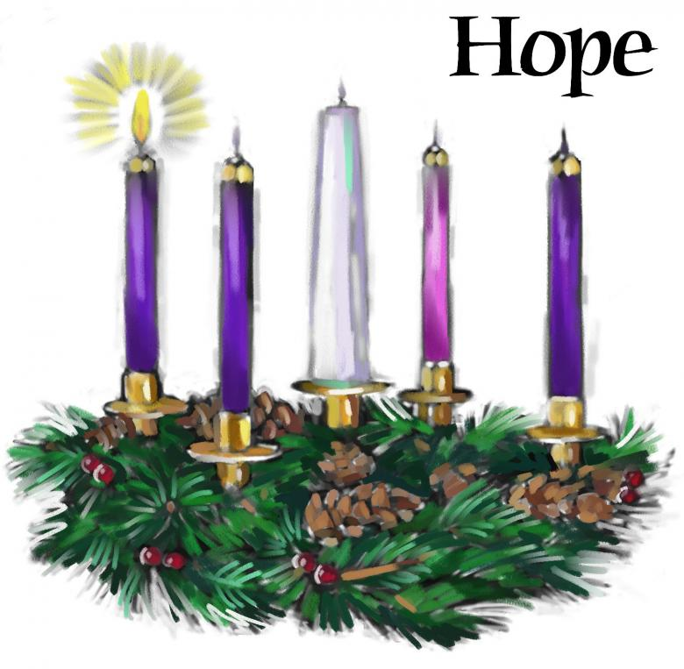

Second Sunday of Advent

Celebrant: “Today we light the first and second candles of the Advent wreath. Each candle has a meaning. The first candle is HOPE, the second candle is PEACE.”

The candles are lit.

Scripture: “Colossians 3:15 – Let the peace of Christ rule in your hearts, since as members of one body you were called to peace.”

Prayer: “Almighty God, you offer rest for our hearts, and peace for our souls. Give us grace to seek peace in our lives, peace in this community, and peace in the world. Through Jesus Christ, the prince of peace. Amen.” First Sunday of Advent

Advent Hymn: O come, O come, Emmanuel (Verse 7, altered),
O come, Desire of nations, bind / all peoples in one heart and mind
Bid envy, strife and quarrels cease. / Fill the whole world with
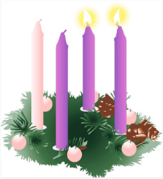
Heaven’s peace
Rejoice! Rejoice! / Emmanuel
Shall come to thee/ O Israel
Peace

Third Sunday of Advent

Celebrant: “Today we light the first, second, and third candles of the Advent wreath. Each candle has a meaning. The first candle is HOPE, the second candle is PEACE, and the third candle is JOY.”

The candles are lit.

Scripture: “Isaiah 55:12 – You will go out in joy and be led forth in peace; the mountains and hills will burst into song before you, and all the trees of the field will clap their hands.”

Prayer: “Gracious God, you came to us in human flesh, and you abide with us in the Holy Spirit. Fill us with your joy and help us shine as a light to the world. Through Jesus Christ, who makes our joy complete. Amen.”

Sunday of Advent

Advent Hymn: O come, O come, Emmanuel (Verse 6, altered),
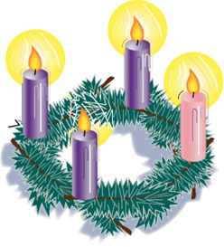
O Come, Thou Dayspring come and cheer/ our spirits by thy advent here
Disperse the gloomy clouds of night/and death's dark shadows put to flight.
Rejoice! Rejoice! / Emmanuel
Shall come to thee / O Israel. Joy

Fourth Sunday of Advent

Celebrant: “Today we light the first, second, third, and fourth candles of the Advent wreath. Each candle has a meaning. The first candle is HOPE, the second candle is PEACE, the third candle is JOY, and the fourth candle is LOVE.”

The candles are lit.

Scripture: “John 13:34 – Jesus said to them, I give you a new commandment, that you love one another. Just as I have loved you, you also should love one another. By this everyone will know that you are my disciples, if you have love for one another."

Prayer: “Loving God, your mercy and compassion endure forever. Open our hearts, that we may receive your love; and following the example of your Son, spread that love to a love-starved world. Through Jesus Christ, who loved us to the end. Amen.”

Advent Hymn: O come, O come, Emmanuel (Verse 5),

O Come, O Key of David, come/and open wide our heavenly home
Make safe the way that leads on high/and close the path to misery
Rejoice! Rejoice! / Emmanuel
Shall come to thee / O Israel.

Love
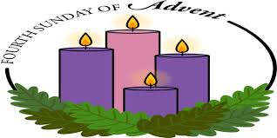

Christmas Eve and Christmas Season

Celebrant: “Today we light all the candles of the Advent wreath. Each candle has a meaning. The first candle is HOPE, the second candle is PEACE, the third candle is JOY, and the fourth candle is LOVE. The center candle is the Christ candle.” The candles are lit.

Scripture: “Isaiah 9:6 – For to us a child is born, to us a son is given, and the government will be on his shoulders. And he will be called Wonderful Counselor, Mighty God, Everlasting Father, Prince of Peace.”

Prayer: “O God of hope, peace, joy, and love. As Mary and Joseph welcomed you into the world, now help us welcome you into our lives. Give us courage to hope; strength to seek peace. Fill our spirits with joy; and our hearts with love. Through Jesus Christ, the Lord of all. Amen.”
Hope, Peace, Joy, and Love
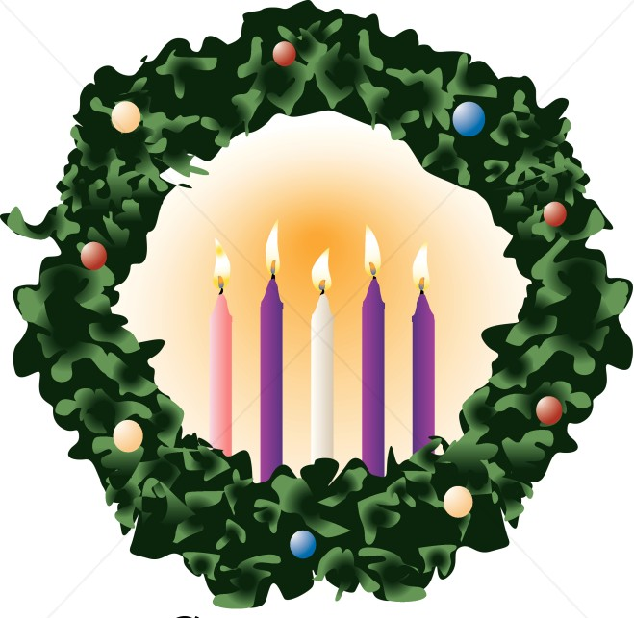

St. Luke’s News

INTERCESSIONS:
- Anglican Communion: The Anglican Church of Melanesia, the Most Rev. Leonard Dawea, Archbishop. Archbishop Linda Nicholls, Anglican Church of Canada. The Anglican Council of Indigenous Peoples and Archbishop-elect Chris Harper. Diocese of Ho, Bishop Matthias Meduadues-Badohu. Diocese of Yukon, Bishop Lesley Wheeler-Dame. Archbishop David, retired bishops Claude and William and their families.
- Missions: The Rev. Canon Paul Jeffries, and his father, Bishop McAllister College, in Uganda, fellow missionaries, teachers, volunteers. The Diocese of Ho, Companion Diocese of the Diocese of Fredericton.
- Fredericton, Archbishop David, retired bishops Claude and William, and their families, the Lemmon family. Camp Medley and Camp Brookwood, Threshold Ministries, The Anglican Diocese of Yukon: our retired clergy, and our fellow Anglicans: Parish of Saint John, the Rev. Steven Scribner; Hampton, the Rev. David Turner; Gondola Point, the Rev. Rob Montgomery, and his family
- Gondola Point: Christmas Family Support Parish family: Karen Patterson and her family Parish Ministry: parish and cemetery treasurers and stewardship.
- Community Needs: those without work, food, or shelter, and those who serve and care for them. Pray also for those who are travelling.
- Shut-Ins, especially if due to COVID-1.9.
- Sick: Alice, Barb, Bev, Catharine, Diane, Flora, Janet, John, Katie, Laverne, Loie, Peter, Paul, Peggy, Sarah, Shawn, Wanda., James F, Travis B., Jack D., Natalie D., James F., Isaac D. , John E., Lisa G., Diane M., Calvin M., Kathy M., Malcolm M., Donna P., David S., Keaton S., Donna T., Wendy W., and any others we have been asked to include in our prays….
- Thanksgiving: Canada, New Brunswick, and political freedom.

St. Luke’s A.C.W meets every Monday at 10:00 am all are welcome.

The Rev. Montgomery’s Online Bible Study is on hold until after the New Year.

The Rev. Rob Montgomery’s Midweek Contemplative Services are on hold until the New Year.

Upcoming Activities and Events at St. Luke’s:
Sunday December 25, 2022, at 11:00 a.m.
Traditional BCP Christmas Day - Service of Holy Communion
Sunday, January 1, 2023 at 11:00 a.m.
Traditional BCP - Service of Holy Communion

Sunday, January 8 ,2023 at 10:00 a.m.
Traditional BAS - Service of Holy Communion, followed by Hymn Tortons - games, fellowship, and social time together. More details to follow…

Mission Visionary Group – Meet monthly for guidance and direction of out missionary outreach of the Parish. Further details please contact the Rev. Rob Montgomery.

Quarters for A Kilometer: We will be collecting quarters ($0.25) for the distance of a kilometer for the Church Restoration Fund. There will be a container at the back table for the quarters.

Work on our Building Restoration Project is complete. St. Luke’s is in the process of raising funds for re- investments funds used for the Restoration repairs of St. Luke’s Anglican Church. White envelopes for this are on the entry table. If you have any questions, please speak with Rev. Rob Montgomery, Rosemarie Kingston, or Terry Sleep.

Safe Church Trainer and Renewals: Please note a new online safe church training platform has been developed to allow the Diocese to better track who has taken the training, as well as working to make the training more relevant, accessible, and simple to complete. The new training should take 30-45 minutes and the Diocese would appreciate all feedback that you can provide on the entire process to ensure this is the ideal system to roll out to the diocese. Please contact Donna Dobbin for your training, thank you.

We are collecting refundable items from the parish for the Restoration Fund for the Church. If you have any you would like picked up, you may call Terry and Susan Sleep at 847-7609, or Darryl.

On this website is also St. Luke's Blog, posting of our Orders of Service and Sermons for Sundays, as well as other resources for us from time to time. Feel free to explore and spread the news if you can.

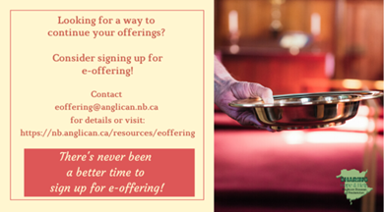
We must continue to meet our monthly expenses while we are unable to come to our church to meet at times for worship and fellowship. Since all worship services, meetings, and events at our church placed are on hold at times, and our bulletin has changed. As the situation changes, activities will begin to be re-scheduled. Please contact Terry Sleep at 847-7609. He is our Parish E-offering Representative or by mail to St. Luke’s Anglican Church, 12 Quispamsis Road, Quispamsis, New Brunswick, E2E 1M2 or e-transfer. Please contact Terry Sleep at 847-7609 for further information or instructions, thank you.

Many of you received the e-news from Gisele McKnight, Diocesan Communications Officer. It contains messages from the archbishop concerning the coronavirus and the resulting procedural changes and cancellations that have been put in place. Bishop David’s message contains links to his earlier messages on the coronavirus, as well as to prayers, on-line worship services and the Book of
Common Prayer. If you did not receive e-news, it may be found at https://nb.anglican.ca/newsletters/102/display A call to prayer has been issued and details may be found in e-news. As well, you can keep up with Diocesan events at https://nb.anglican.ca/

E - News wants subscriber
e-News is the best way to keep up to date on what is going on in the diocese
Click here to subscribe.

THE ANGLICAN JOURNAL AND THE NEW BRUNSWICK ANGLICAN: If you are not currently receiving the Anglican Journal and the New Brunswick Anglican and would like to, there are two ways to subscribe: 1. On-line at https://www.anglicanjournal.com/newsubscription/ checking off that you want the Diocesan paper called "Fredericton - New Brunswick Anglican" in the drop-down menu to accompany your subscription to the Anglican Journal, or 2. E-mail circulation@national.anglican.ca indicating that you would like to receive both the Anglican Journal and the New Brunswick Anglican. Include the name of your parish and the Diocese.

Donations for Ukraine relief
Donate via PWRDF
PWRDF is supporting Ukrainians forced to flee their homes due to the
Russian invasion. The initial grant of $20,000 issued to an ACT Alliance appeal has been increased to $50,000. The grants will fund the work of
Action by Churches Together (ACT) member Hungarian Interchurch Aid
(HIA).
On Feb. 27, HIA set up a 24-hour refugee support point on the Hungarian
side of the border at Beregsurány, where the line of refugees trying to cross into Hungary is kilometres long, says an ACT communiqué. HIA is providing hot tea, sandwiches, refreshments, blankets, and basic hygiene items for Ukrainians, including many elderly and children who are waiting long hours
to cross the border into Hungary.
How you can help. To make a donation to this response online, click here
You may also donate by phone at 416-822-9083 or leave a voicemail
toll-free at 1-866-308-7973 and PWRDF will return your call; or mail your cheque to PWRDF, 80 Hayden, 3rd floor, Toronto, Ontario, M4Y 3G2.
Please mark Ukraine in the memo field.
apply to be part of Say Yes! To Kids and be on their way to making their projects a reality.
The first step is to take a webinar, which are being held throughout March

