ST. LUKE’S ANGLICAN Church

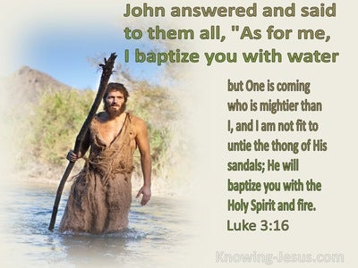

3rd Sunday in Advent

Sunday Service

December 13, 2021, at 10:00 a.m.
The Rev. Robert Montgomery
Priest–in-Charge
rob.montgomery@anglican.nb.ca / (506) 608-1772

Facebook: https://www.facebook.com/StLukesGP
Website: http://www.stlukesgp.ca

Readings: Zephaniah 3: 14-20 Isaiah 12: 2-6

Philippians 4: 4-7 Luke 3:7-

Hope

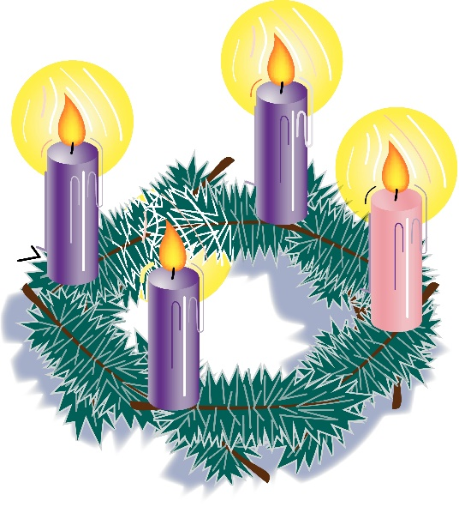

St. Luke’s News

INTERCESSIONS:
- Anglican Communion: The Anglican Church of Canada. Archbishop Linda Nicholls and the Council of General Synod. Diocese of Central Newfoundland, Bishop John Watton.
- Bishop McAllister College, in Uganda, fellow missionaries, teachers, volunteers. The Diocese of Ho, Companion Diocese of the Diocese of Fredericton
- Fredericton, Archbishop David Edwards, retired Bishops Claude, William and George, and their families. Camp Medley and Camp Brookwood, Threshold Ministries, The Anglican Diocese of Yukon: our retired clergy, and our fellow Anglicans: Fundy and the Lakes, the Rev. Canon Leo Martin; Hampton, the Rev. David Turner; Gondola Point, the Rev. Rob Montgomery, and his family
- Gondola Point: Sunday School Parish family: Patti Jo McCully and her family Parish Ministry: Parish Monthly Schedule Designer and stewardship.
- Community Needs: those without work, food, or shelter, and those who serve and care for them. Pray also for those who are travelling.
- Shut-Ins, especially if due to COVID-19.
- Sick: Flora, Katie, Lori, Shawn, Wanda., James F, Travis B., Jack D., James F., Isaac D. Doreen E., John E., Lisa G., Laverne L., Diane M., Calvin M., Kathy M., Malcolm M., David S., Keaton S., John W., Wendy W., and any others we have been asked to include in our prays…
- Thanksgiving: All that reminds us of our dependence upon God.
Advent Readings

THIRD SUNDAY OF ADVENT
Speaker 1: The light glowing from our Advent wreath is burning brighter. This radiance warms our hearts and fills us with joy! The Lord has done great things for us. Let us rejoice.

Speaker 2: “May those who sow in tears reap with shouts of joy. Those who go out weeping, bearing the seed for sowing, shall come home with shouts of joy, carrying their sheaves” (Psalm 126:5–6).
The first three candles are lit.
Speaker 3: Light three candles, see them glow
Brightly, so that all may know
How three candles show the way
Making our darkness bright as God’s day.

Speaker 4: Those who go out weeping, bearing the seed for sowing, shall come home with shouts of joy, carrying their sheaves.

All pray: Dear God, we carry many burdens and worry over many things. Help us to hear your promise in this Advent season, that in hearing, we may receive the Spirit’s gift of joy. And may our spirits be kept sound at the coming of our Lord Jesus Christ, in whose name we pray. Amen.
THE THIRD SUNDAY OF ADVENT (option 2)
The blind receive their sight!
(Based on Matthew 11:2–11)
Leader: | John asked Jesus, “Are you the one who is to come, or are we to wait for another?”
People: | Jesus said, “The blind receive their sight, the lame walk, the lepers are cleansed, the deaf hear.
Leader: | The dead are raised, and the poor have good news brought to them. Blessed is anyone who takes no offense at me.
People: | Truly I tell you, no one has arisen greater than John the Baptist; yet the least in the kingdom of heaven is greater than he.” We light the first Advent candle to remind us to keep awake and be ready. (Pause while the first candle is lit.) The second Advent candle reminds us to change our ways. (Pause while the second candle is lit.) We light the third Advent candle to remind us of the good news that the blind can see and the lame can walk.
To we will be decorating the church after the service for Christmas. We hope you can stay and help.

PLEASE NOTE: Due to limited space and social distancing while still under Covid 19 restrictions, it will be necessary to register at https://mailchi.mp/8c460962d4b0/st-lukes-gp-christmas-2021-newsletter-15565935 if you wish to attend these services. When registering, please specify how many will be attending with you as you will have assigned seating or speak with Mary Smith or the Rev. Rob Montgomery. For any visitors, proof of double vaccination is required. Masks are mandatory. St. Luke’s can seat 50 people/service so please register early.

Christmas Services: You mut Register for Christmas Services

December 24/21 Christmas Eve Service at 6:00 p.m. Lessons & Carols

December 25/21 Christmas Day at 11AM - Traditional BCP Service of Holy Communion

December 26/21 Sunday at 10AM - Contemporary BAS Service of Holy Communion

January 2/22 Blue Christmas Service of Mourning, Comfort, & Prayer, on Sunday at 6:00 p.m.

January 25/22 Seafood Chowder lunch at ST. LUKE’S ANGLICAN CHURCH, St. Luke's Parish Hall, 12 Quispamsis Road, Quispamsis.; tickets $15 must be paid for in advance. Do not delay - only 100 tickets will be sold! Pick-up is from 11:30 to 12:30.

January 30/22 St. Luke’s Annual Meeting after our morning service. All reports are to be in be by January 15/22 to Wendy Wilson.

Quarters for A Kilometer: We will be collecting quarters ($0.25) for the distance of a kilometer for the Church Restoration Fund. There will be a container at the back table for the quarters.

Work continues on our Building Restoration Project and will continue throughout this Fall. Stay tuned for more updates on our Building Restoration Project progress and funds raised towards it so far.

Restoration of St. Luke’s Anglican Church: As of November 30/21

Funds needed: $ 62,500.00. Funds on hand: $ 24,205.19

Safe Church Trainer and Renewals: Please note a new online safe church training platform has been developed to allow the Diocese to better track who has taken the training, as well as working to make the training more relevant, accessible, and simple to complete. The new training should take roughly 30-45 minutes and the Diocese would appreciate all feedback that you can provide on the entire process to ensure this is the ideal system to roll out to the diocese. Please contact Donna Dobbin for your training, thank you.

PWRDF's 2021 World of Gifts
The 2021 World of Gifts is officially here. This year's guide will bring new opportunities and hope for communities across the world as our PWRDF partners strive to build a truly just, healthy and peaceful world.
Click here to start shopping our secure, online guide today!
There are lots of ways to order! Copies of the World of Gifts Guide are included in issues of the Anglican Journal. You can also download the PDF version by clicking here.
Prefer to speak with us? Give us a call toll-free at 1-877- 936-9199, between 9 a.m. and 5 p.m. EST and make your order over the phone

Mission Visionary Group - Further details to follow by speaking to the Rev. Rob Montgomery.
St. Luke’s A.C.W. will be on holding their meeting on Monday in the hall starting at 10:00 a.m.,

The Rev. Montgomery leads St. Luke’s Parish Bible Study online on Tuesdays at 3:00 pm. Please contact Rev. Rob for further instructions.

We are collecting refundable items from the parish for the Restoration Fund for the Church. If you have any you would like picked up, you may call Terry and Susan Sleep at 847-7609, or Darryl.

On this website is also St. Luke's Blog, posting of our Orders of Service and Sermons for Sundays, as well as other resources for us from time to time. Feel free to explore and spread the news if you can.

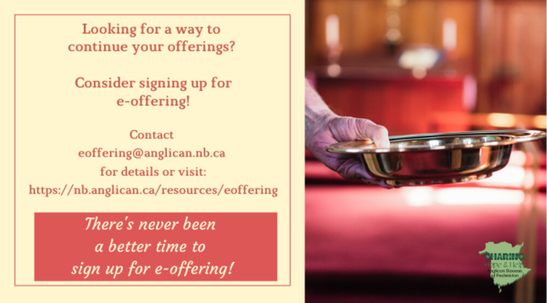
We must continue to meet our monthly expenses too while we are unable to come to our church to meet at times for worship and fellowship. Since all worship services, meetings, and events at our church has been put on hold at times, for the time being, our bulletin has changed. As the situation changes, activities will begin to be re-schedule. Please contact Terry Sleep at 847-7609. He is our Parish E-offering Representative or by mail to St. Luke’s Anglican Church, 12 Quispamsis Road, Quispamsis, New Brunswick, E2E 1M2 or e-transfer. Please contact Terry Sleep at 847-7609 for further information or instructions, thank you.

St. Luke’s is in the process of raising Funds for Restoration repairs of St. Luke’s Anglican Church with the matching of fund coming from a grant we have applied for from the Federal Government. White envelopes for this may be found on the entry table. If you have any questions, please speak with Rev. Rob Montgomery, Rosemarie Kingston, or Terry Sleep. They can help you.

Many of you received the e-news from Gisele McKnight, Diocesan Communications Officer. It contains messages from the Bishop concerning the coronavirus and the resulting procedural changes and cancellations that have been put in place. Bishop David’s message contains links to his earlier messages on the coronavirus, as well as to prayers, on-line worship services and the Book of
Common Prayer. If you did not receive e-news, it may be found at https://nb.anglican.ca/newsletters/102/display A call to prayer has been issued and details may be found in e-news. As well, you can keep up with Diocesan events at https://nb.anglican.ca/

WOODWORKING GROUP: The woodworking group at St. Augustine’s is on-going most days of the week. They welcome innovative ideas for seasonal craft projects. Please contact Kevin Tupper for more information or if you are interested in joining.

Trinity Church Columbarium the Trinity Columbarium is located inside the Germaine Street entrance at Trinity Anglican Church in Saint John, NB. This beautiful, historical church provides a place of remembrance for families wanting that connection with the church. There are various niche sizes (individual, couples, and family) available for purchase. Inquiries can be directed to the Trinity Parish office at (506) 693-8558 or email: trinsj@nb.aibn.com

E - News wants subscriber
e-News is the best way to keep up to date on what is going
on in the diocese Click here to subscribe.

THE ANGLICAN JOURNAL AND THE NEW BRUNSWICK ANGLICAN: If you are not currently receiving the Anglican Journal and the New Brunswick Anglican and would like to, there are two ways to subscribe: 1. On-line at https://www.anglicanjournal.com/newsubscription/ checking off that you want the Diocesan paper called "Fredericton - New Brunswick Anglican" in the drop-down menu to accompany your subscription to the Anglican Journal, or 2. E-mail circulation@national.anglican.ca indicating that you would like to receive both the Anglican Journal and the New Brunswick Anglican. Include the name of your parish and the Diocese.

