St. Luke’s Anglican Church

August 9, 2020

At 10:00 a.m.
The Rev. Rob Montgomery
Priest-In-Charge
Parish of Gondola Point in Quispamsis, N.B.
rob.montgomery@anglican.nb.ca / 506-608-1772
https://www.facebook.com/StLukesGP
Website - www.stlukesgp.ca

Parish Telephone: (506) 847-3670

Reading: 1 Kings 19:9-18 Psalm 85:8-13

Romans 10:5-15 Matthew 14:22-33

INTERCESSIONS:
- Anglican Communion: The Province de L'Eglise Anglicane au Rwanda, the Most Rev. Laurent Mbanda
- Missions: The Rev. Canon Paul Jeffries, Bishop McAllister College, in Uganda, fellow missionaries, teachers, volunteers. The Diocese of Ho, Companion Diocese of the Diocese of Fredericton.
- Fredericton, Bishop David Edwards, retired Bishops Claude, William and George, and their families. Camp Medley and Camp Brookwood, Threshold Ministries, The Anglican Diocese of Yukon: our retired clergy, and our fellow Anglicans: Kent, the Rev. Christopher Ketch; Upper Kennebecasis, the Rev. Daniel McMullen; Gondola Point, the Rev. Rob Montgomery
- Gondola Point: Sunday School Parish family: Charles, Vicky, Bobae, and Elijah Lee Parish Ministry: cemetery committee and stewardship.
- Community Needs: those without work, food, or shelter, and those who serve and care for them. Pray also for those who are travelling.
- Sick: Clare, Diane, Flora, Katie, Melissa, Nicola, Shawn, Wanda., Travis B., ,Winnie C., Jack D., John D., Sarah D., Doreen E., John E., Rebecca K., Susan L., Barb M., Anne Marie M., Karen M., Audrey M. Calvin M., Malcom M., Alice P., Eleri P., Emilie P., Paul P., David S., Keaton S., Robert W. and any others we have been asked for prays…
- Thanksgiving: Beauty and Wonder of Creation.

Rev. Rob Montgomery will be on vacation from July 19/20 to August 9/20. Our layreaders will be leading Morning Prayer Services with a few additions of speakers and presentations. We hope to see you on Sunday morning.

Please contacted Rev. Montgomery on the website to sign up for our service next weeks at 10:00 a.m. We would encourage you to do so in preparation for our services.

August 26/20 Wednesday is our next vestry meeting at the hall at 7:00 p.m. If you are not able to attend please send regrets to Rev. Rob Montgomery, the Wardens, or our vestry clerk.

The Rev. Montgomery has put our Parish Bible Study on Tuesday, on hold for the summer.

St. Luke’s has developed our COVID-19 Plan to allow us to return to having Sunday Services. If you have not done so, please check out our COVID-19 Plan page on our St. Luke's GP website for more information on what to expect, and how to stay safe: http://www.stlukesgp.ca/covid-19-plan.html

On this website is also St. Luke's Blog, posting of our Orders of Service and Sermons for Sundays, as well as other resources for us from time to time. Feel free to explore and spread the news if you can.

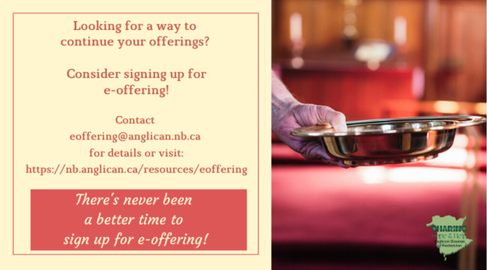
We must continue to meet our monthly expenses too while we are unable to come to our church to meet for worship and fellowship. Since all worship services, meetings and events at our church has been put on hold for the time being, our bulletin has changed. As the situation changes, activities will begin to be re-schedule. Please contact Terry Sleep at 847-7609. He is our Parish E-offering Representative or by mail to St. Luke’s Anglican Church, 12 Quispamsis Road, Quispamsis, New Brunswick, E2E 1M2 or e-transfer. Please contact Terry Sleep at 847-7609 for further information or instructions, thank you.
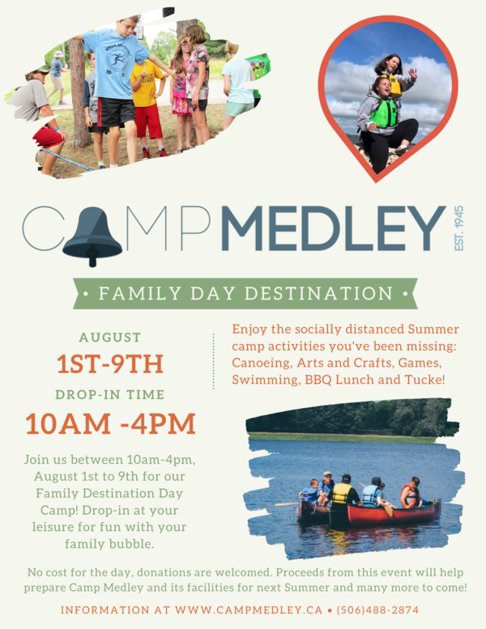
Longing for camp?
Camp Medley has an eight days of drop-in camping fun for the whole family. This is for children of all ages and their parents/guardians.

St. Luke’s is in the process of raising Funds for Restoration repairs of St. Luke’s Anglican Church with the matching of fund coming
from a grant we have applied for from the Federal Government. White envelopes for this may be found on the entry table. If you have any questions, please speak with Rev. Rob Montgomery, Rosemarie Kingston, or Terry Sleep. We how you can help.

Many of you received the e-news from Gisele McKnight, Diocesan Communications Officer. It contains messages from the Bishop concerning the coronavirus and the resulting procedural changes and cancellations that have been put in place. Bishop David’s message contains links to his earlier messages on the coronavirus, as well as to prayers, on-line worship services and the Book of
Common Prayer. If you did not receive e-news, it may be found at https://nb.anglican.ca/newsletters/102/display A call to prayer has been issued and details may be found in e-news. As well, you can keep up with Diocesan events at https://nb.anglican.ca/

E - News wants subscriber
e-News is the best way to keep up to date on what is going
on in the diocese

Click here to subscribe.
Thank You Letters to the Frontline Workers:
During these unparalleled, and honestly scary times, most of us have a social responsibility to help stop the spread of COVID-19 by staying home and staying safe; but not everyone. Doctors, nurses, and other medical staff, as well as police, firefighters, grocery store employees, postal/delivery workers, gas station attendants, public transportation workers, mental health and social services workers, farmers, and countless other “essential workers” are putting themselves in harm’s way daily so the rest of us can stay safe. We want to thank you for all the hard work you are doing to keep our community safe during this time. Thank you for being so dedicated, courageous and selfless as we continue to work together to overcome this challenge we are currently facing. We are all trying to do our part by staying at home. You are inspiring us to take care of our community, and in the future, we will continue to take care of it. Your efforts, sacrifices, commitment, and leadership during these uncertain times is greatly appreciated! We are all in this together. Thank you again!
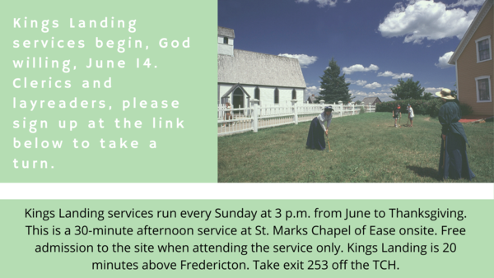
Kings Landing Summer Services

Sign up to take a turn at this link.

YIG leaders meet on Wednesdays at 11 am- 12:30 pm Here is your Zoom meeting connection.

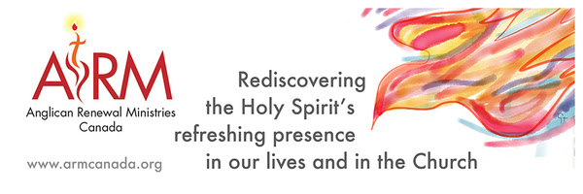

Anglican Renewal Ministries
Anglican Renewal Ministries is dedicated to bringing the life and power of the Holy Spirit to all Christians. ARM has been serving the Anglican Church of Canada for over 30 years. In addition to workshops, we offer a quarterly magazine with articles to uplift and encourage people in their walk with Christ. We hope it will be a source of encouragement to all in these difficult times. Sample articles and a free copy of the magazine are available on our website.

The Parish Development Officer and Council Spiritual Development Team, on behalf of Bishop David, are coordinating some diocesan-wide initiatives to recognize this time. We ask you to share these with your parishioners.

We certainly also encourage you in any parish or church events you are planning - and would be happy to publicize these on our diocesan event page.

Links to join and for resources are being added here: https://nb.anglican.ca/events/thy-kingdom-come

Shawn offers a video summary of all of this at: https://youtu.be/qCTgUSaIS-0

1. Video Testimonies
Jesus talking with the disciples asked, “Who do you say that I am?” (Matthew 16) That’s a great and important question! Who do you say Jesus is? We’re inviting you to share your response to this question. Record a 2-minute video and post it to your social media, tagging it with #ThyKingdomCome #NBAnglicans .

2. 24-7 Prayer Vigil
Everyone is invited to sign up for one or more 1-hour time slots and pray in their own space for God's Kingdom to come, for their church, and for family, friends and neighbours. Prayer guidelines will be available.
Daily Morning and Evening Prayer Offices using the Thy Kingdom Come prayer booklet (text will be provided) at 8:00 am and 6:00 pm (temporarily replacing the Litany@6)

Keep in touch with your favourite summer camps using the links below.
St. Michael’s Youth Conference
https://smyc.ca/
https://www.facebook.com/SMYCAtlantic/
Diocesan Choir School
http://www.anglicanchoirschool.com/
https://www.facebook.com/groups/121354914558579/
Camp Brookwood
http://www.campbrookwood.ca/
camp.brookwood@outlook.com
http://campmedley.ca/
https://www.facebook.com/camp.medley/

