St. Luke’s Anglican Church

August 30, 2020
At 10:00 a.m.
The Rev. Rob Montgomery
Priest-In-Charge
Parish of Gondola Point in Quispamsis, N.B.
rob.montgomery@anglican.nb.ca / 506-608-1772
https://www.facebook.com/StLukesGP
Website - www.stlukesgp.ca

Parish Telephone: (506) 847-3670

Reading: Exodus 3:1-15 Psalm 105:1-6, 23-26, 45c Romans 12:9-21 Matthew 16:21-28

INTERCESSIONS:
- Anglican Communion: The united Church of South India, the Most Rev. Dharmaraj Rasalam
- Missions: The Rev. Canon Paul Jeffries, Bishop McAllister College, in Uganda, fellow missionaries, teachers, volunteers. The Diocese of Ho, Companion Diocese of the Diocese of Fredericton.
- Fredericton, Bishop David Edwards, retired Bishops Claude, William and George, and their families. Camp Medley and Camp Brookwood, Threshold Ministries, The Anglican Diocese of Yukon: our retired clergy, and our fellow Anglicans: Pennfield, the Rev. Caleb Twinamatsiko; Rothesay Netherwood and Gondola Point, the Rev. Rob Montgomery
- Gondola Point: Christmas Family Support Parish family: David and Carolyn MacLeod and their family Parish Ministry: envelope secretary and stewardship.
- Community Needs: those without work, food, or shelter, and those who serve and care for them. Pray also for those who are travelling.
- Sick: Clare, Diane, Flora, Katie, Melissa, Nicola, Shawn, Wanda., Travis B., ,Winnie C., Jack D., Doreen E., John E., Susan L., Anne Marie M., Karen M., Audrey M. Calvin M., Malcom M., Alice P., Eleri P., Emilie P., Paul P., Madhav R., David S., Keaton S., and any others we have been asked for prays…
- Thanksgiving: All that reminds us of our dependence upon God.

Today is Food Basket Sunday, the last Sunday of the month and we are thankful for the donations to the KV Food Basket.

Today is also Birthday Sunday:

Happy birthday to you.
To our Lord be true.
May God's love and blessings,
Rain down upon you.

Lynn Chase | Bronwyn McIntyre
Patti Jo McCully | Karen Patterson
Bethany Heb

Aug. 31/20 St. Luke’s A.C.W. will be starting to get together again with the safe rules for COVID-19 to allow this group to restart. Please speak with Rosemarie Kingston if you have any questions.

We are collecting donations for the Saint John Community Christmas Exchange for the month of September and first part of October 2020. You will find small white envelopes marked Saint John Christmas Exchange on the back table. Thank you. The Saint John Community Christmas Exchange serves the areas of Browns Flat; Grand Bay - Westfield; Hampton; Quispamsis; Rothesay; St John County; Welsford; and Kingston Peninsula.

Sept 9/20 Wednesday is our next vestry meeting at the hall at 7:00 p.m. If you are not able to attend please send regrets to Rev. Rob Montgomery, the Wardens, or our vestry clerk.

Please contacted Rev. Montgomery on the website to sign up for our service next weeks at 10:00 a.m. We would encourage you to do so in preparation for our services.

Sept. 26/19 St. Luke’s Roast Beef Supper at the hall. 12 Quispamsis Road, Quispamsis.
There will be 4 - 1/2 Hour Pickup Intervals from: 4:00pm – 4:30 pm.
4:30 pm - 5:00 pm; 5:00 pm - 5:30 pm; 5:30 pm - 6:00 pm
Tickets: $15.00 For Tickets: Call Susan at 847-7609 “Drive Through” Take-Out Only. Call Early. All ticket sales will end on September 22/20 Tickets Must Be Picked-Up and Paid for Before Dinner.
Tickets Are Limited So Call Early. Join us for delicious roast beef, potato, gravy, veggies & roll, apple crisp and whip cream.

St. Luke’s is collecting fund for Bishop McAllister College, in Uganda. The is a box at the back of the room. You can place your donation in the envelopes provided. All donations are tax deductible.

St. Luke’s has developed our COVID-19 Plan to allow us to return to having Sunday Services. If you have not done so, please check out our COVID-19 Plan page on our St. Luke's GP website for more information on what to expect, and how to stay safe: http://www.stlukesgp.ca/covid-19-plan.html We are currently developing the COVID-19 plan for outside use of the hall and church.

The Rev. Montgomery has put our Parish Bible Study on Tuesday, on hold for the summer.

On this website is also St. Luke's Blog, posting of our Orders of Service and Sermons for Sundays, as well as other resources for us from time to time. Feel free to explore and spread the news if you can.

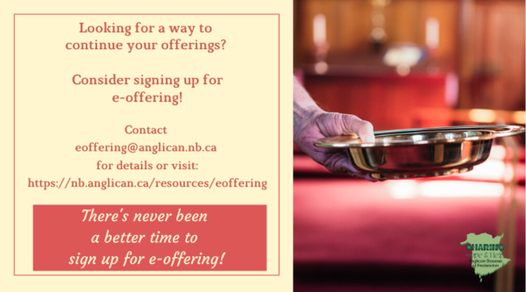
We must continue to meet our monthly expenses too while we are unable to come to our church to meet for worship and fellowship. Since all worship services, meetings and events at our church has been put on hold for the time being, our bulletin has changed. As the situation changes, activities will begin to be re-schedule. Please contact Terry Sleep at 847-7609. He is our Parish E-offering Representative or by mail to St. Luke’s Anglican Church, 12 Quispamsis Road, Quispamsis, New Brunswick, E2E 1M2 or e-transfer. Please contact Terry Sleep at 847-7609 for further information or instructions, thank you.

St. Luke’s is in the process of raising Funds for Restoration repairs of St. Luke’s Anglican Church with the matching of fund coming from a grant we have applied for from the Federal Government. White envelopes for this may be found on the entry table. If you have any questions, please speak with Rev. Rob Montgomery, Rosemarie Kingston, or Terry Sleep. We how you can help.
Many of you received the e-news from Gisele McKnight, Diocesan Communications Officer. It contains messages from the Bishop concerning the coronavirus and the resulting procedural changes and cancellations that have been put in place. Bishop David’s message contains links to his earlier messages on the coronavirus, as well as to prayers, on-line worship services and the Book of
Common Prayer. If you did not receive e-news, it may be found at https://nb.anglican.ca/newsletters/102/display A call to prayer has been issued and details may be found in e-news. As well, you can keep up with Diocesan events at https://nb.anglican.ca/

E - News wants subscriber
e-News is the best way to keep up to date on what is going
on in the diocese

Click here to subscribe.

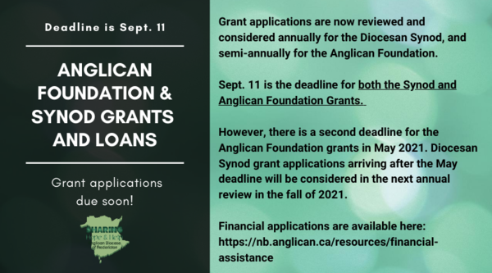

Grant application notice
Click here for the financial application.
Thank You Letters to the Frontline Workers:
During these unparalleled, and honestly scary times, most of us have a social responsibility to help stop the spread of COVID-19 by staying home and staying safe; but not everyone. Doctors, nurses, and other medical staff, as well as police, firefighters, grocery store employees, postal/delivery workers, gas station attendants, public transportation workers, mental health and social services workers, farmers, and countless other “essential workers” are putting themselves in harm’s way daily so the rest of us can stay safe. We want to thank you for all the hard work you are doing to keep our community safe during this time. Thank you for being so dedicated, courageous, and selfless as we continue to work together to overcome this challenge we are currently facing. We are all trying to do our part by staying at home. You are inspiring us to take care of our community, and in the future, we will continue to take care of it. Your efforts, sacrifices, commitment, and leadership during these uncertain times is greatly appreciated! We are all in this together. Thank you again!

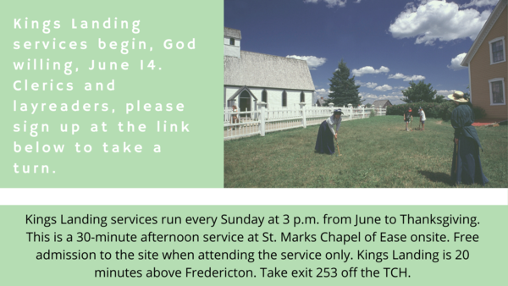

Here is your Zoom meeting connection.

Kings Landing Summer Services

Sign up to take a turn at this link.

YIG leaders meet on Wednesdays at 11 am- 12:30 pm

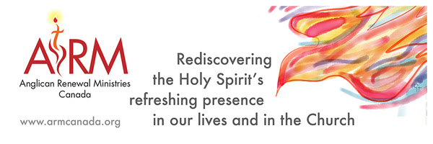

Anglican Renewal Ministries
Anglican Renewal Ministries is dedicated to bringing the life and power of the Holy Spirit to all Christians. ARM has been serving the Anglican Church of Canada for over 30 years. In addition to workshops, we offer a quarterly magazine with articles to uplift and encourage people in their walk with Christ. We hope it will be a source of encouragement to all in these difficult times. Sample articles and a free copy of the magazine are available on our website.

The Parish Development Officer and Council Spiritual Development Team, on behalf of Bishop David, are coordinating some diocesan-wide initiatives to recognize this time. We ask you to share these with your parishioners.

We certainly also encourage you in any parish or church events you are planning - and would be happy to publicize these on our diocesan event page.

Links to join and for resources are being added here: https://nb.anglican.ca/events/thy-kingdom-come

Shawn offers a video summary of all of this at: https://youtu.be/qCTgUSaIS-0

1. Video Testimonies
Jesus talking with the disciples asked, “Who do you say that I am?” (Matthew 16) That’s a great and important question! Who do you say Jesus is? We’re inviting you to share your response to this question. Record a 2-minute video and post it to your social media, tagging it with #ThyKingdomCome #NBAnglicans .

2. 24-7 Prayer Vigil
Everyone is invited to sign up for one or more 1-hour time slots and pray in their own space for God's Kingdom to come, for their church, and for family, friends and neighbours. Prayer guidelines will be available.
Daily Morning and Evening Prayer Offices using the Thy Kingdom Come prayer booklet (text will be provided) at 8:00 am and 6:00 pm (temporarily replacing the Litany@

Keep in touch with your favourite summer camps using the links below.
St. Michael’s Youth Conference
https://smyc.ca/
https://www.facebook.com/SMYCAtlantic/
Diocesan Choir School
http://www.anglicanchoirschool.com/
https://www.facebook.com/groups/121354914558579/
Camp Brookwood
http://www.campbrookwood.ca/
camp.brookwood@outlook.com
http://campmedley.ca/
https://www.facebook.com/camp.medley/

