ST. LUKE’S ANGLICAN CHURCH
Happy Easter

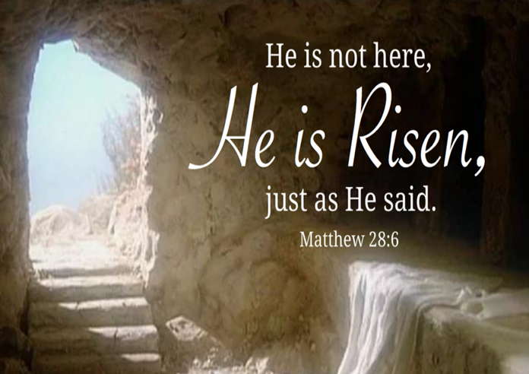

Easter Morning Communion Service

April 9, 2023, at 10:00 a.m.

The Rev. Rob Montgomery
Priest-In-Charge

rob.montgomery@anglican.nb.ca / 506-608-1772
https://www.facebook.com/StLukesGP

12, Quispamsis Road, Quispamsis, N.B. E2E 1M2

Easter Day 2023 | Service of Lessons & Hymns
Welcome | Introduction | Rev. Rob
Hymn | Christ the Lord is Risen Today (MP #76 v. 1, 4, & 5) | Congregation
Bidding for Easter |  | Craig Mc.
Reader 1 | Genesis 1.1–5 | Heather H.
Reader 2 | Exodus 14.19–31 | Terry S.
First Prayer of Response |  | Craig Mc.
Hymn | Alleluia! The Strife is O'er (CP #212) | Rev. Rob
Reader 3 | Isaiah 35.1–10 | Karen P.
Reader 4 | Ezekiel 37.1–14 | Carolyn Mac.
Second Prayer of Response |  | Craig Mc.
Hymn | Crown Him with Many Crowns (CP #378) | Congregation
Reader 5 | 1 Corinthians 15.1–28, 51–58 | Wally C.
Reader 6 | 1 Peter 1:3-9, 13-23 | Wendy W.
Third Prayer of Response |  | Craig Mc.
Hymn | In Christ Alone (MP #1072) | Congregation
Reader 7 | Matthew 28:1-10 | Craig Mc
Gospel Reading | Matthew 28:11-20 | Rev. Rob
Fourth Prayer of Response |  | Craig Mc.
Offertory Hymn | Alleluia! Sing to Jesus (CP #374) | Congregation
Eucharistic Prayer 3 |  | Rev. Rob
Hymns During Communion | Rock of Ages (MP #582) See What A Morning (MP #1105)  Behold the Lamb (MP #1157) | Choir
Blessing |  | Rev. Rob
Recessional Hymn | Rejoice, the Lord is King (CP #379) | Congregation

St. Luke’s News

INTERCESSIONS:
- Anglican Communion: Province of the Episcopal Church of Sudan, the Most Rev Ezekiel Kumir Kondo, Archbishop. The Peace of Jerusalem. Archbishop Linda Nicholls, Anglican Church of Canada. Diocese of Nova Scotia and Prince Edward Island, Bishop Sandra Fyfe.
- Missions: The Rev. Canon Paul Jeffries, and his father, Bishop McAllister College, in Uganda, fellow missionaries, teachers, volunteers. The Diocese of Ho, Bishop Matthias Meduadues-Badohui, Ghana, West Africa the Companion Diocese of the Diocese of Fredericton
- Fredericton, Archbishop David, retired bishops Claude and William, and their families, the Lemmon family. Camp Medley and Camp Brookwood, Threshold Ministries, The Anglican Diocese of Yukon: our retired clergy, and our fellow Anglicans; Westmorland, the Rev. Lidvald Haugen-Strand; Hampton, the Rev. David Turner; Gondola Point, the Rev. Rob Montgomery, and his family
- Gondola Point: Romero House Parish family: Lynn Chase and her family Parish Ministry: layreaders and stewardship.
- Community Needs: those without work, food, or shelter, and those who serve and care for them. Pray also for those who are travelling.
- Shut-Ins, especially if due to COVID-1.9.
- Sick: Alice, Barb, Bev, Catharine, Danielle, Diane, Flora, Janet, Katie, Laverne, Peggy, Shawn, Wanda., James F, Travis B., Jack D., Natalie D., James F., Isaac D. , John E., Lisa G., Diane M., Calvin M., Kathy M., Malcolm M., Donna P., David S., Keaton S., Donna T., Wendy W., and any others we have been asked to include in our prays….
- Thanksgiving: Tasks which demand our best efforts.

Parish Mission Outreach: For the next Sundays, we are collecting boxes of “Cheerios” Cereal for an Elementary School Breakfast Program. Non-name brands are acceptable if there are no nuts (peanuts, peanut oil) in the ingredients or facilities in which they are made. Again, we will collect them at the church and then deliver them to the school.

April 12/23 Wednesday is our next vestry meeting at the hall at 7:00 p.m. If you are not able to attend, please send your regrets to the Rev. Rob Montgomery, the Wardens, or our vestry clerk.

April 22/23 St. Luke’s Annual Multi Table Indoor Sale. No admission charge. Crafts, antiques, etc. Tables on two levels. at 12 Quispamsis Road from 9 am to 1 pm.

May 28/23 Will be our next All Ages Event on Pentecost Sunday in Hall 3-6pm.

+++++++++++++++++++++++++++++++++++++++++++++++++++++
A Baker’s Dozen Years Serving the KV COMMUNITY VOLUNTEER INCOME TAX PROGRAM For Rothesay & Quispamsis Residents
What is it? F R E E - Preparation & Filing – F R E E of Basic Income Tax Returns for current or prior years. Income limits $35,000 (singles) or $45,000 (couples) When and Where? Every Tuesday March 7th to April 25th, 2023 9:00 to 2:00 at St. Paul’s Parish Centre on the Rothesay Common ** Due to continuing COVID concerns ** Clients are asked to Drop off one Tuesday and Pick up the next Tuesday.

April 15, 6 - 8 p.m. Saturday The 'Mystery Auction' is back at Holy Trinity in Hammond River! Desserts will be served at 6 p.m. in the church hall followed by the Mystery Auction. Items will once again be auctioned off by Canon David Barrett. We are looking for donations of useful wrapped items (so they cannot be identified). Save the date for this fun event! Contact 506-647-8170 for more information! All proceeds are for mission activities.

May 13, 2-4 p.m. Saturday, Willing Workers Spring Tea at St. George's Anglican Church, Moncton. $10 per person. Menu: Sandwiches, sweets, tea & coffee. Prize Draws. For more information call the church at 506-855-5209.

++++++++++++++++++++++++++++++++++++++++++++++++++++++

St. Luke’s A.C.W meet every Monday at 10:00 am all are welcome.

The Rev. Montgomery’s Online Bible Study continues Tuesday at 3:30 p.m.

St. Luke’s Book Club the last Tuesday of the month at 2:00 p.m. at St. Luke’s Parish Hall. Please contact Heather Hynds for the list of books.

The Rev. Rob Montgomery’s Midweek Contemplative Services on hold until after Easter at St. Luke’s Anglican Church
Mission Visionary Group – Meet monthly for guidance and direction of out missionary outreach of the Parish. Further details please contact the Rev. Rob Montgomery.

Quarters for A Kilometer: We will be collecting quarters ($0.25) for the distance of a kilometer for the Church Restoration Fund. There will be a container on the back table for the quarters.

Work on our Building Restoration Project is complete. St. Luke’s is in the process of raising funds for re- investments funds used for the Restoration repairs of St. Luke’s Anglican Church. White envelopes for this are on the entry table. If you have any questions, please speak with Rev. Rob Montgomery, Rosemarie Kingston, or Terry Sleep.

Safe Church Trainer and Renewals: Please note a new online safe church training platform has been developed to allow the Diocese to better track who has taken the training, as well as working to make the training more relevant, accessible, and simple to complete. The new training should take 30-45 minutes and the Diocese would appreciate all feedback that you can provide on the entire process to ensure this is the ideal system to roll out to the diocese. Please contact Donna Dobbin for your training, thank you.

We are collecting refundable items from the parish for the Restoration Fund for the Church. If you have any you would like picked up, you may call Terry and Susan Sleep on 847-7609, or Darryl.

On this website is also St. Luke's Blog, posting of our Orders of Service and Sermons for Sundays, as well as other resources for us from time to time. Feel free to explore and spread the news if you can.

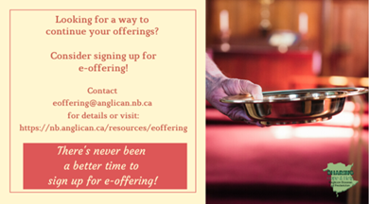
We must continue to meet our monthly expenses while we are unable to come to our church to meet at times for worship and fellowship. Since all worship services, meetings, and events at our church are on hold at times, our bulletin has changed. As the situation changes, activities will begin to be re-scheduled. Please contact Terry Sleep at 847-7609. He is our Parish E-offering Representative or by mail to St. Luke’s Anglican Church, 12 Quispamsis Road, Quispamsis, New Brunswick, E2E 1M2 or e-transfer. Please contact Terry Sleep at 847-7609 for further information or instructions, thank you.

Many of you received the e-news from Gisele McKnight, Diocesan Communications Officer. It contains messages from the archbishop concerning the coronavirus and the resulting procedural changes and cancellations that have been put in place. Bishop David’s message contains links to his earlier messages on the coronavirus, as well as to prayers, on-line worship services and the Book of
Common Prayer. If you did not receive e-news, it may be found at https://nb.anglican.ca/newsletters/102/display A call to prayer has been issued and details may be found in e-news. As well, you can keep up with Diocesan events at https://nb.anglican.ca/
E - News wants subscriber
e-News is the best way to keep up to date on what is going on in the diocese.
Click here to subscribe.

THE ANGLICAN JOURNAL AND THE NEW BRUNSWICK ANGLICAN: If you are not currently receiving the Anglican Journal and the New Brunswick Anglican and would like to, there are two ways to subscribe: 1. On-line at https://www.anglicanjournal.com/newsubscription/ checking off that you want the Diocesan paper called "Fredericton - New Brunswick Anglican" in the drop-down menu to accompany your subscription to the Anglican Journal, or 2. E-mail circulation@national.anglican.ca indicating
that you would like to receive both the Anglican Journal and the New Brunswick Anglican. Include the name of your parish and the Diocese.

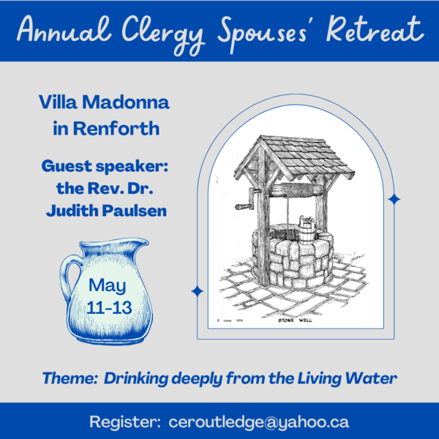

Annual Clergy Spouses Retreat Registration: ceroutledge@yahoo.ca

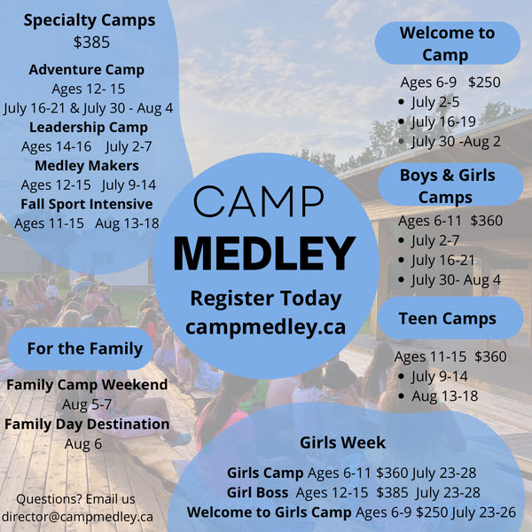

Donations for Ukraine relief
Donate via PWRDF
PWRDF is supporting Ukrainians forced to flee their homes due to the
Russian invasion. The initial grant of $20,000 issued to an ACT Alliance appeal has been increased to $50,000. The grants will fund the work of
Action by Churches Together (ACT) member Hungarian Interchurch Aid
(HIA).
On Feb. 27, HIA set up a 24-hour refugee support point on the Hungarian
side of the border at Beregsurány, where the line of refugees trying to cross into Hungary is kilometres long, says an ACT communiqué. HIA is providing hot tea, sandwiches, refreshments, blankets, and basic hygiene items for Ukrainians, including many elderly and children who are waiting long hours.
to cross the border into Hungary.
How you can help. To make a donation to this response online, click here
You may also donate by phone at 416-822-9083 or leave a voicemail
toll-free at 1-866-308-7973 and PWRDF will return your call; or mail your cheque to PWRDF, 80 Hayden, 3rd floor, Toronto, Ontario, M4Y 3G2.
Please mark Ukraine in the memo field.
apply to be part of Say Yes! To Kids and be on their way to making their projects a reality.
The first step is to take a webinar, which are being held throughout March

