ST. LUKE’S ANGLICAN CHURCH

Sunday Morning Communion Service
5th Sunday in Lent

April 3, 2022, at 10:00 a.m.

The Rev. Robert Montgomery
Priest–in-Charge
rob.montgomery@anglican.nb.ca / (506) 608-1772
https://www.facebook.com/StLukesGP

Readings: Isaiah 43: 16-21 Psalm 126

Philippians 3: 4b -14 John 12: 1-8

St. Luke’s News

INTERCESSIONS:
- Anglican Communion: The Church of Nigeria (Anglican Communion), the Most Rev. Henry Ndukuba, Metropolitan and Primate.
- Bishop McAllister College, in Uganda, fellow missionaries, teachers, volunteers. The Diocese of Ho, Companion Diocese of the Diocese of Fredericton
- Fredericton, Archbishop David Edwards, retired Bishops Claude, William and George, and their families. Camp Medley and Camp Brookwood, Threshold Ministries, The Anglican Diocese of Yukon: our retired clergy, and our fellow Anglicans: Portland, the Rev. Dr. Cole Hartin; Rothesay, the Rev. Paul Rideout; Gondola Point, the Rev. Rob Montgomery, and his family
- Gondola Point: Fellowship of Prayer, Prayer Chain Parish family: Paul and Jennifer Woodrow Parish Ministry: Vestry and stewardship.
- Community Needs: those without work, food, or shelter, and those who serve and care for them. Pray also for those who are travelling.
- Shut-Ins, especially if due to COVID-1.9.
- Sick: Alex, Bev, Catharine, Flora, Janet, Katie, Laverne, Lori, Loie, Peter, Paul, Shawn, Wanda., James F, Joyce G, Travis B., Jack D., Natalie D., James F., Isaac D. Doreen E., John E., Lisa G., Diane M., Calvin M., Kathy M., Malcolm M., David S., Keaton S., John W., Wendy W., and any others we have been asked to include in our prays…
- Thanksgiving: Tasks which demand our best efforts.

PWRDF LENTEN CONVERSATION: PWRDF invites you into a Lenten Conversation. As PWRDF’s “Creation Care: Climate Action” education focus moves into its second year, now centering on gender, they have invited three women who participated in COP26 to enter into a Lenten conversation. Subscribe and learn more here https://pwrdf.org/lent2022/ The program began on Sun Mar 6th and comes to your email daily.

March 25-26/22 "Freedom through Lent" - Diocesan Lenten Retreat
at the Villa Madonna, Rothesay NB Join us for a 24hr break-away during Lent to help still our hearts and minds as we continue in our Lenten journey, looking forward to the Easter mysteries and celebrations. The Rev. Jasmine Chandra is our retreat leader. Register: nb.anglican.ca/Lent-Retreat

May 26-June 5/22 THY KINGDOM COME: The “Thy Kingdom Come” global prayer event is happening again this year, from May 26th to June 5th. More information may be found at: https://us06web.zoom.us/webinar/register/tZErdeyqrD4jG9RIId0s1CMSuOLWH6KEvcPB/success ?user_id=fawMFnf4SY6ejr_p4hdHrQ&timezone_id=Europe%2FLondon

FREE TAX CLINIC: A free income tax clinic (for current or prior years) takes place on Tuesdays from 9 am-noon and 1-3 pm until April 26th at St. Paul’s Anglican Church Hall in Rothesay. Drop off your tax information one Tuesday and pick up the completed return the following Tuesday. Your return will be e-filed on your behalf by volunteer tax preparers. This service is available to Quispamsis and Rothesay residents with basic tax returns and a maximum income of $35,000 for singles or $45,000 per couple. A Covid operational plan will be in place.

April 12/22 Seafood Chowder lunch at ST. LUKE’S ANGLICAN CHURCH, St. Luke's Parish Hall, 12 Quispamsis Road, Quispamsis.; tickets $15 must be paid for in advance. Do not delay - only 100 tickets will be sold! Pick-up is from 11:30 to 12:30.

April 30/22 St. Luke’s ACW Annual Yard Sale and Bake Sale in the Parish Hall, at 12 Quispamsis Road from 8 am to 1 pm. Further details to follow.

April 30/22 SPRING FLING TAKE-OUT: Instead of a spring community lunch, Holy Trinity invites you to enjoy a take-out lunch of either hearty hamburg soup or delicious corn chowder, with a roll and dessert included. Cost is $8. Pre-order by calling Kathy & Mark Allaby at 832-3759. Meal pickup is Sat Apr 30th from 10 am-12 noon at Holy Trinity Church, 2 Hammond River Road. Help support Holy Trinity's Mission for Ukraine and other projects.

Quarters for A Kilometer: We will be collecting quarters ($0.25) for the distance of a kilometer for the Church Restoration Fund. There will be a container at the back table for the quarters.

Work on our Building Restoration Project and will continue throughout this Spring. Stay tuned for more updates on our Building Restoration Project progress and funds raised towards it so far.

Safe Church Trainer and Renewals: Please note a new online safe church training platform has been developed to allow the Diocese to better track who has taken the training, as well as working to make the training more relevant, accessible, and simple to complete. The new training should take 30-45 minutes and the Diocese would appreciate all feedback that you can provide on the entire process to ensure this is the ideal system to roll out to the diocese. Please contact Donna Dobbin for your training, thank you.

Mission Visionary Group - Further details to follow by speaking to the Rev. Rob Montgomery.

We are collecting refundable items from the parish for the Restoration Fund for the Church. If you have any you would like picked up, you may call Terry and Susan Sleep at 847-7609, or Darryl.

On this website is also St. Luke's Blog, posting of our Orders of Service and Sermons for Sundays, as well as other resources for us from time to time. Feel free to explore and spread the news if you can.

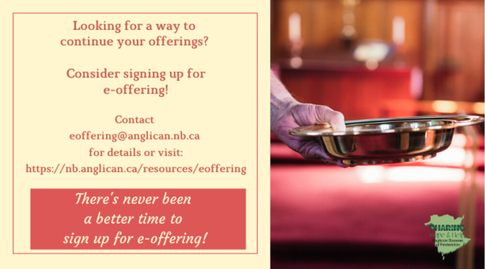
We must continue to meet our monthly expenses too while we are unable to come to our church to meet at times for worship and fellowship. Since all worship services, meetings, and events at our church has been put on hold at times, for the time being, our bulletin has changed. As the situation changes, activities will begin to be re-schedule. Please contact Terry Sleep at 847-7609. He is our Parish E-offering Representative or by mail to St. Luke’s Anglican Church, 12 Quispamsis Road, Quispamsis, New Brunswick, E2E 1M2 or e-transfer. Please contact Terry Sleep at 847-7609 for further information or instructions, thank you.

St. Luke’s is in the process of raising Funds for Restoration repairs of St. Luke’s Anglican Church with the matching of fund coming from a grant we have applied for from the Federal Government. White envelopes for this may are on the entry table. If you have any questions, please speak with Rev. Rob Montgomery, Rosemarie Kingston, or Terry Sleep. They can help you.

Many of you received the e-news from Gisele McKnight, Diocesan Communications Officer. It contains messages from the archbishop concerning the coronavirus and the resulting procedural changes and cancellations that have been put in place. Bishop David’s message contains links to his earlier messages on the coronavirus, as well as to prayers, on-line worship services and the Book of
Common Prayer. If you did not receive e-news, it may be found at https://nb.anglican.ca/newsletters/102/display A call to prayer has been issued and details may be found in e-news. As well, you can keep up with Diocesan events at https://nb.anglican.ca/

E - News wants subscriber
e-News is the best way to keep up to date on what is going
on in the diocese Click here to subscribe.

THE ANGLICAN JOURNAL AND THE NEW BRUNSWICK ANGLICAN: If you are not currently receiving the Anglican Journal and the New Brunswick Anglican and would like to, there are two ways to subscribe: 1. On-line at https://www.anglicanjournal.com/newsubscription/ checking off that you want the Diocesan paper called "Fredericton - New Brunswick Anglican" in the drop-down menu to accompany your subscription to the Anglican Journal, or 2. E-mail circulation@national.anglican.ca indicating that you would like to receive both the Anglican Journal and the New Brunswick Anglican. Include the name of your parish and the Diocese.

Lenten study book
Practicing Lament by Rebekah Eklund
https://nb.anglican.ca/pages/lent-resource

Inner City Youth Ministry green initiative invokes 5th Mark of Mission
Seamstresses needed for lunch bag production
Inner City Youth Ministry has been very busy over the years putting the 3rd Mark of Mission into action: To respond to human need by loving service.
But ICYM’s director, Erin Rideout, believes now is the time to also act on number five: To strive to safeguard the integrity of creation and sustain and renew the life of the earth.
“While we’re working on the 3rd Mark of Mission, we’re also thinking of the 5th,” she said. “It’s an easy and natural thing.”
Read More
Read More

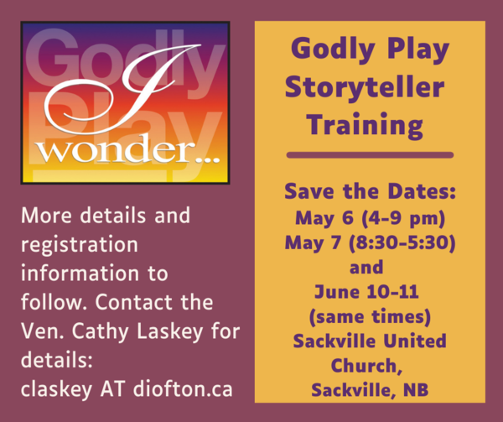

Say Yes! To Kids
During its first year, 2021, the Say Yes! To Kids campaign awarded a grant of $15,000 to Inner City Youth Ministry in Saint John for its Lunch Connection program in city schools. Let’s continue the momentum!
This year, the program has changed from the usual application process to peer-to-peer financing, where groups fundraise and keep 60 per cent of the proceeds for their project, with 20 per cent going to their diocese and the remaining 20 per cent to the Anglican Foundation.
The campaign launches April 1 and runs to June 30. Interested groups can apply to be part of Say Yes! To Kids and be on their way to making their projects a reality.
The first step is to take a webinar, which are being held throughout March.

Lenten series

Online or in person in Fredericton
Each service will be posted to the Christ Church (Parish) Church YouTube channel.

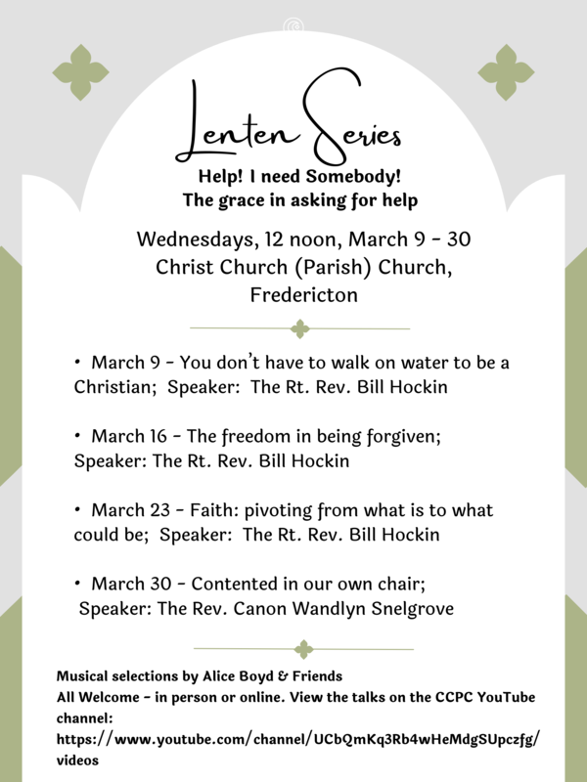

Donations for Ukraine relief
Donate via PWRDF
PWRDF is supporting Ukrainians forced to flee their homes due to the Russian invasion. The initial grant of $20,000 issued to an ACT Alliance appeal has been increased to $50,000. The grants will fund the work of Action by Churches Together (ACT) member Hungarian Interchurch Aid (HIA).
On Feb. 27, HIA set up a 24-hour refugee support point on the Hungarian side of the border at Beregsurány, where the line of refugees trying to cross into Hungary is kilometres long, says an ACT communiqué. HIA is providing hot tea, sandwiches, refreshments, blankets and basic hygiene items for Ukrainians, including many elderly and children who are waiting long hours to cross the border into Hungary.
How you can help
To make a donation to this response online, click here
You may also donate by phone at 416-822-9083 or leave a voicemail toll-free at 1-866-308-7973 and PWRDF will return your call; or mail your cheque to PWRDF, 80 Hayden, 3rd floor, Toronto, Ontario, M4Y 3G2. Please mark Ukraine in the memo field.

