St. Luke’s Anglican Church

April 26, 2020

At 10:00 a.m.
The Rev. Rob Montgomery
Priest-In-Charge
Parish of Gondola Point in Quispamsis, N.B.
rob.montgomery@anglican.nb.ca / 506-608-1772
https://www.facebook.com/StLukesGP
Parish Telephone: (506) 847-3670

Reading: Acts 2:14a, 36-41 Psalm 116:1-4, 12-19

1 Peter 1:17-23 Luke 24:13-35

St. Luke’s News

INTERCESSIONS:
- Anglican Communion: The Episcopal Church in Jerusalem & The Middle East, the Most Rev. Michael Lewis
- Missions: The Rev. Canon Paul Jeffries, Bishop McAllister College, in Uganda, fellow missionaries, teachers, volunteers. The Diocese of Ho, Companion Diocese of the Diocese of Fredericton.
- Fredericton, Bishop David Edwards, retired Bishops Claude, William and George, and their families. Camp Medley and Camp Brookwood, Threshold Ministries, The Anglican Diocese of Yukon: our retired clergy, and our fellow Anglicans: Cambridge and Waterborough, the Rev. Andrew Horne; Quispamsis, the Rev. Michael O’Hara; Gondola Point, the Rev. Rob Montgomery
- Gondola Point: Parish Breakfasts Parish family: Laurine Bushey and her family Parish Ministry: event convening committee and stewardship.
- Community Needs: those without work, food, or shelter, and those who serve and care for them. Pray also for those who are travelling.
- Shut-Ins: Martha M.
- Sick: Clare, Diane, Flora, Katie, Melissa, Nicola, Shawn, Wanda., Caroline B., Travis B., ,Winnie C., Jack D., John D., Doreen E., John E., Susan L., Barb M., Karen M., Audrey M. Calvin M., Malcom M., Alice P., Eleri P., Emilie P., Paul P., David S., Keaton S., Robert W. and any others we have been asked for prays…
- Thanksgiving: Tasks which demand our best efforts.

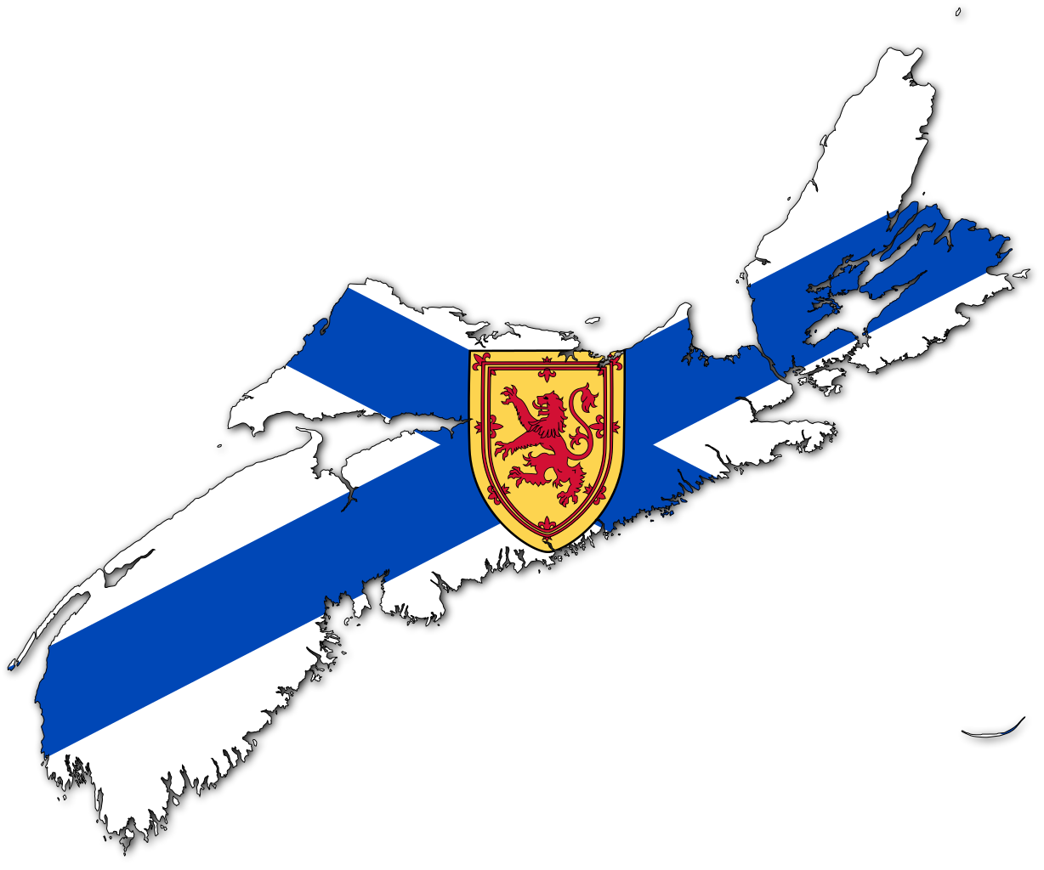
This week we would like to take the time to remember the many people who lost their lives or were injured this past week. We also remember their loved ones and friends. We want to say thank you to the many first responders, RCMP, police, firefighter, ambulance works, doctors, nurses and so many other support workers so numerous to mention. You are in our thoughts and prayers at the most difficult time when we cannot physically come together to support each other.

This is just a note to let you know that we have just launched our new Parish Website, and you can check it out at www.stlukesgp.ca

On this website is also St. Luke's Blog, posting of our Orders of Service and Sermons for Sundays, as well as other resources for us from time to time.

Feel free to explore, and spread the news if you can

-We have developed this Website which is available, and it will cost $180.00. Donations for this will allow us to reach a wider number of people.

Our Parish Bible Study is taking place online (using Zoom) every Tuesday at 3 PM. To join in or for mor information, please contact Rev. Rob Montgomery

Please contact Terry Sleep at 847-7609. He is our Parish E-offering Representative
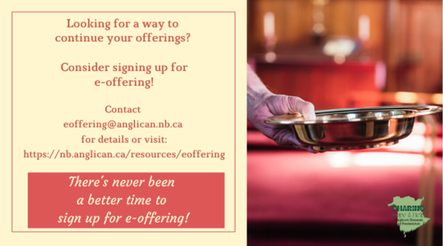
Or by mail to St. Luke’s Anglican Church, 12 Quispamsis Road, Quispamsis, New Brunswick, E2E 1M2 or e-transfer. Please contact Terry Sleep at 847-7609 for further information or instructions, thank you.

We must continue to meet our monthly expenses too while we are unable to come to our church to meet for worship and fellowship. Since all worship services, meetings and events at our church has been put on hold for the time being, our bulletin has changed . As the situation changes, activities will begin to be re-scheduled.

-Old eyeglasses are being collected in a box on the table at the back of the church when we return.

St. Luke’s is in the process of raising Funds for Restoration repairs of St. Luke’s Anglican Church with the matching of fund coming from a grant we have applied for from the Federal Government. White envelopes for this may be found on the entry table. If you have any questions, please speak with Rev. Rob Montgomery, Rosemarie Kingston or Terry Sleep. We how you can help.
Many of you received the e-news from Gisele McKnight, Diocesan Communications Officer. It contains messages from the Bishop concerning the coronavirus and the resulting procedural changes and cancellations that have been put in place. Bishop David’s message contains links to his earlier messages on the coronavirus, as well as to prayers, on-line worship services and the Book of Common Prayer. If you did not receive e-news, it may be found at https://nb.anglican.ca/newsletters/102/display A call to prayer has been issued and details may be found in e-news. As well, you can keep up with Diocesan events at https://nb.anglican.ca/

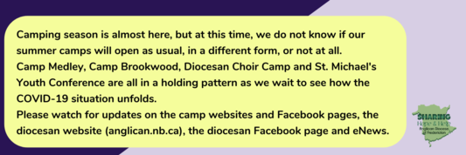

Wondering about summer camp? So are we!

Keep in touch with your favourite summer camps using the links below.
St. Michael’s Youth Conference
https://smyc.ca/
https://www.facebook.com/SMYCAtlantic/
Diocesan Choir Camp
http://www.anglicanchoirschool.com/
https://www.facebook.com/groups/121354914558579/
Camp Brookwood
http://www.campbrookwood.ca/
camp.brookwood@outlook.com
Camp Medley
http://campmedley.ca/
https://www.facebook.com/camp.medley/

