ST. LUKE’S ANGLICAN CHURCH

Sunday Morning Communion Service

April 23, 2023, at 10:00 a.m.

The Rev. Rob Montgomery
Priest-In-Charge

rob.montgomery@anglican.nb.ca / 506-608-1772
https://www.facebook.com/StLukesGP

12, Quispamsis Road, Quispamsis, N.B. E2E 1M2

Readings: Acts 2:14a, 36-41 Psalm 116; 1-4, 12-19

1 Peter 1: 17-23 Luke 24: 13-35

St. Luke’s News

INTERCESSIONS:
- Anglican Communion: The Church of the Province of Uganda, the Most Rev Stephen Kaziimba, Archbishop. Archbishop Linda Nicholls, Anglican Church of Canada. Bishop Ordinary to the Canadian Armed Forces Nigel Shaw and all military chaplains.
- Missions: The Rev. Canon Paul Jeffries, and his father, Bishop McAllister College, in Uganda, fellow missionaries, teachers, volunteers. The Diocese of Ho, Bishop Matthias Meduadues-Badohui, Ghana, West Africa the Companion Diocese of the Diocese of Fredericton
- Fredericton, Archbishop David, retired bishops Claude and William, and their families, the Lemmon family. Camp Medley and Camp Brookwood, Threshold Ministries, The Anglican Diocese of Yukon: our retired clergy, and our fellow Anglicans; Coldbrook - St. Mary, the Rev. Canon Gregory McMullin; Upham, The Ven, Rob Marsh; Gondola Point, the Rev. Rob Montgomery, and his family
- Gondola Point: Wednesday Night Contemplative Prayer Services Parish family: Janet Cunningham and her family Parish Ministry: parish communications officer and stewardship.
- Community Needs: those without work, food, or shelter, and those who serve and care for them. Pray also for those who are travelling.
- Shut-Ins, especially if due to COVID-1.9.
- Sick: Alice, Barb, Bev, Catharine, Danielle, Diane, Flora, Janet, Katie, Laverne, Peggy, Shawn, Wanda., James F, Travis B., Jack D., Natalie D., James F., Isaac D. , John E., Lisa G., Diane M., Calvin M., Kathy M., Malcolm M., Donna P., David S., Keaton S., Donna T., Wendy W., and any others we have been asked to include in our prays….
- Thanksgiving: Canada, New Brunswick, and political freedom.

Archbishop David urgently asks for your prayers for Archbishop Ezekial Kumir Kondo, Archbishop of the Province of Sudan, and Bishop of Khartoum. He, his family and staff have had to flee as the Cathedral and compound have been attacked in an uprising there.
The BBC is reporting 185 dead since fighting began on Saturday.

Parish Mission Outreach: For the next Sundays, we are collecting boxes of “Cheerios” Cereal for an Elementary School Breakfast Program. Non-name brands are acceptable if there are no nuts (peanuts, peanut oil) in the ingredients or facilities in which they are made. Again, we will collect them at the church and then deliver them to the school.

May 6/23 Girls Day Out at St. Luke’s Parish Hall, 12 Quispamsis Road Further detail to follow.

May 28/23 Will be our next All Ages Event on Pentecost Sunday in Hall 3-6pm.

+++++++++++++++++++++++++++++++++++++++++++++++++++++
April 25/23 A FUN OPPORTUNITY! Plans are underway for The Balysto Steelband Society to begin meeting at St. Luke’s Church Hall, corner of Metcalf St. and Lansdowne Ave., Saint John in May. Learning to play steel pan is easy, fun, and great exercise for children and adults of all ages. No previous musical experience is necessary: the music is written in letters, so although being able to read regular music is an asset, it is not necessary at all. Free classes will be offered for children aged 10 to 12, teens and young adults aged 13+, and adults aged 18+. A short class will be offered for older seniors who just want to meet some new people and have fun. All instruments and music will be provided free of charge; if you play the drums or just want to sit in a chair and shake a tambourine, come join in the fun! Registration for classes is from 6.30 to 7 pm this Tuesday (April 25), at St. Luke’s. Classes are scheduled to start the first week of May.

A Baker’s Dozen Years Serving the KV COMMUNITY VOLUNTEER INCOME TAX PROGRAM For Rothesay & Quispamsis Residents
What is it? F R E E - Preparation & Filing – F R E E of Basic Income Tax Returns for current or prior years. Income limits $35,000 (singles) or $45,000 (couples) When and Where? Every Tuesday March 7th to April 25th, 2023 9:00 to 2:00 at St. Paul’s Parish Centre on the Rothesay Common ** Due to continuing COVID concerns ** Clients are asked to Drop off one Tuesday and Pick up the next Tuesday.

Camp Medley workdays
Camp Medley will hold two camp workdays: Saturday, April 29, and Saturday, June 3. Both days run 9 a.m.-4 p.m.
There are lots of cleaning and projects requiring different skill levels. All welcomed and needed. Please let camp director John Galbraith know if you are thinking of coming as it will help him prepare. Lunch will be provided.
director@campmedley.ca

May 6/23 You are invited to a coronation breakfast!
As a Constitutional Monarchy, with His Majesty King Charles III as our official Head of State, Canada will witness an historic moment with the Coronation on May 6, 2023. As members of the Worldwide Anglican Communion, this event will also be an historic moment in the life of our church. At the center of the coronation is a Christian service in which His Majesty will be anointed as King. It will be rooted in longstanding tradition and Christian symbolism and is an opportunity for us as followers of King Jesus to pray for Charles and others in positions of earthly authority. Join us IN-PERSON at 7 a.m. on Sat. May 6 to view the live-stream of coronation service together at St. Paul's in Hampton. There will be tea and scones at the beginning of the service (bring your favorite teacup), and breakfast bake and juice to share after the service. All are welcome, so please invite your friends and neighbours.

Saturday May 6 Takeout Salmon Supper in the Parish of Quispamsis, St. Augustine's Church, 239 Quispamsis Rd., Quispamsis. Menu: salmon, potatoes, vegetable, a roll, and a dessert all for $15. Pick up times are 4:30, 5:00 and 5:30 p.m. For tickets please call Art Scott: 506-849-2430.
Tickets will not be available at the door.

Saturday, May 6, 11 a.m.-1 p.m. St. Mary & St. Bartholomew’s Church, 646 Westmorland Rd., Saint John will host its annual Spring Tea & Quilt Show, with crafts, gifts, collectibles, silent auction and bake sale. Sandwiches and cakes will be served. $8 adults $4 children; tickets available from church office 696-1347 or at the door.

May 13, 2-4 p.m. Saturday, Willing Workers Spring Tea at St. George's Anglican Church, Moncton. $10 per person. Menu: Sandwiches, sweets, tea & coffee. Prize Draws. For more information call the church at 506-855-5209.

May 13, 4:30-6:30 p.m. St. Paul’s, Hampton is hosting a free Community Supper and you are invited. Everyone is welcome to come and eat for free. MENU: roast pork & gravy, mashed potatoes, mixed vegs, pie for dessert. If you feel moved to make a small donation, you can do so in person or via Interac E-Transfer to stpauls-hampton@outlook.com

JULY 8/23, Please save the date for a one-day Choir School Workshop and Evensong. Clinicians and music are being finalized.
Trinity Church is the locale. There will be an optional rehearsal Friday July 7 and music selections will be available before the event

++++++++++++++++++++++++++++++++++++++++++++++++++++++

St. Luke’s A.C.W meet every Monday at 10:00 am all are welcome.

The Rev. Montgomery’s Online Bible Study continues Tuesday at 3:30 p.m.

St. Luke’s Book Club the last Tuesday of the month at 2:00 p.m. at St. Luke’s Parish Hall. Please contact Heather Hynds for the list of books.

The Rev. Rob Montgomery’s Midweek Contemplative Services on hold until after Easter at St. Luke’s Anglican Church
Mission Visionary Group – Meet monthly for guidance and direction of out missionary outreach of the Parish. Further details please contact the Rev. Rob Montgomery.

Quarters for A Kilometer: We will be collecting quarters ($0.25) for the distance of a kilometer for the Church Restoration Fund. There will be a container on the back table for the quarters.

Work on our Building Restoration Project is complete. St. Luke’s is in the process of raising funds for re- investments funds used for the Restoration repairs of St. Luke’s Anglican Church. White envelopes for this are on the entry table. If you have any questions, please speak with Rev. Rob Montgomery, Rosemarie Kingston, or Terry Sleep.

Safe Church Trainer and Renewals: Please note a new online safe church training platform has been developed to allow the Diocese to better track who has taken the training, as well as working to make the training more relevant, accessible, and simple to complete. The new training should take 30-45 minutes and the Diocese would appreciate all feedback that you can provide on the entire process to ensure this is the ideal system to roll out to the diocese. Please contact Donna Dobbin for your training, thank you.

We are collecting refundable items from the parish for the Restoration Fund for the Church. If you have any you would like picked up, you may call Terry and Susan Sleep on 847-7609, or Darryl.

On this website is also St. Luke's Blog, posting of our Orders of Service and Sermons for Sundays, as well as other resources for us from time to time. Feel free to explore and spread the news if you can.

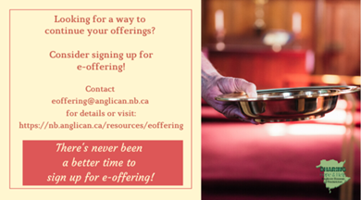
We must continue to meet our monthly expenses while we are unable to come to our church to meet at times for worship and fellowship. Since all worship services, meetings, and events at our church are on hold at times, our bulletin has changed. As the situation changes, activities will begin to be re-scheduled. Please contact Terry Sleep at 847-7609. He is our Parish E-offering Representative or by mail to St. Luke’s Anglican Church, 12 Quispamsis Road, Quispamsis, New Brunswick, E2E 1M2 or e-transfer. Please contact Terry Sleep at 847-7609 for further information or instructions, thank you.

Many of you received the e-news from Gisele McKnight, Diocesan Communications Officer. It contains messages from the archbishop concerning the coronavirus and the resulting procedural changes and cancellations that have been put in place. Bishop David’s message contains links to his earlier messages on the coronavirus, as well as to prayers, on-line worship services and the Book of
Common Prayer. If you did not receive e-news, it may be found at https://nb.anglican.ca/newsletters/102/display A call to prayer has been issued and details may be found in e-news. As well, you can keep up with Diocesan events at https://nb.anglican.ca/
E - News wants subscriber
e-News is the best way to keep up to date on what is going on in the diocese.
Click here to subscribe.

THE ANGLICAN JOURNAL AND THE NEW BRUNSWICK ANGLICAN: If you are not currently receiving the Anglican Journal and the New Brunswick Anglican and would like to, there are two ways to subscribe: 1. On-line at https://www.anglicanjournal.com/newsubscription/ checking off that you want the Diocesan paper called "Fredericton - New Brunswick Anglican" in the drop-down menu to accompany your subscription to the Anglican Journal, or 2. E-mail circulation@national.anglican.ca indicating
that you would like to receive both the Anglican Journal and the New Brunswick Anglican. Include the name of your parish and the Diocese.

Annual Clergy Spouses Retreat Registration: ceroutledge@yahoo.ca

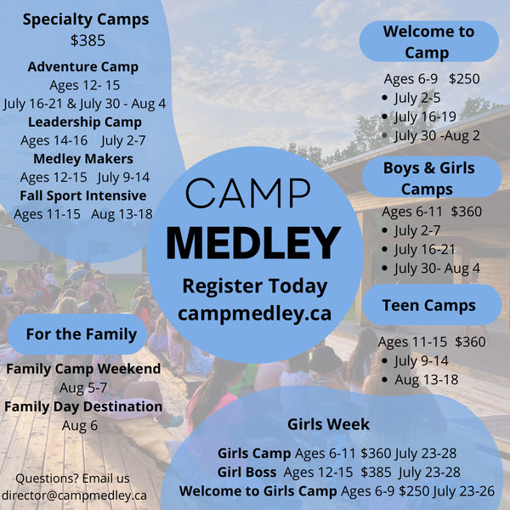

Donations for Ukraine relief
Donate via PWRDF
PWRDF is supporting Ukrainians forced to flee their homes due to the
Russian invasion. The initial grant of $20,000 issued to an ACT Alliance appeal has been increased to $50,000. The grants will fund the work of
Action by Churches Together (ACT) member Hungarian Interchurch Aid
(HIA). On Feb. 27, HIA set up a 24-hour refugee support point on the Hungarian side of the border at Beregsurány, where the line of refugees trying to cross into Hungary is kilometres long, says an ACT communiqué. HIA is providing hot tea, sandwiches, refreshments, blankets, and basic hygiene items for Ukrainians, including many elderlies and children who are waiting long hours to cross the border into Hungary. How you can help. To donate to this response online, you may also donate by phone at 416-822-9083 or leave a voicemail, toll-free at 1-866-308-7973 and PWRDF will return your call; or mail your cheque to PWRDF, 80 Hayden, 3rd floor, Toronto, Ontario, M4Y 3G2. Please mark Ukraine in the memo field. Apply to be part of Say Yes! To Kids and be on their way to making their projects a reality. The first step is to take a webinar, which are being held throughout March

