ST. LUKE’S ANGLICAN CHURCH

1st Sunday of Advent
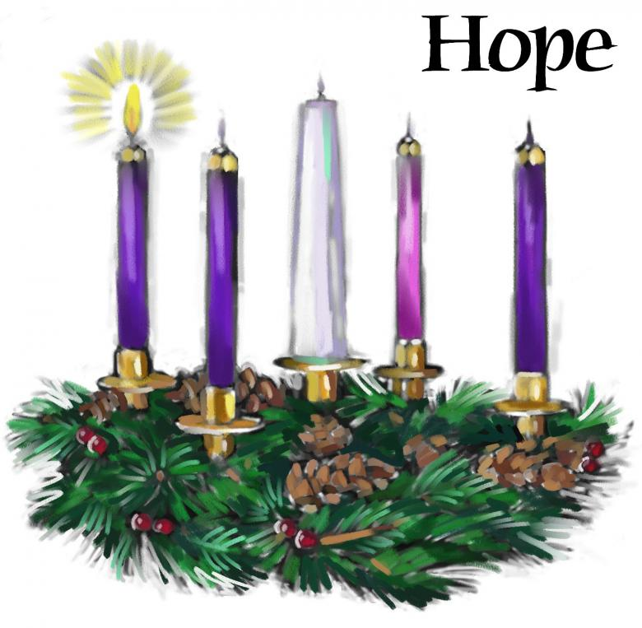
November 29, 2020
At 10:00 a.m.
The Rev. Rob Montgomery
Priest-In-Charge
Parish of Gondola Point in Quispamsis, N.B.

rob.montgomery@anglican.nb.ca / 506-608-1772
https://www.facebook.com/StLukesGP
Website - www.stlukesgp.ca
Parish Telephone: (506) 847-3670

Reading: Isaiah 64: 1-9 Psalm 80: 1-7, 17- 19

1 Corinthians 1: 3 - 9 Mark 13: 24-37

INTERCESSIONS:
- Anglican Communion: The Lusitanian Church (Extra-Provincial to the Archbishop of Canterbury), the Rt. Rev. Jorge Pina Cabral, Bishop.
- Missions: The Rev. Canon Paul Jeffries, Bishop McAllister College, in Uganda, fellow missionaries, teachers, volunteers. The Diocese of Ho, Companion Diocese of the Diocese of Fredericton
- Fredericton, Archbishop David Edwards, retired Bishops Claude, William and George, and their families. Camp Medley and Camp Brookwood, Threshold Ministries, The Anglican Diocese of Yukon: our retired clergy, and our fellow Anglicans: Riverview, the Rev. Julian Pillay; Hampton, the Rev. David Turner; Gondola Point, the Rev. Rob Montgomery
- Gondola Point: Baden Powell Program Parish family: Greg Theobald and Bronwyn McIntyre and their family Parish Ministry: parish communications officer and stewardship.
- Community Needs: those without work, food, or shelter, and those who serve and care for them. Pray also for those who are travelling.
- Shut Ins due to COVID-19
- Sick: Flora, Katie, Lenard, Melissa, Shawn, Wanda., Travis B., Jack D., Doreen E., John E., Calvin M., Eleri P., Emilie P., David S., Keaton S., and any others we have been asked for prays…
- Thanksgiving: Family, Friends and Community Employment.

Parish Mission Outreach: For the next 2 Sundays, we are collecting boxes of “Cheerios” Cereal for a School Breakfast Program. Non-name brand is acceptable if there are no nuts (peanuts, peanut oil) in the ingredients or facilities they are made in. Again, we will collect them at the church and then deliver them to the school.

St. Luke’s A.C.W. will be on hold for now

Trinity Church Columbarium The Trinity Columbarium is located inside the Germaine Street entrance at Trinity Anglican Church in Saint John, NB. This beautiful, historical church provides a place of remembrance for families wanting that connection with the church. There are various niche sizes (individual, couples, and family) available for purchase. Inquiries can be directed to the Trinity Parish office at (506) 693-8558 or email: trinsj@nb.aibn.com

Dec. 1/20The Rev. Montgomery will be holding St. Luke’s Parish Bible Study on Tuesday, virtually at 2:30PM. Please contact Rev. Rob for further instructions.

ADVENT TALKS: The 2020 Advent series of weekly talks with Bishop Bill Hockin and Friends will be presented again this year, but in an on-line format. “Shopping for a Messiah: Keeping Christmas in the time of a Pandemic” begins at noon on Mon Nov 30th with “Finding the Stable in the Storm.” For the complete schedule and instructions on how to log in, please visit www.billhockin.ca.

On this website is also St. Luke's Blog, posting of our Orders of Service and Sermons for Sundays, as well as other resources for us from time to time. Feel free to explore and spread the news if you can.

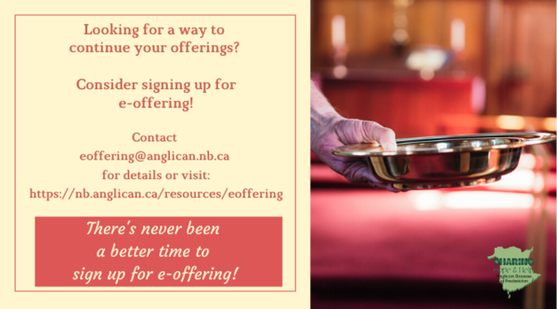
We must continue to meet our monthly expenses too while we are unable to come to our church to meet for worship and fellowship. Since all worship services, meetings and events at our church has been put on hold for the time being, our bulletin has changed. As the situation changes, activities will begin to be re-schedule. Please contact Terry Sleep at 847-7609. He is our Parish E-offering Representative or by mail to St. Luke’s Anglican Church, 12 Quispamsis Road, Quispamsis, New Brunswick, E2E 1M2 or e-transfer. Please contact Terry Sleep at 847-7609 for further information or instructions, thank you.

St. Luke’s is in the process of raising Funds for Restoration repairs of St. Luke’s Anglican Church with the matching of fund coming from a grant we have applied for from the Federal Government. White envelopes for this may be found on the entry table. If you have any questions, please speak with Rev. Rob Montgomery, Rosemarie Kingston, or Terry Sleep. We how you can help.

Many of you received the e-news from Gisele McKnight, Diocesan Communications Officer. It contains messages from the Bishop concerning the coronavirus and the resulting procedural changes and cancellations that have been put in place. Bishop David’s message contains links to his earlier messages on the coronavirus, as well as to prayers, on-line worship services and the Book of
Common Prayer. If you did not receive e-news, it may be found at https://nb.anglican.ca/newsletters/102/display A call to prayer has been issued and details may be found in e-news. As well, you can keep up with Diocesan events at https://nb.anglican.ca/
E - News wants subscriber
e-News is the best way to keep up to date on what is going
on in the diocese Click here to subscribe.

Advent Readings

First Candle - The Candle of Hope

Leader: Today is the First Sunday of Advent, in which we recall the hope we have in Christ.

God told Abraham that through him all the nations of the world would be blessed, because he trusted and put his hope in God:

“I will make you into a great nation,” God told Abraham. “I will bless you and you will be a blessing to others … All the families on earth will be blessed through you.”

The Old Testament spoke of the coming of Christ, of how a Saviour would be born, a king in the line of King David. He would rule the world wisely and bless all the nations.

We too believe in God's promise to bless all people through Jesus. And we believe Jesus will come again to this world to bring light into the darkness and to establish his kingdom upon the earth.

(A person lights the First Candle here)

Hope is like a light shining in a dark place. As we look at the light of this candle, we celebrate the hope we have in Jesus Christ.

Leader: Let us pray:

All: All-mighty, all-loving God, your love is revealed to us in Jesus Christ, Son of God, and Son of David. Help us in preparing to celebrate his birth, to make our hearts ready and to place our hope in you. Help us today and every day to worship you, to hear your word, and to do your will by sharing your hope with others. We ask it in the name of the one who was born in Bethlehem. Amen

