ST. LUKE’S ANGLICAN CHURCH

2nd Sunday of Advent
Peace

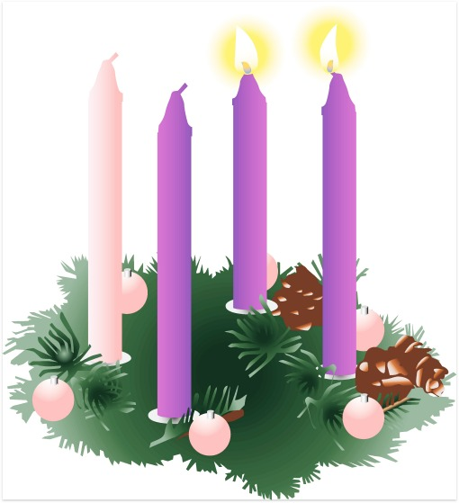
December 6, 2020
At 10:00 a.m.
The Rev. Rob Montgomery
Priest-In-Charge
Parish of Gondola Point in Quispamsis, N.B.

rob.montgomery@anglican.nb.ca / 506-608-1772
https://www.facebook.com/StLukesGP
Website - www.stlukesgp.ca
Parish Telephone: (506) 847-3670

Reading: Isaiah 40: 1-11 Psalm 85: 1-13

2 Peter 3: 8-15a Mark 1: 1- 8

INTERCESSIONS:
- Anglican Communion: The Reformed Episcopal Church of Spain (Extra-Provincial to the Archbishop of Canterbury), the Rt. Rev. Carlos López-Lozano
- Missions: The Rev. Canon Paul Jeffries, Bishop McAllister College, in Uganda, fellow missionaries, teachers, volunteers. The Diocese of Ho, Companion Diocese of the Diocese of Fredericton
- Fredericton, Archbishop David Edwards, retired Bishops Claude, William and George, and their families. Camp Medley and Camp Brookwood, Threshold Ministries, The Anglican Diocese of Yukon: our retired clergy, and our fellow Anglicans: St. David and St. Patrick, the Ven. John Matheson Riverview; Renforth, the Rev. Jonathan Hallewell; Gondola Point, the Rev. Rob Montgomery
- Gondola Point: Fellowship of Prayer, Prayer Chain Parish family: Chris and Laura Wilson and their family Parish Ministry: Baden Powell liaison and stewardship.
- Community Needs: those without work, food, or shelter, and those who serve and care for them. Pray also for those who are travelling.
- Shut Ins due to COVID-19
- Sick: Flora, Katie, Lenard, Melissa, Shawn, Wanda., Travis B., Jack D., Peggy D., Doreen E., John E., Calvin M., Eleri P., Emilie P., David S., Keaton S., and any others we have been asked for prays…
- Thanksgiving: Health and our Health Care System Family.

Up Coming Services at St. Luke’s:

Lessons & Carols Service on Dec. 20 at 10:00 a.m.

Christmas Eve Service on Dec. 24 at 5:00 p.m. and 7:30 p.m.

Christmas Day Service on Dec. 25 at 11:00 a.m.

Blue Christmas Service: date to be determined

These services are subject to change due to Covid-19 regulations.

Parish Mission Outreach: For the next 2 Sundays, we are collecting boxes of “Cheerios” Cereal for a School Breakfast Program. Non-name brand is acceptable if there are no nuts (peanuts, peanut oil) in the ingredients or facilities they are made in. Again, we will collect them at the church and then deliver them to the school.

St. Luke’s A.C.W. will be on hold for now

Trinity Church Columbarium The Trinity Columbarium is located inside the Germaine Street entrance at Trinity Anglican Church in Saint John, NB. This beautiful, historical church provides a place of remembrance for families wanting that connection with the church. There are various niche sizes (individual, couples, and family) available for purchase. Inquiries can be directed to the Trinity Parish office at (506) 693-8558 or email: trinsj@nb.aibn.com

Dec.2020The Rev. Montgomery will be holding St. Luke’s Parish Bible Study on Tuesday, virtually at. Please contact Rev. Rob for further instructions.

ADVENT TALKS: The 2020 Advent series of weekly talks with Bishop Bill Hockin and Friends will be presented again this year, but in an on-line format. “Shopping for a Messiah: Keeping Christmas in the time of a Pandemic” begins at noon on Mon Nov 30th with “Finding the Stable in the Storm.” For the complete schedule and instructions on how to log in, please visit www.billhockin.ca.

On this website is also St. Luke's Blog, posting of our Orders of Service and Sermons for Sundays, as well as other resources for us from time to time. Feel free to explore and spread the news if you can.

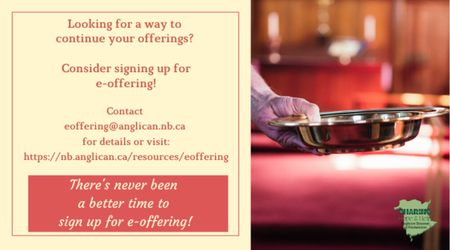
We must continue to meet our monthly expenses too while we are unable to come to our church to meet for worship and fellowship. Since all worship services, meetings and events at our church has been put on hold for the time being, our bulletin has changed. As the situation changes, activities will begin to be re-schedule. Please contact Terry Sleep at 847-7609. He is our Parish E-offering Representative or by mail to St. Luke’s Anglican Church, 12 Quispamsis Road, Quispamsis, New Brunswick, E2E 1M2 or e-transfer. Please contact Terry Sleep at 847-7609 for further information or instructions, thank you.

St. Luke’s is in the process of raising Funds for Restoration repairs of St. Luke’s Anglican Church with the matching of fund coming from a grant we have applied for from the Federal Government. White envelopes for this may be found on the entry table. If you have any questions, please speak with Rev. Rob Montgomery, Rosemarie Kingston, or Terry Sleep. We how you can help.

Second Candle - The Candle of Peace

Leader: Today is the Second Sunday of Advent and we will light the Candle of Peace.

Last Sunday we lit the First Candle in our Advent Wreath and celebrated the faith of the people in the Old Testament, who looked forward to God’s blessing, hope in Christ. We light it again as we remember our Saviour, born a king in the line of King David. Jesus was born in Bethlehem, and we believe that he will come again to fulfill all of God's promises to us, to rule the world wisely and bless all nations.

(A person lights the First Candle, the Candle of Hope)

Today we light the Second Candle of Advent, the Candle of Peace. We remember the prophets who spoke of the coming of Christ, of how a Saviour would be born, a king in the line of King David.

Isaiah wrote, “The people who walk in darkness will see a great light. For those who live in a land of deep darkness, a light will shine. For a child is born to us, a son is given to us. The government will rest on his shoulders. And he will be called: Wonderful Counselor, Mighty God, Everlasting Father, Prince of Peace.”

When Jesus came, he taught people the importance of being peacemakers. He said that those who make peace shall be called the children of God. When Christ comes to us, he brings us peace and he will bring everlasting peace when he comes again. We light the Candle of Peace to remind us that Jesus is the Prince of Peace and that through him peace is found.

(A person lights Second Candle, the Candle of Peace)

Peace is like a light shining in a dark place. As we look at this candle, we celebrate the peace we find in Jesus Christ.

Leader: Let us pray:

All: Lord Jesus, Light of the World, the prophets said you would bring peace and save your people from trouble. Give peace in our hearts this year. We ask that as we wait for you to come again, that you would remain present with us. Help us today, and everyday to worship you, to hear your word, and to do your will by sharing your peace with each other. We ask it in the name of the one who was born in Bethlehem. Amen.
Many of you received the e-news from Gisele McKnight, Diocesan Communications Officer. It contains messages from the Bishop concerning the coronavirus and the resulting procedural changes and cancellations that have been put in place. Bishop David’s message contains links to his earlier messages on the coronavirus, as well as to prayers, on-line worship services and the Book of
Common Prayer. If you did not receive e-news, it may be found at https://nb.anglican.ca/newsletters/102/display A call to prayer has been issued and details may be found in e-news. As well, you can keep up with Diocesan events at https://nb.anglican.ca/
E - News wants subscriber
e-News is the best way to keep up to date on what is going
on in the diocese Click here to subscribe.

