ST. LUKE’S ANGLICAN CHURCH

3rd Sunday of Advent
Joy

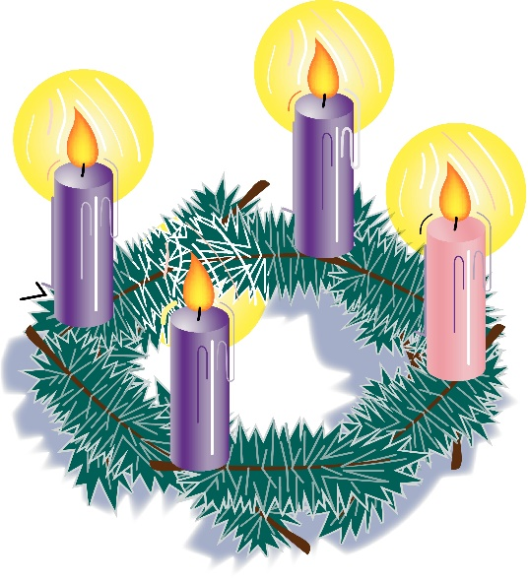
December 13, 2020
At 10:00 a.m.
The Rev. Rob Montgomery
Priest-In-Charge
Parish of Gondola Point in Quispamsis, N.B.

rob.montgomery@anglican.nb.ca / 506-608-1772
https://www.facebook.com/StLukesGP
Website - www.stlukesgp.ca
Parish Telephone: (506) 847-3670

Reading: Isaiah 61: 1-4, 8-11 Psalm 126 OR Luke 1: 46b - 55

1 Thessalonians 5: 16-24 John 1:6-8, 19-28

INTERCESSIONS:
- Anglican Communion: The Falkland Islands (Extra-Provincial to Canterbury), the Rt. Rev. Timothy Thornton
- Missions: The Rev. Canon Paul Jeffries, Bishop McAllister College, in Uganda, fellow missionaries, teachers, volunteers. The Diocese of Ho, Companion Diocese of the Diocese of Fredericton
- Fredericton, Archbishop David Edwards, retired Bishops Claude, William and George, and their families. Camp Medley and Camp Brookwood, Threshold Ministries, The Anglican Diocese of Yukon: our retired clergy, and our fellow Anglicans: St. Peter, the Rev. Canon Dr. Ross Hebb; Upham The Ven, Rob Marsh; Gondola Point, the Rev. Rob Montgomery
- Gondola Point: Romero House Parish family: Chris and Laura Wilson and their family Parish Ministry: sidesmen and stewardship.
- Community Needs: those without work, food, or shelter, and those who serve and care for them. Pray also for those who are travelling.
- Shut Ins due to COVID-19
- Sick: Flora, Katie, Lenard, Melissa, Shawn, Wanda., Travis B., Jack D., Doreen E., John E., Calvin M., Eleri P., Emilie P., David S., Keaton S., and any others we have been asked for prays…
- Thanksgiving: Our Church Family and Freedom to Worship.

Up Coming Services at St. Luke’s:

Lessons & Carols Service on Dec. 20 at 10:00 a.m.

Christmas Eve Service on Dec. 24 at 5:00 p.m. and 7:30 p.m.

Christmas Day Service on Dec. 25 at 11:00 a.m.

Blue Christmas Service: date to be determined

These services are subject to change due to Covid-19 regulations.

Parish Mission Outreach: For the next 2 Sundays, we are collecting boxes of “Cheerios” Cereal for a School Breakfast Program. Non-name brand is acceptable if there are no nuts (peanuts, peanut oil) in the ingredients or facilities they are made in. Again, we will collect them at the church and then deliver them to the school.

St. Luke’s A.C.W. will be on hold for now

Trinity Church Columbarium The Trinity Columbarium is located inside the Germaine Street entrance at Trinity Anglican Church in Saint John, NB. This beautiful, historical church provides a place of remembrance for families wanting that connection with the church. There are various niche sizes (individual, couples, and family) available for purchase. Inquiries can be directed to the Trinity Parish office at (506) 693-8558 or email: trinsj@nb.aibn.com

Dec.2020The Rev. Montgomery will be holding St. Luke’s Parish Bible Study on Tuesday, virtually at. Please contact Rev. Rob for further instructions.

ADVENT TALKS: The 2020 Advent series of weekly talks with Bishop Bill Hockin and Friends will be presented again this year, but in an on-line format. “Shopping for a Messiah: Keeping Christmas in the time of a Pandemic” begins at noon on Mon Nov 30th with “Finding the Stable in the Storm.” For the complete schedule and instructions on how to log in, please visit www.billhockin.ca.

On this website is also St. Luke's Blog, posting of our Orders of Service and Sermons for Sundays, as well as other resources for us from time to time. Feel free to explore and spread the news if you can.

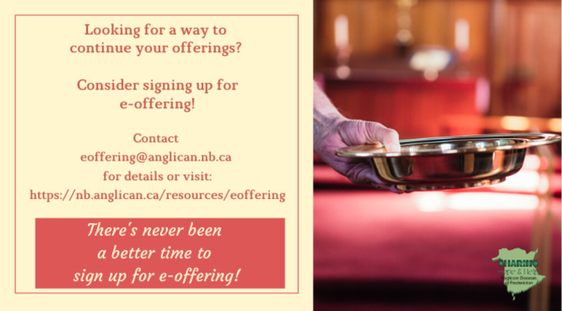
We must continue to meet our monthly expenses too while we are unable to come to our church to meet for worship and fellowship. Since all worship services, meetings and events at our church has been put on hold for the time being, our bulletin has changed. As the situation changes, activities will begin to be re-schedule. Please contact Terry Sleep at 847-7609. He is our Parish E-offering Representative or by mail to St. Luke’s Anglican Church, 12 Quispamsis Road, Quispamsis, New Brunswick, E2E 1M2 or e-transfer. Please contact Terry Sleep at 847-7609 for further information or instructions, thank you.

St. Luke’s is in the process of raising Funds for Restoration repairs of St. Luke’s Anglican Church with the matching of fund coming from a grant we have applied for from the Federal Government. White envelopes for this may be found on the entry table. If you have any questions, please speak with Rev. Rob Montgomery, Rosemarie Kingston, or Terry Sleep. We how you can help.

THIRD SUNDAY OF ADVENT
Speaker 1: The light glowing from our Advent wreath is burning brighter. This radiance warms our hearts and fills us with joy! The Lord has done great things for us. Let us rejoice.

Speaker 2: “May those who sow in tears reap with shouts of joy. Those who go out weeping, bearing the seed for sowing, shall come home with shouts of joy, carrying their sheaves” (Psalm 126:5–6).

The first three candles are lit.
Speaker 3: Light three candles, see them glow
Brightly, so that all may know
How three candles show the way
Making our darkness bright as God’s day.

Speaker 4: Those who go out weeping, bearing the seed for sowing, shall come home with shouts of joy, carrying their sheaves.

All pray: Dear God, we carry many burdens and worry over many things. Help us to hear your promise in this Advent season, that in hearing, we may receive the Spirit’s gift of joy. And may our spirits be kept sound at the coming of our Lord Jesus Christ, in whose name we pray. Amen.

THE THIRD SUNDAY OF ADVENT (option 2)
The blind receive their sight!
(Based on Matthew 11:2–11)
Leader: | John asked Jesus, “Are you the one who is to come, or are we to wait for another?”
People: | Jesus said, “The blind receive their sight, the lame walk, the lepers are cleansed, the deaf hear.
Leader: | The dead are raised, and the poor have good news brought to them. Blessed is anyone who takes no offense at me.
People: | Truly I tell you, no one has arisen greater than John the Baptist; yet the least in the kingdom of heaven is greater than he.” We light the first Advent candle to remind us to keep awake and be ready. (Pause while the first candle is lit.) The second Advent candle reminds us to changes our ways. (Pause while the second candle is lit.) We light the third Advent candle to remind us of the good news that the blind can see and the lame can walk.

Many of you received the e-news from Gisele McKnight, Diocesan Communications Officer. It contains messages from the Bishop concerning the coronavirus and the resulting procedural changes and cancellations that have been put in place. Bishop David’s message contains links to his earlier messages on the coronavirus, as well as to prayers, on-line worship services and the Book of
Common Prayer. If you did not receive e-news, it may be found at https://nb.anglican.ca/newsletters/102/display A call to prayer has been issued and details may be found in e-news. As well, you can keep up with Diocesan events at https://nb.anglican.ca/
E - News wants subscriber
e-News is the best way to keep up to date on what is going
on in the diocese Click here to subscribe.

